1. Explain Hierarchy of Prime? Give table names and how they are linked to each other?

**Hierarchy:**

Once we logged in to Prime, Using card number or account number we can search entire details pertaining to that account.

* Customer
* Account (Customer can have multiple accounts)
* Cards (One account can have multiple cards -> primary card and supplementary card(s))

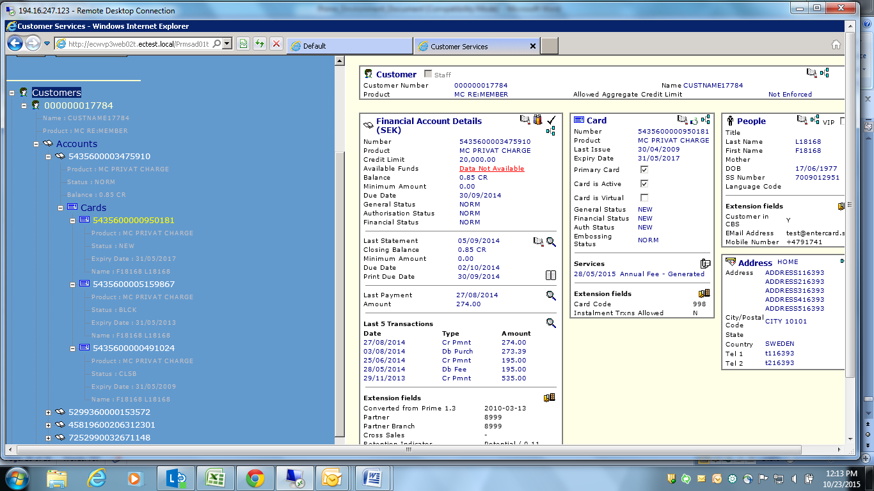

Database Mapping: (If card number is provided = '5435600000950181')

* select * from cardx where Numberx = '5435600000950181';

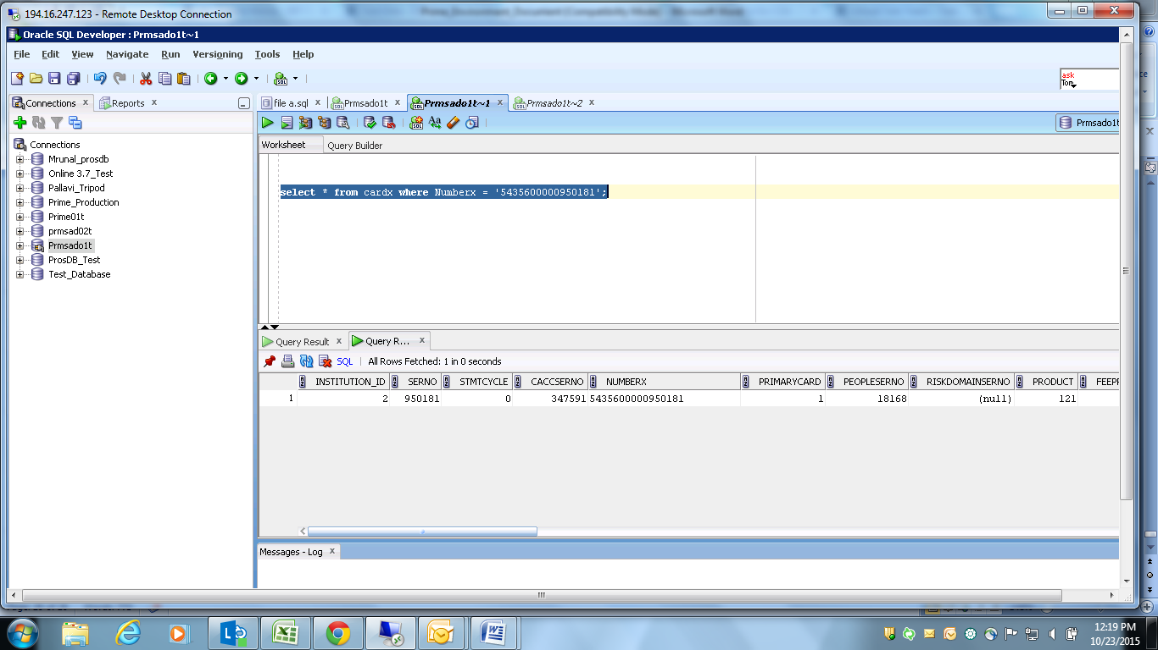

* Pick Peopleserno from cardx table and find ssnumber.

Select * from people where serno = '18168';

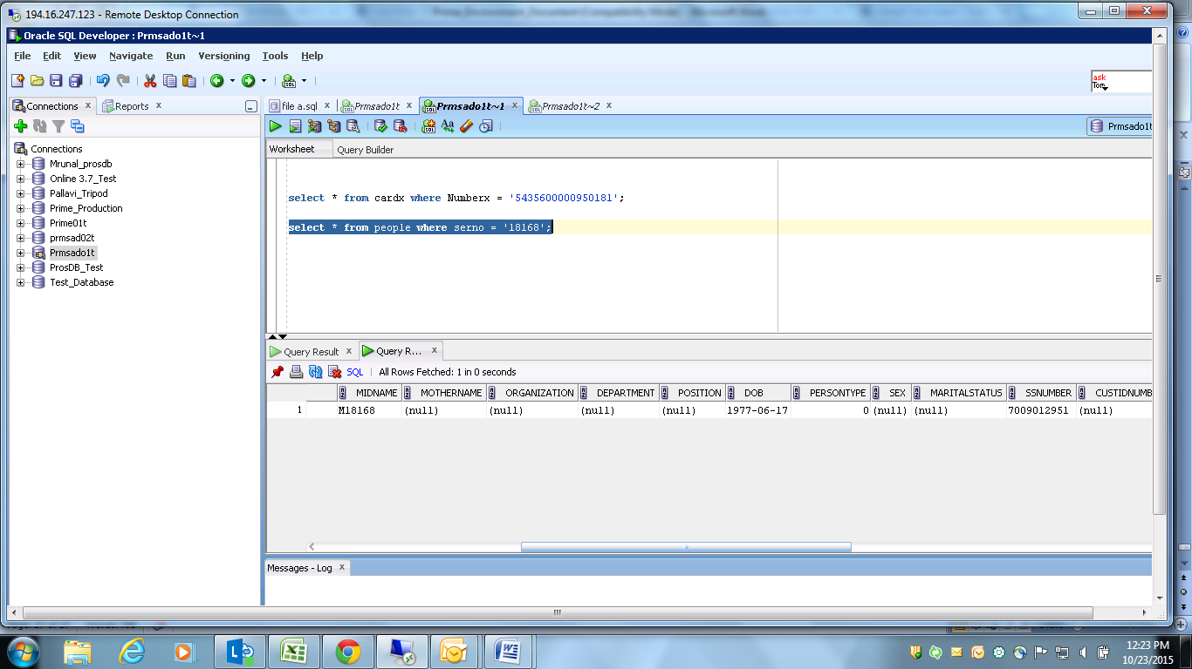

* Pick caccserno from cardx table and find account details pertaining to same selected card.

Select * from caccounts where serno = '347591';

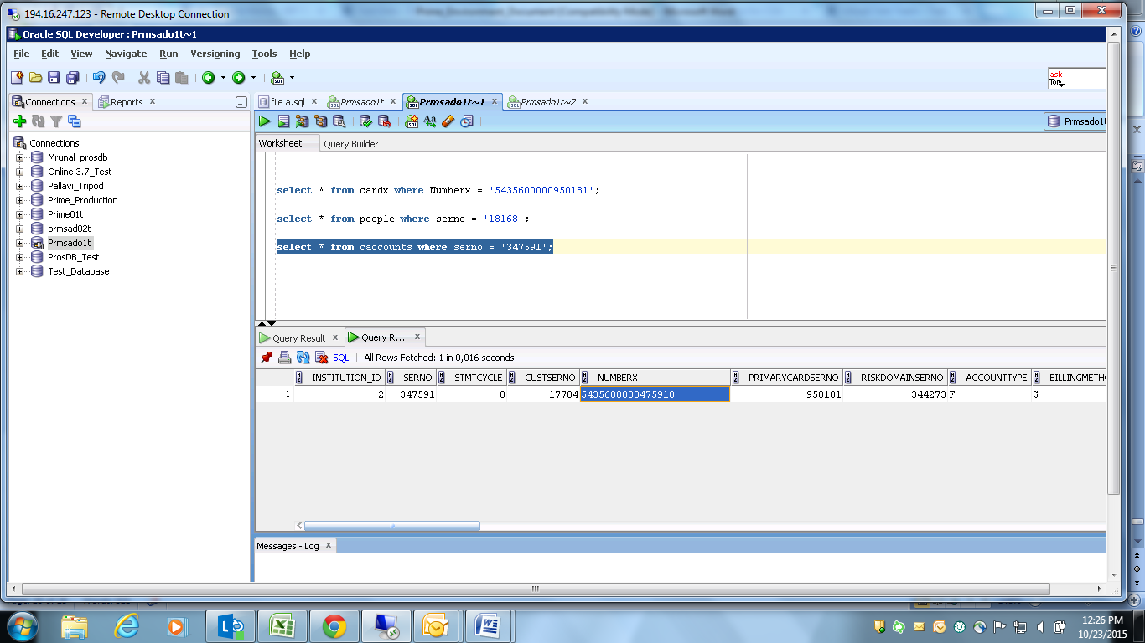

* Pick caccserno from caccounts table and find extension details.

Select * from Cextension where rowserno = '347591'; (rowserno of extension table = serno of caccounts table)

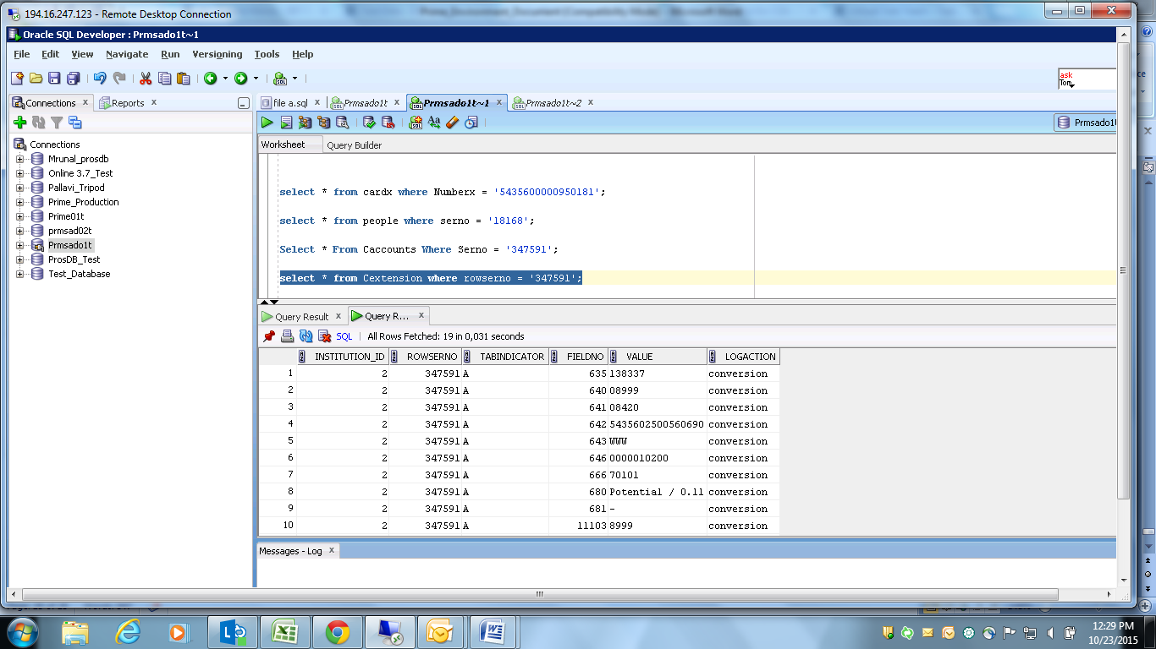

* Pick caccserno from caccounts table and find addresslink details.

Select * from Caddresslinks where rowserno = '347591'; (rowserno of Caddresslinks table = serno of caccounts table)

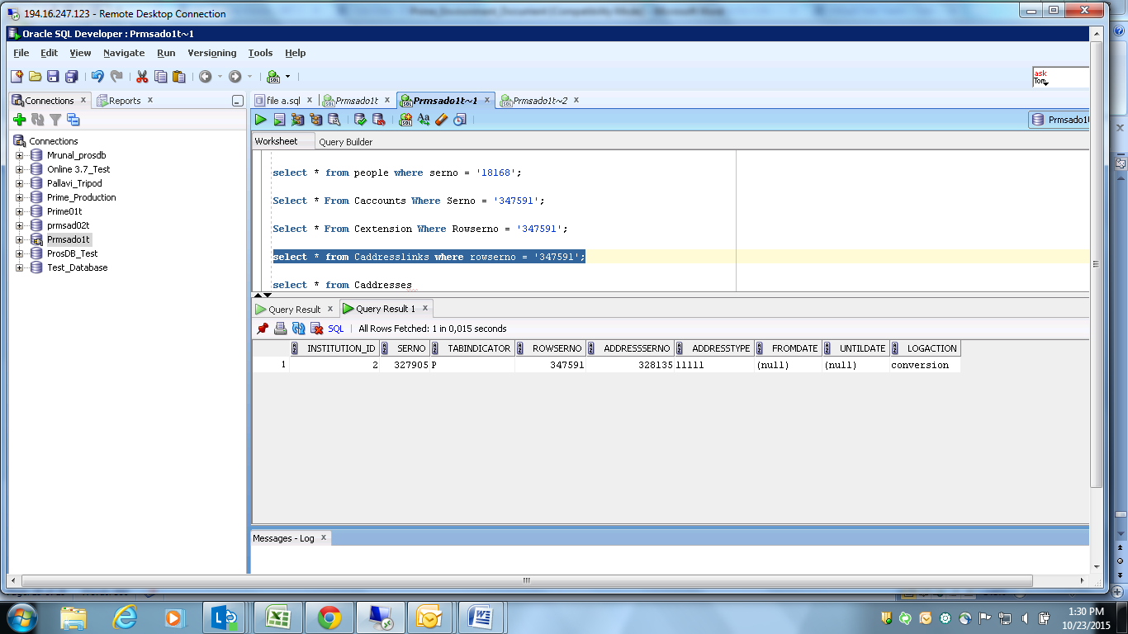

* Pick Addressserno from Caddresslinks table and find address details.

Select * from Caddresses where serno = '328135';

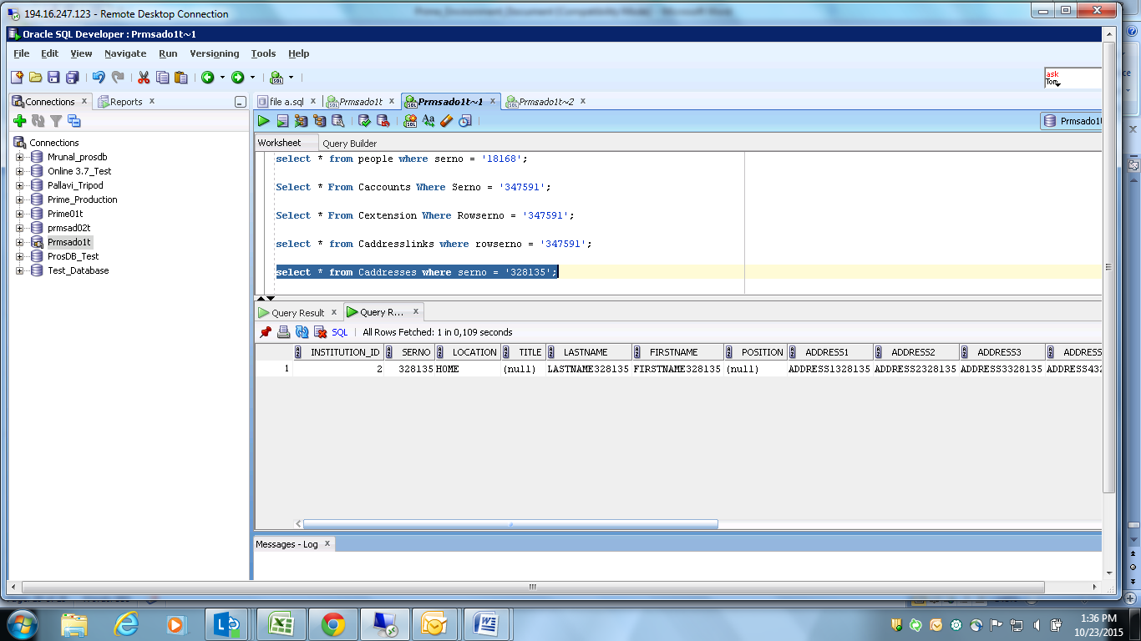

* Pick custserno from caccounts table and find customer details

Select * from Ccustomers where serno = '17784';

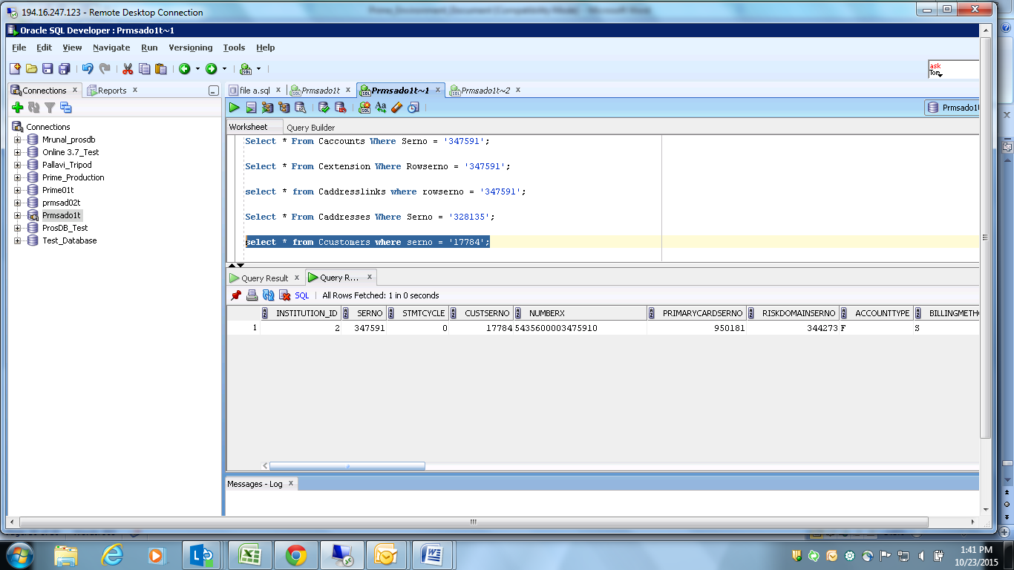

* Pick serno from caccounts table and find services details.

Select * from services Where Rowserno = '347591'; (rowserno of services table = serno of caccounts table)

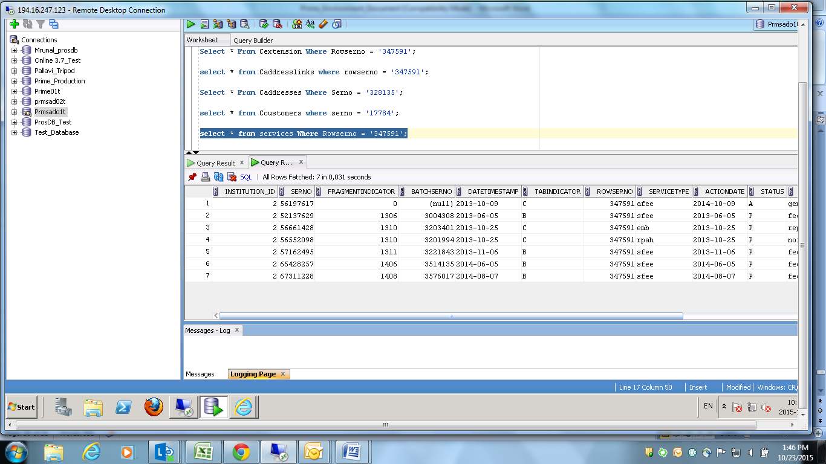

* Pick serno from caccounts table and find statement details.

Select * from cstatements where caccserno = '347591';

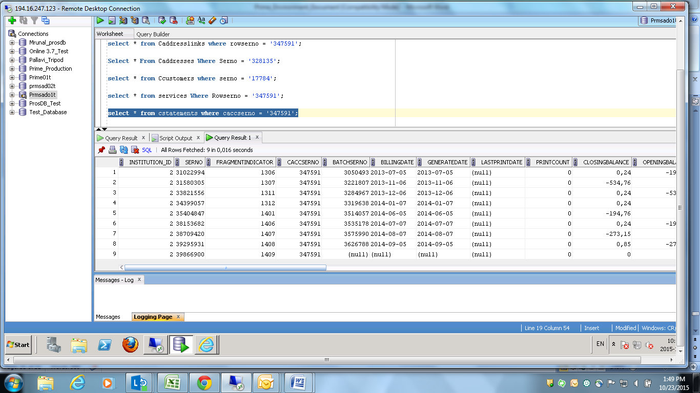

* Pick serno from caccounts table and find transaction details.

Select * from ctransactions where caccserno = '347591';

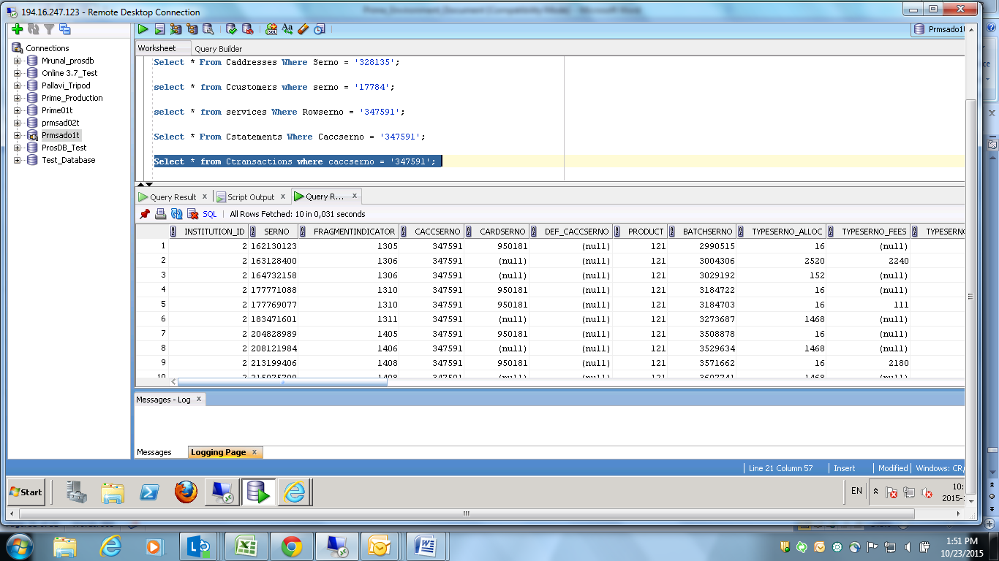

All field details mentioned in the screen can be find using above queries:

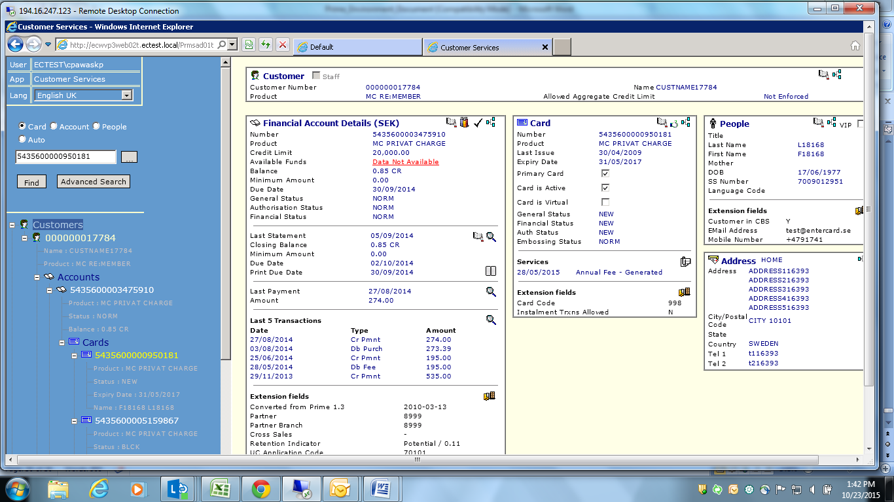

1. Find accounts where balances are greater than 0?

Select serno, numberx, product, Stgeneral, Balance from Caccounts Where Balance > 0;

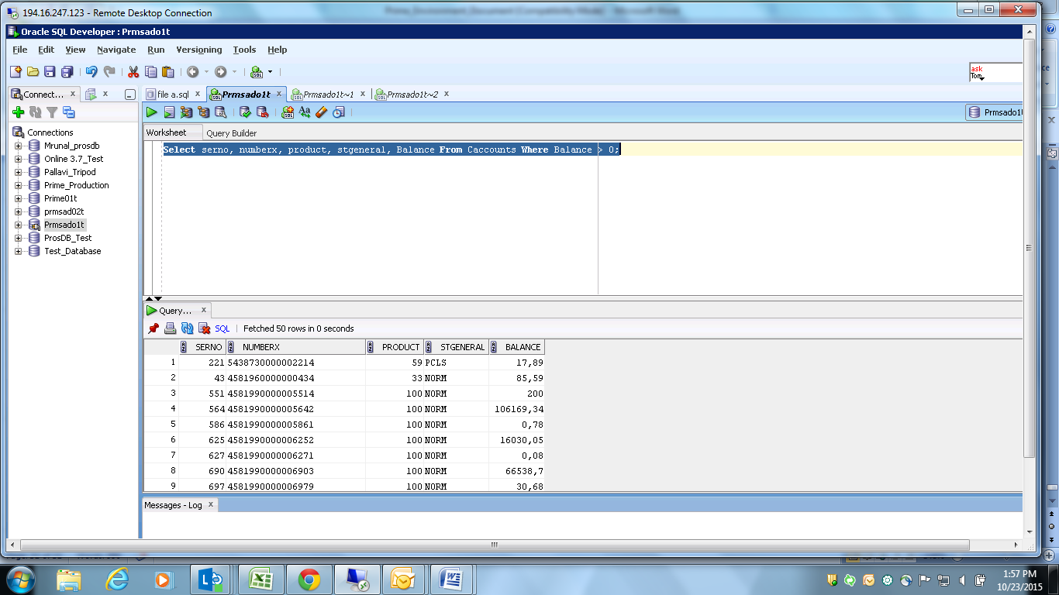

1. What is a debit transaction; explain wit an example and how it affects account balances?

It increases the balance.

1. Where would u be able to see transactions between two statements dates? Provide Screenshots?

Select * from cstatements where caccserno = '1267493';

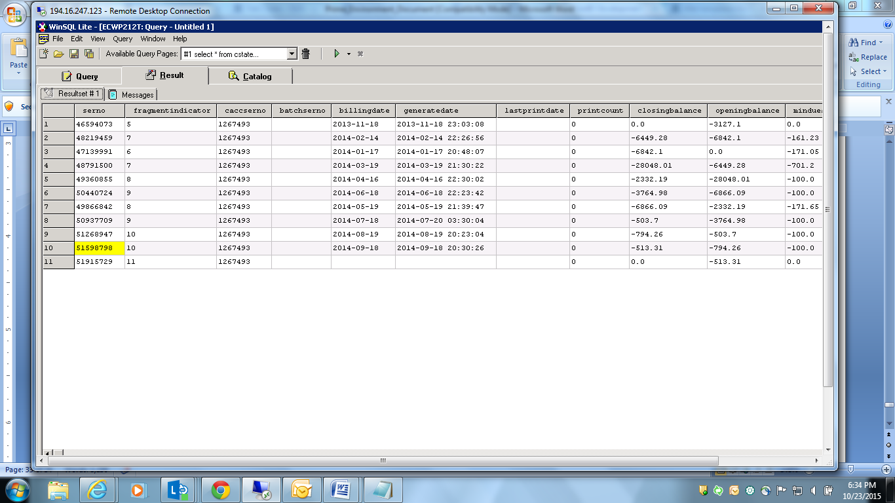

Select * from statementlinks where statementserno = '51598798'

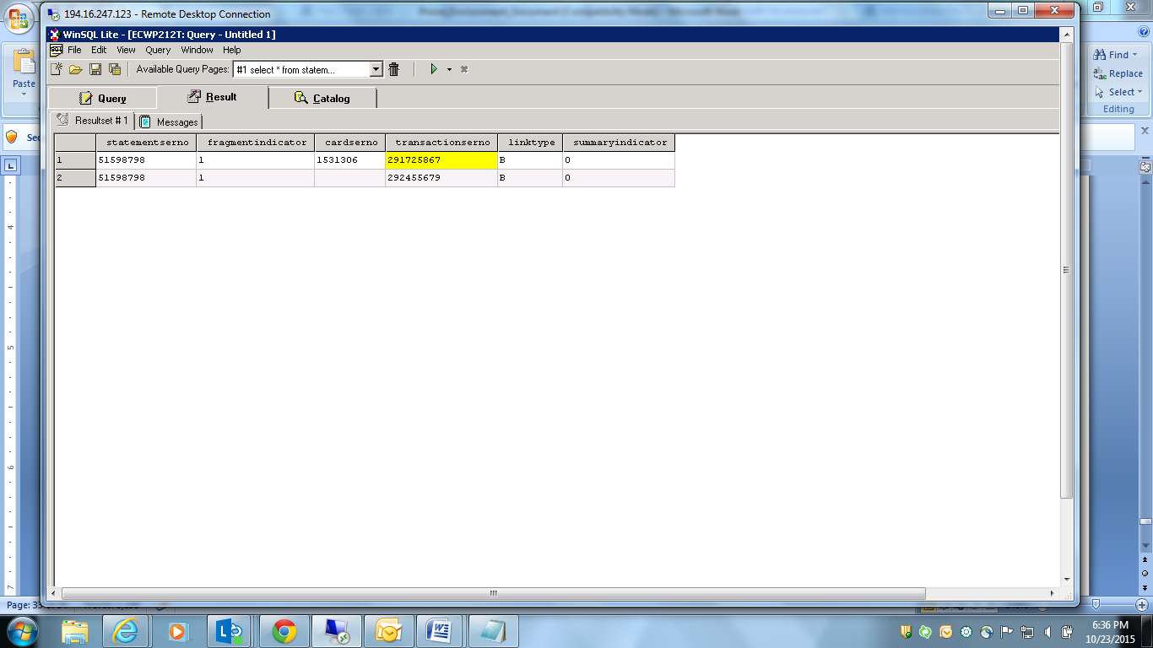

Select * from ctransactions where serno = '291725867';

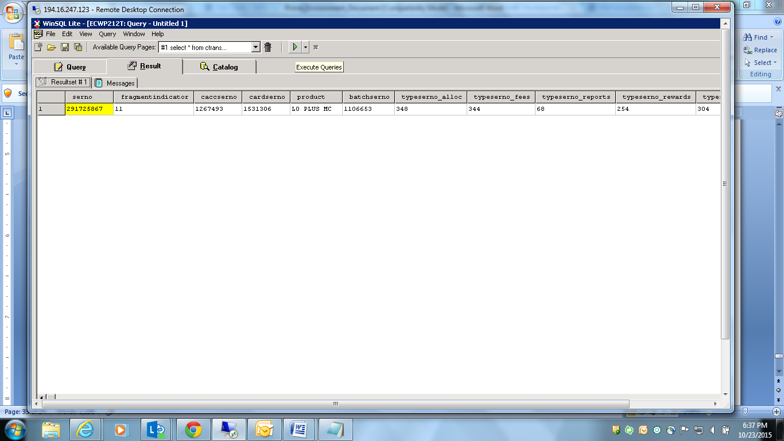

select * from ctransactions where serno = '292455679';

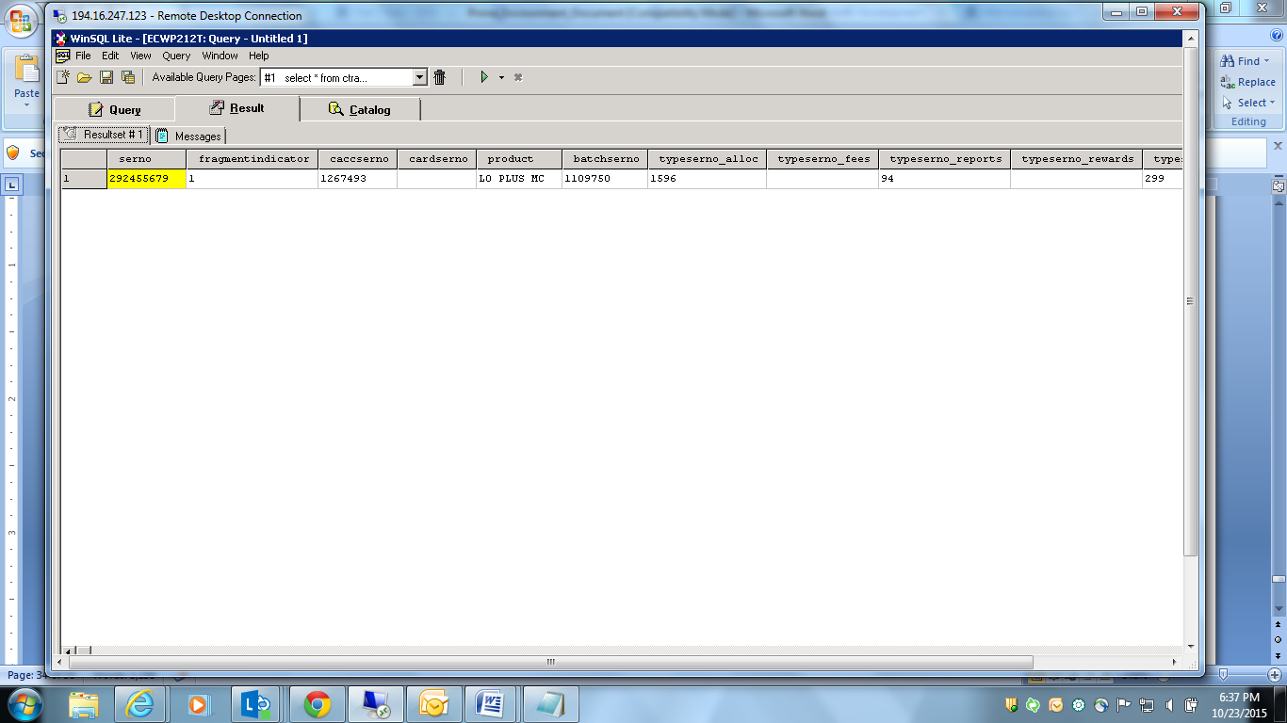

1. Explain Closing balance calculation? Provide screen shot and explain?

Opening Balance + Debit – Credit = Closing Balance

Example 1:

Opening Balance + Debit – Credit = Closing Balance

-3127.1 + 0 – 3127.1 = 0.0

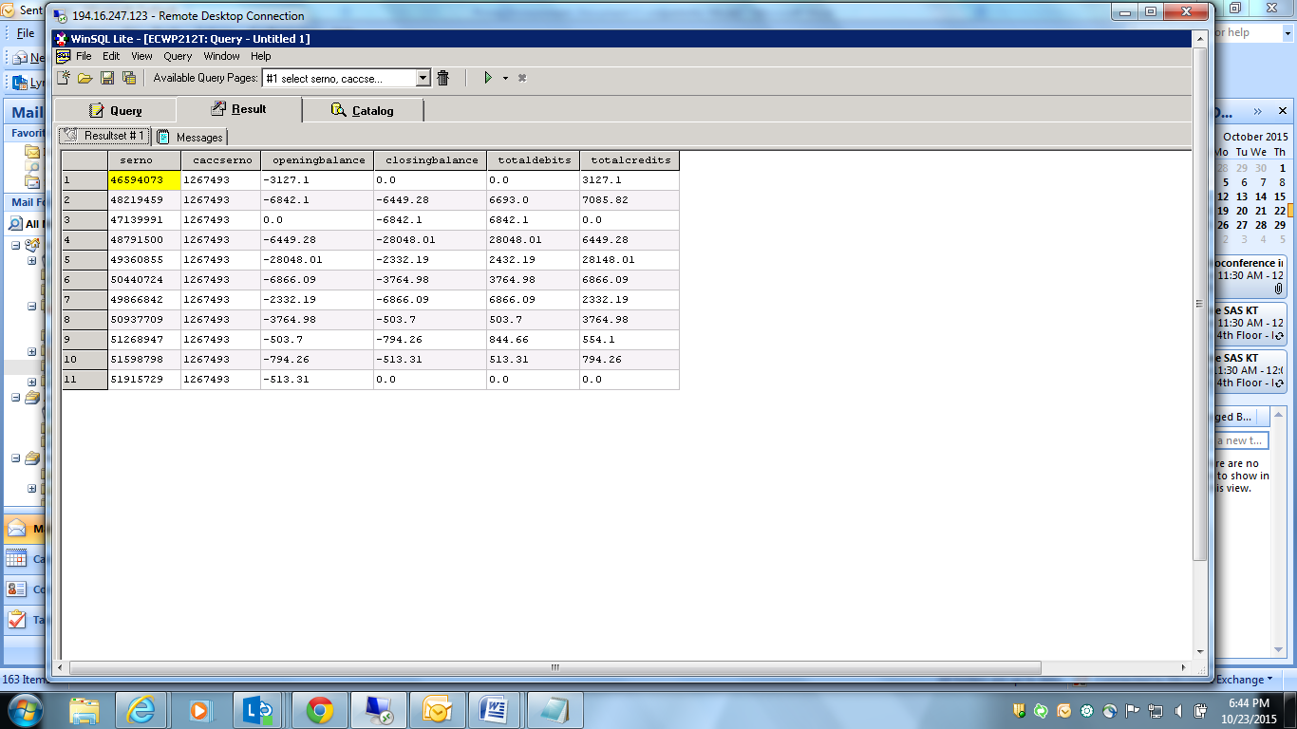

1. Explain the min amount calculation on a account? Provide screen shot and explain?

Minimum to Pay:

select * from cstatements where caccserno = '1267493';

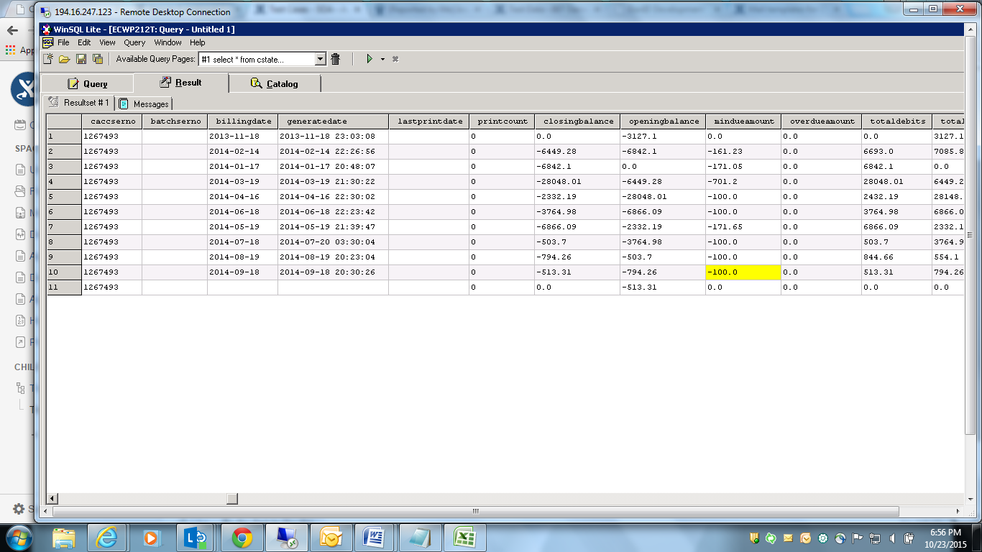

select * from cextension where fieldno = '11078'and rowserno ='1267493';

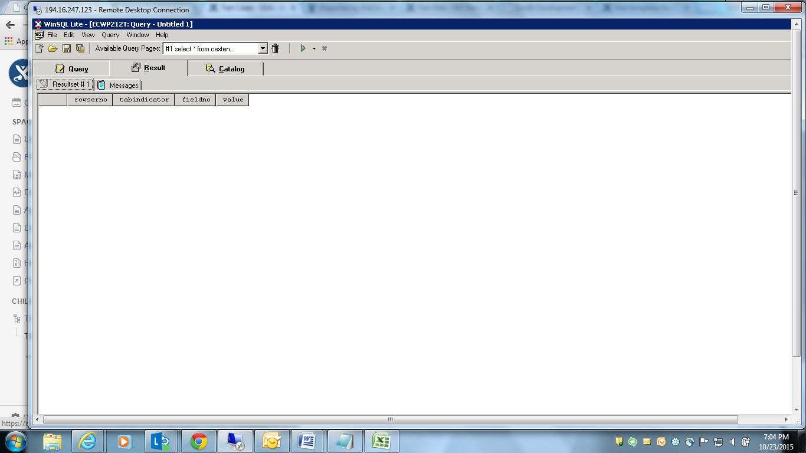

1. Activate a service on an account?

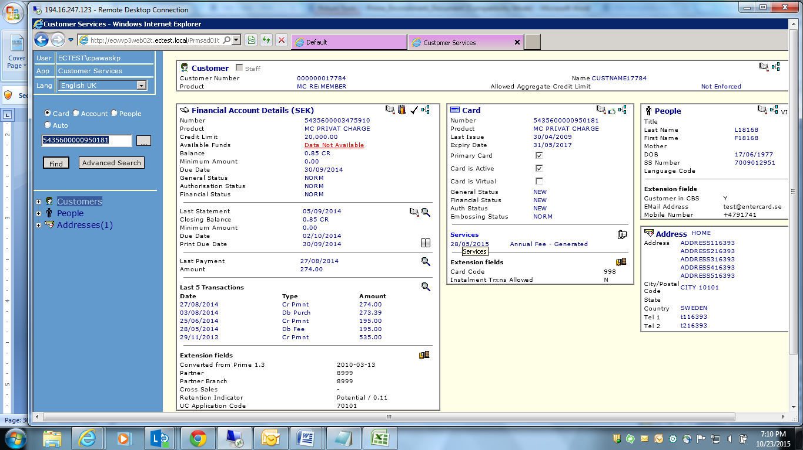

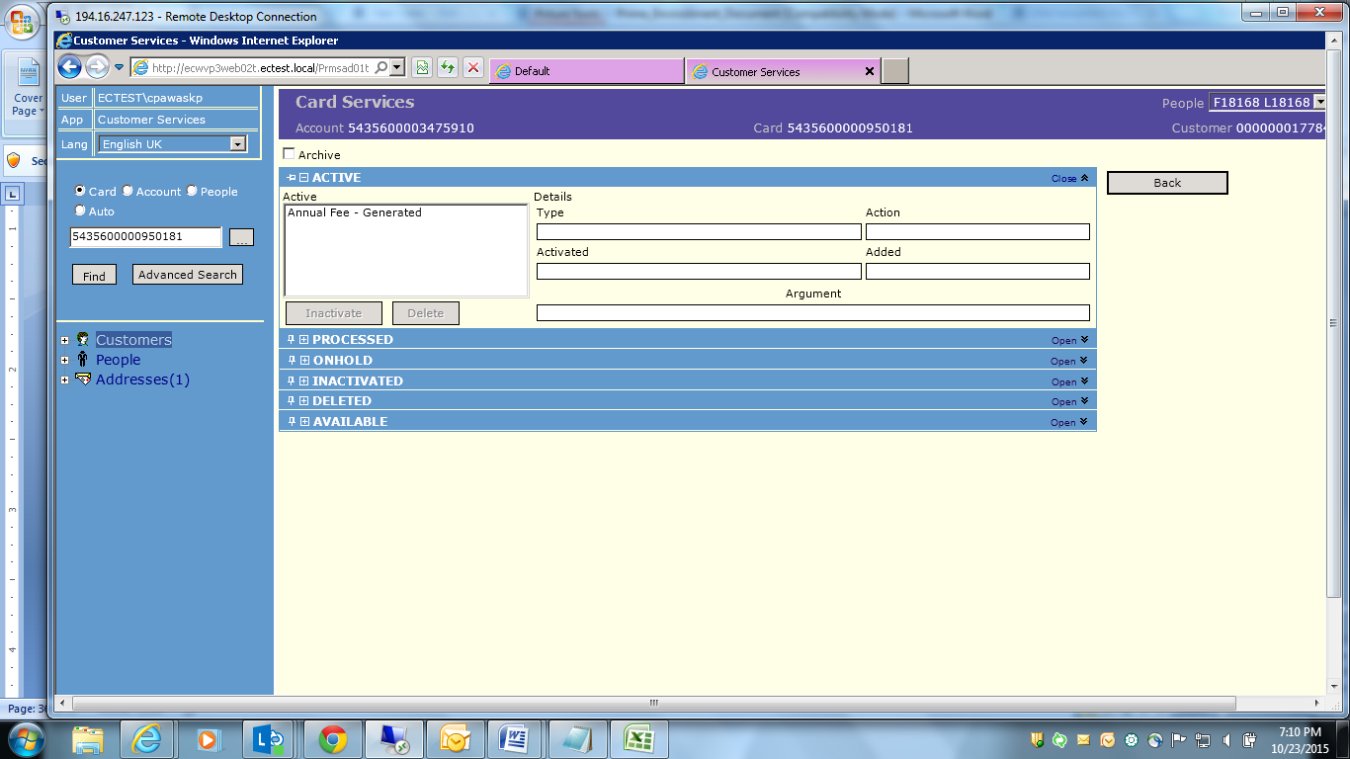

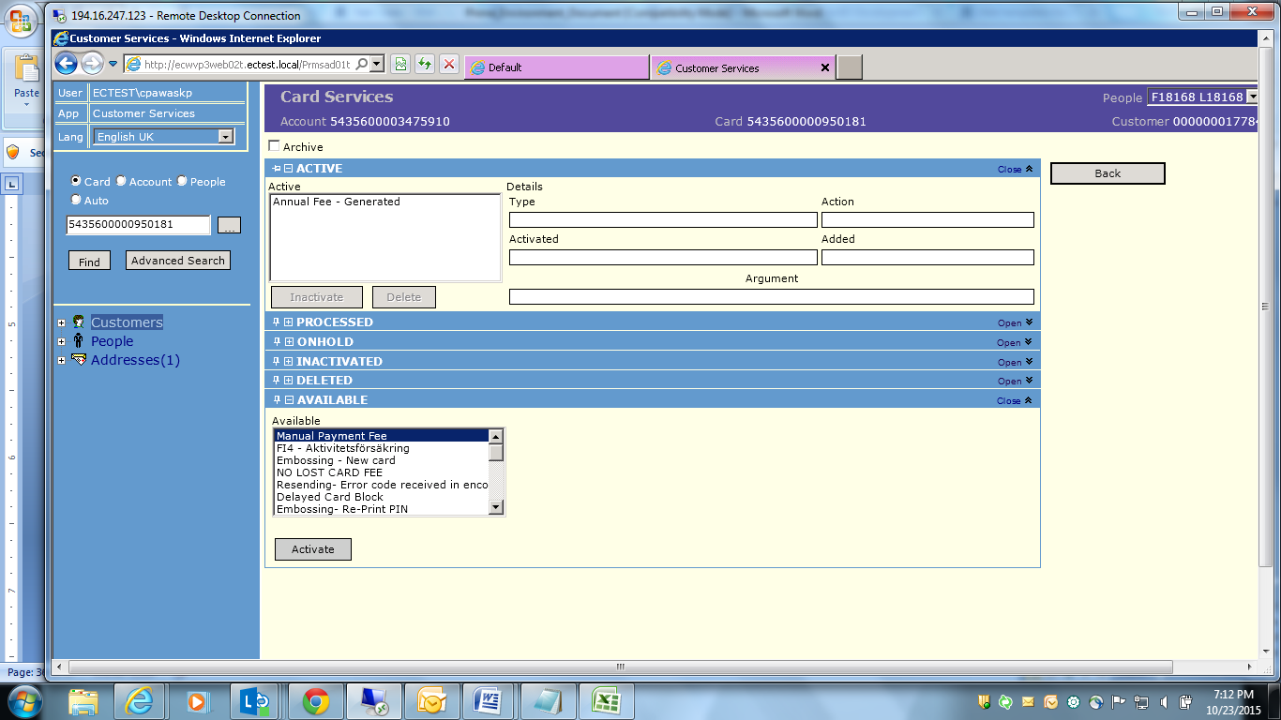

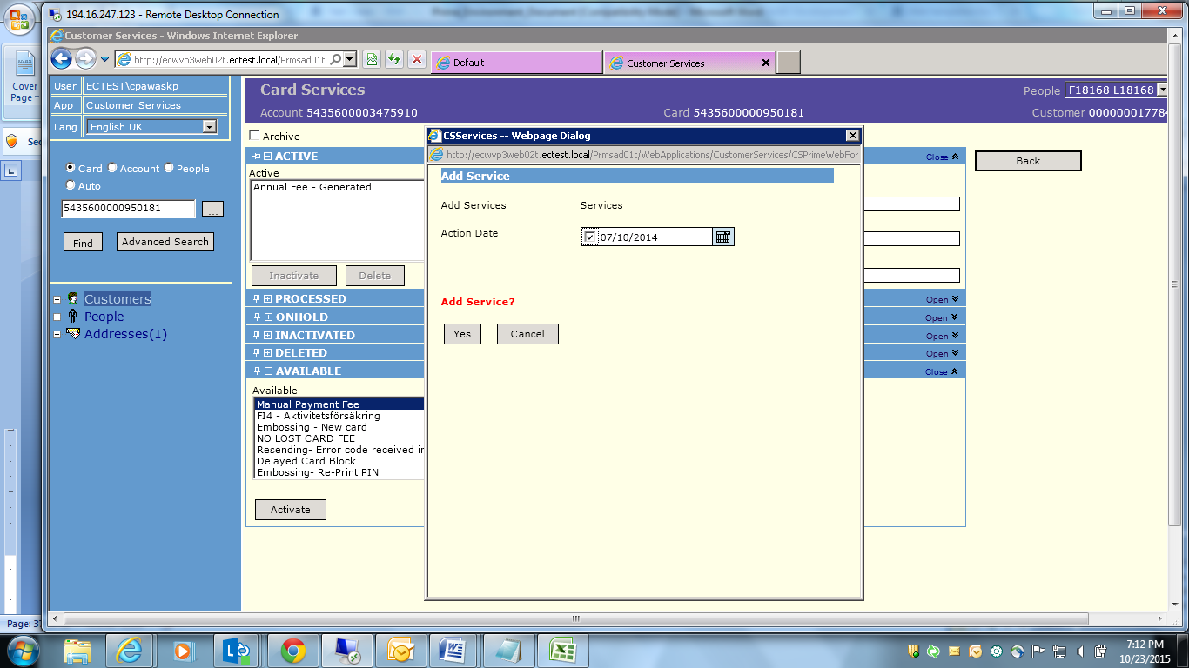

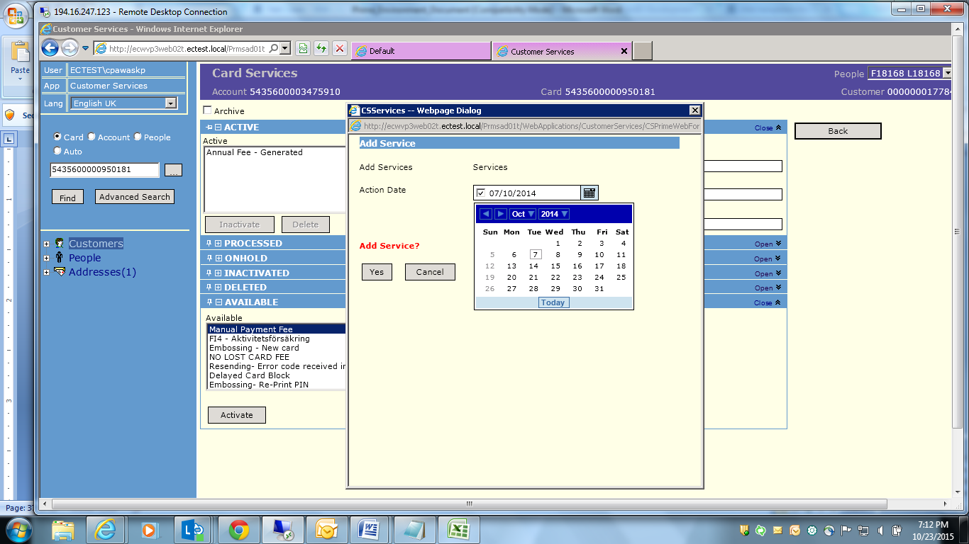

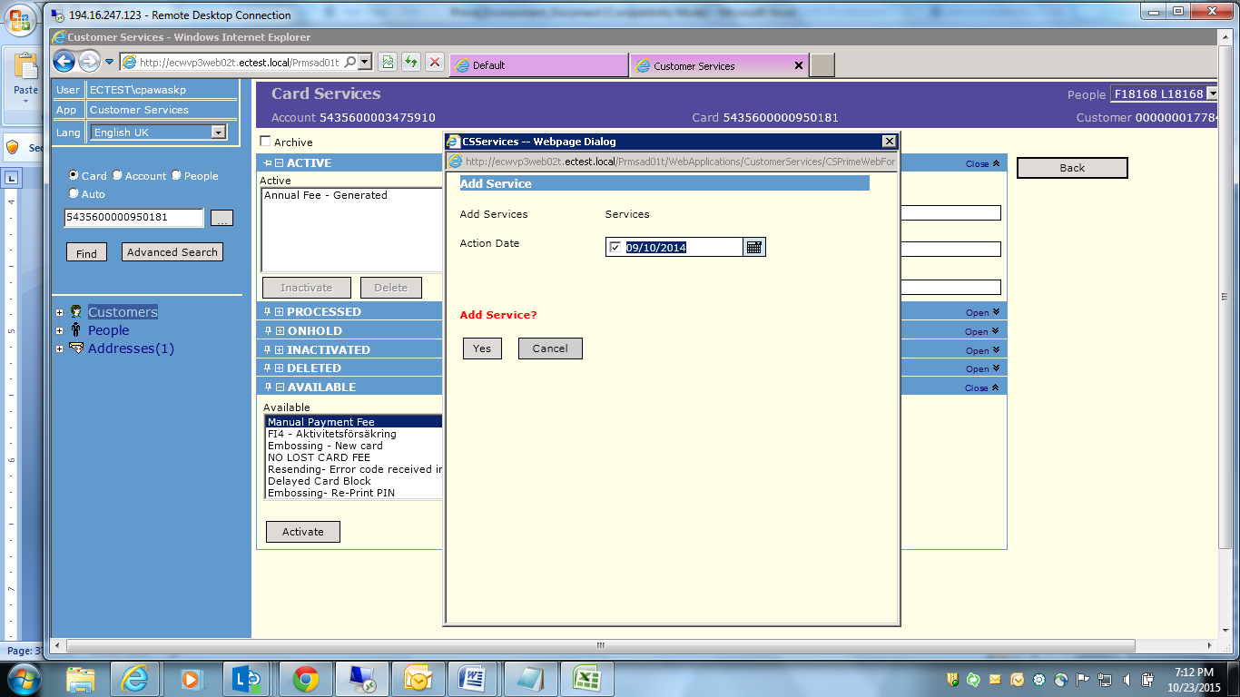

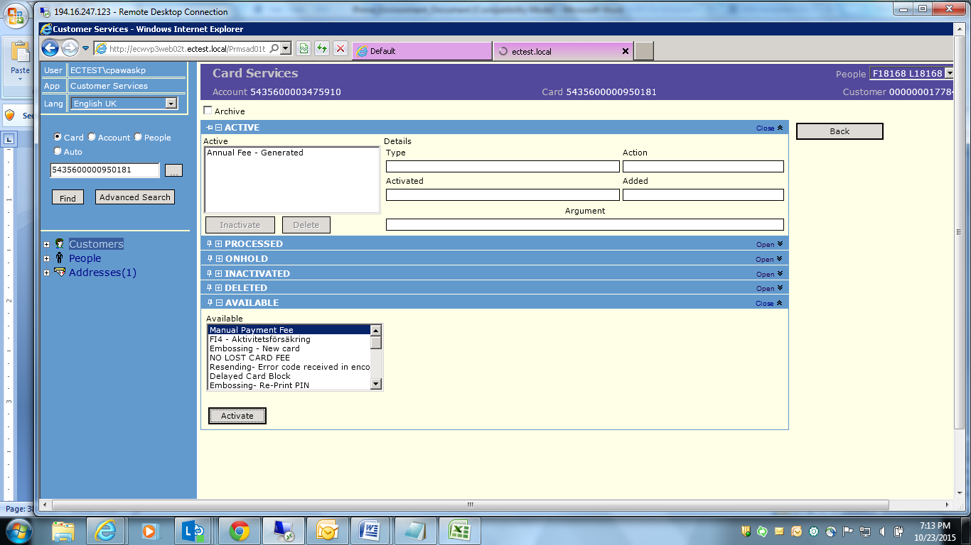

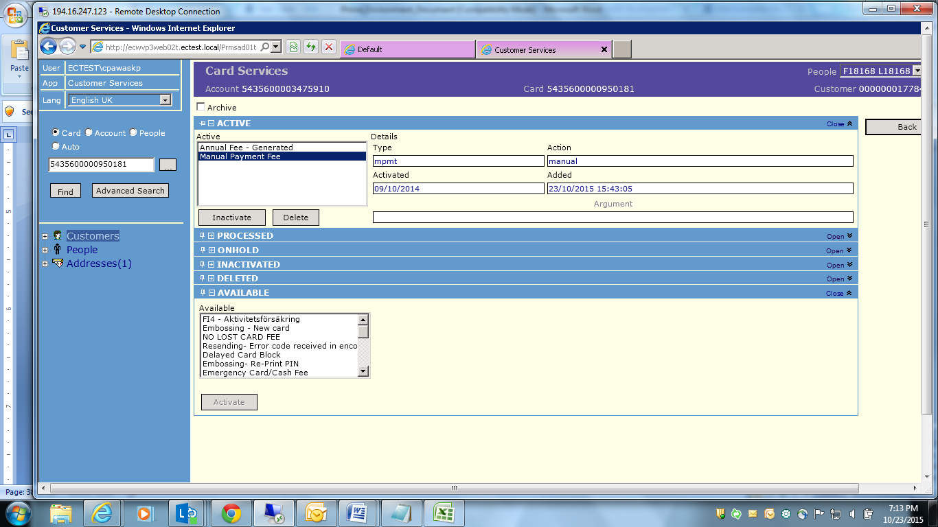

Service is activated. Once EOD is run service will start processing and proceed to next steps. For status change we need to run EOD after each change so that status will reflect in frontend.

1. Explain on what date Eod should be executed for statement generation?

EOD needs to be executed at the end of the day so that changes are shared with middleware like SAS, SIEBAL to get in sync.

1. How do renew, reissue a card? Provide screen shot?

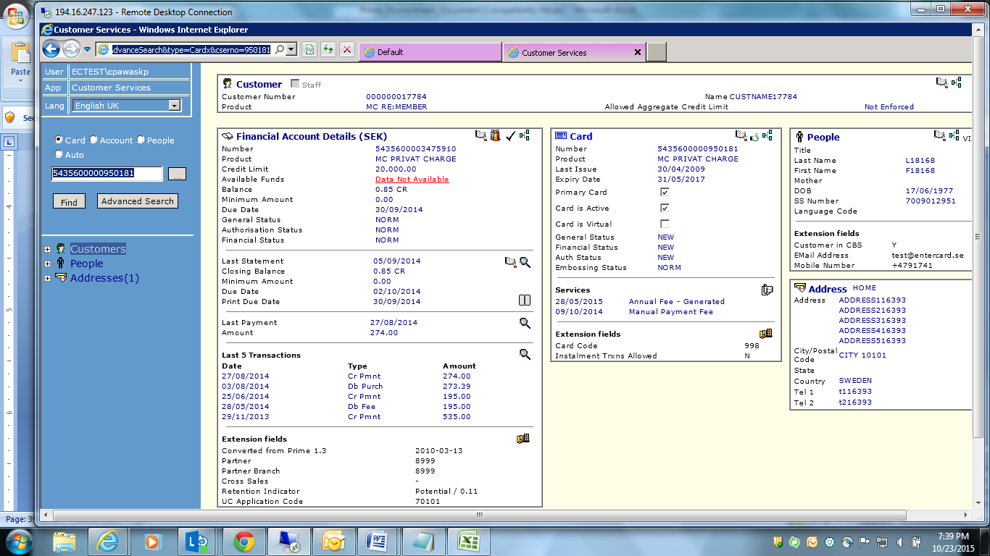

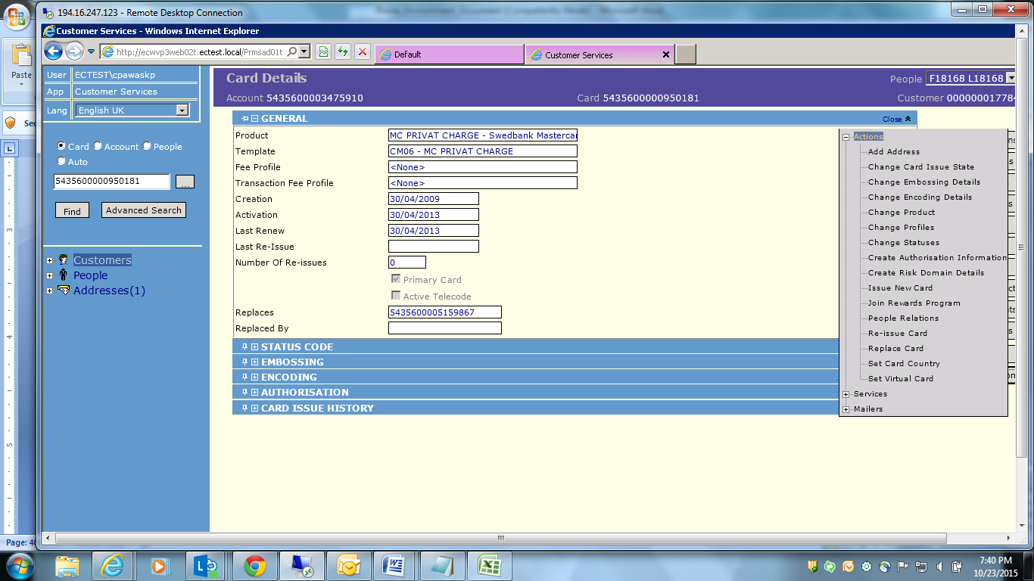

Renew:

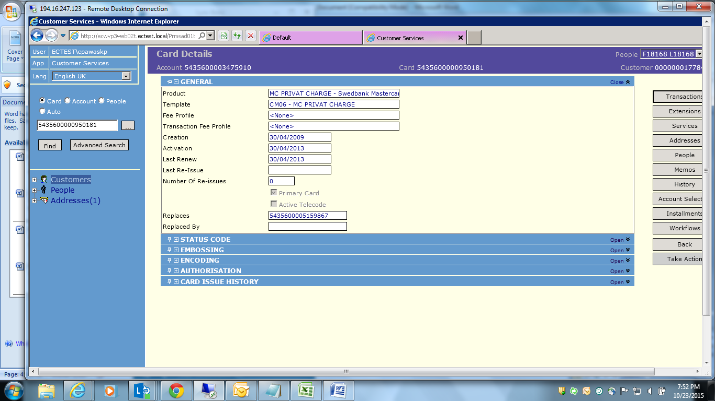

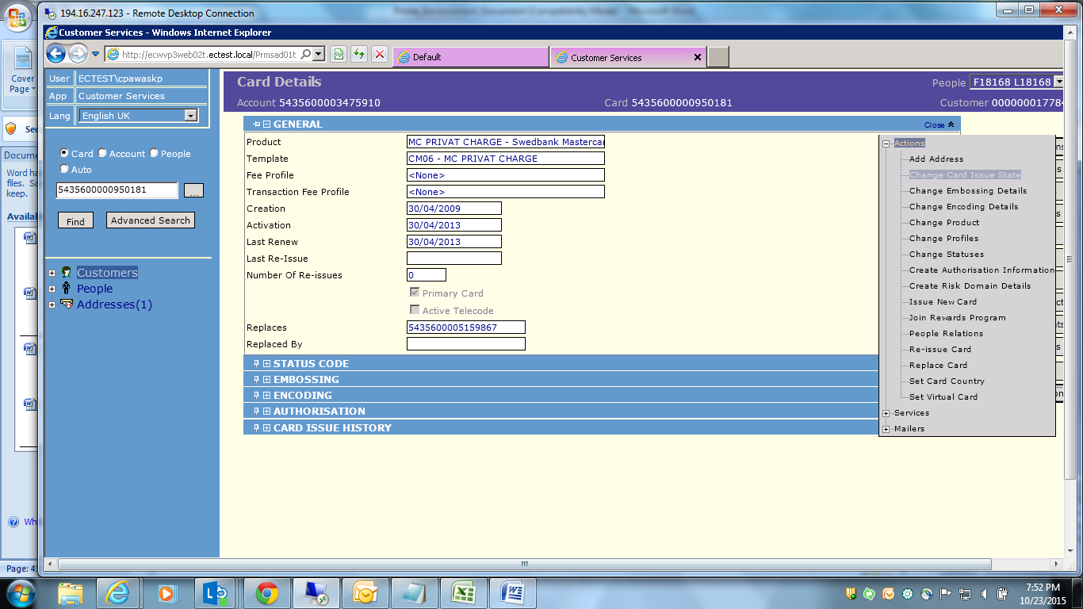

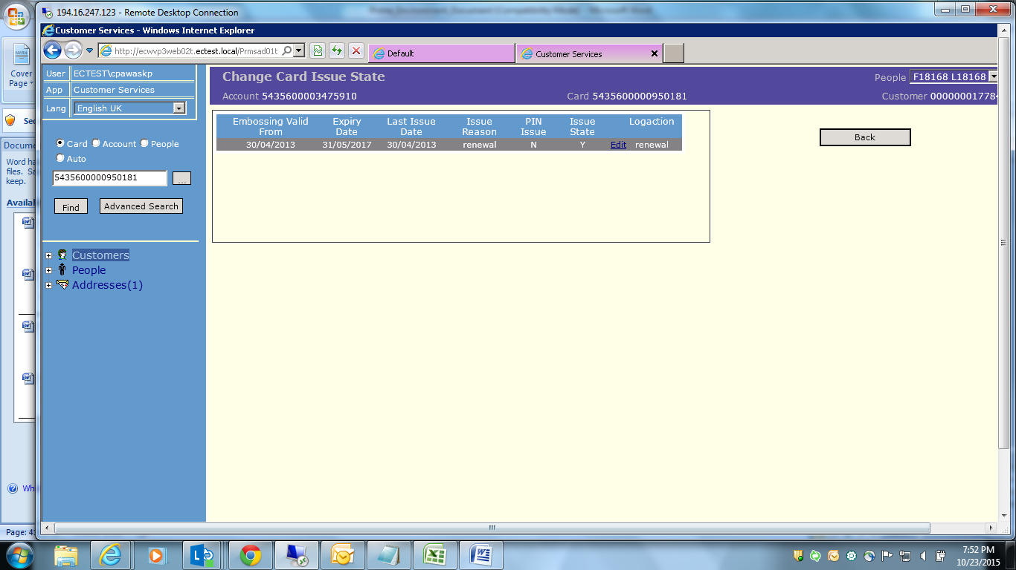

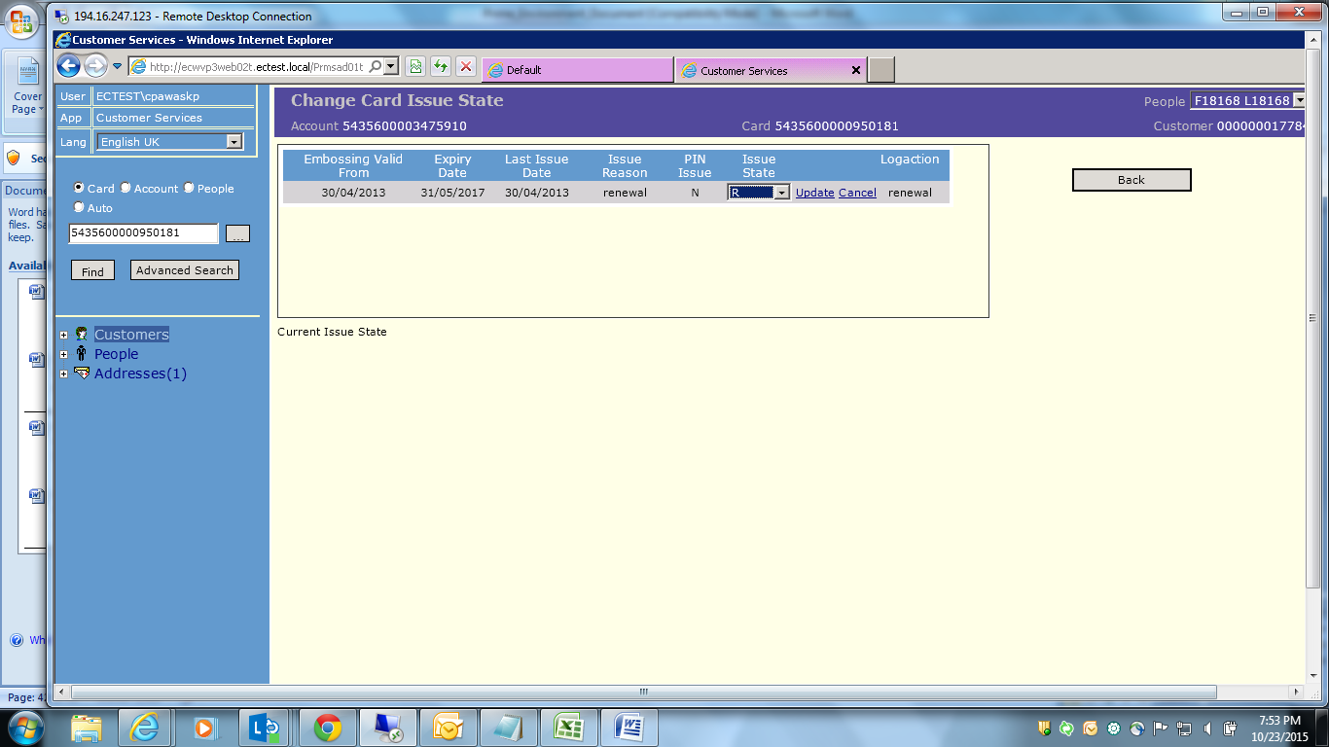

Reissue:

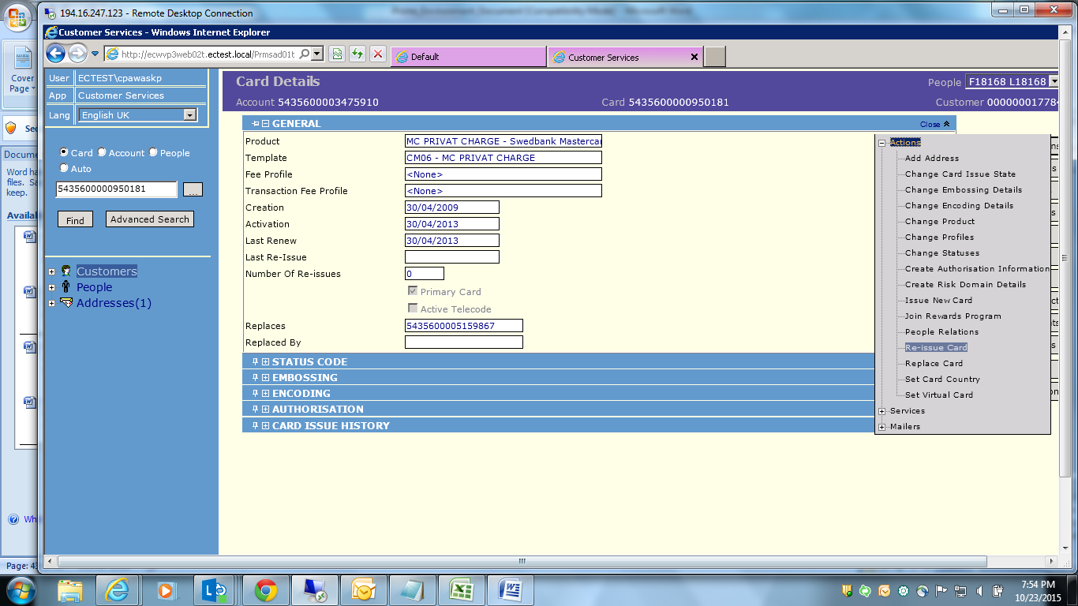

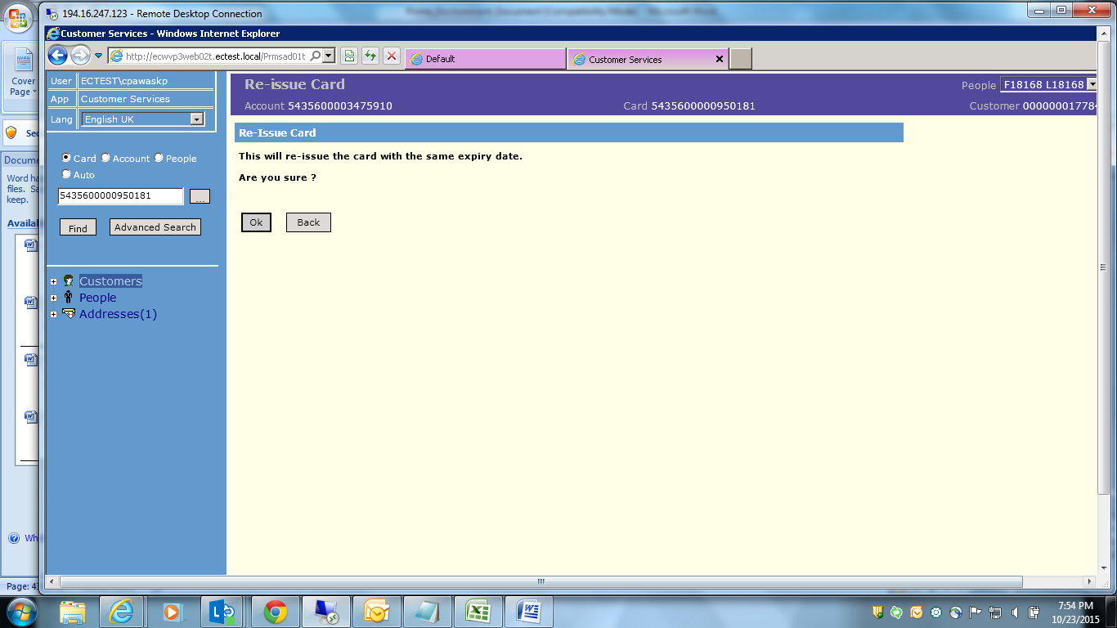

1. How can a card be closed?

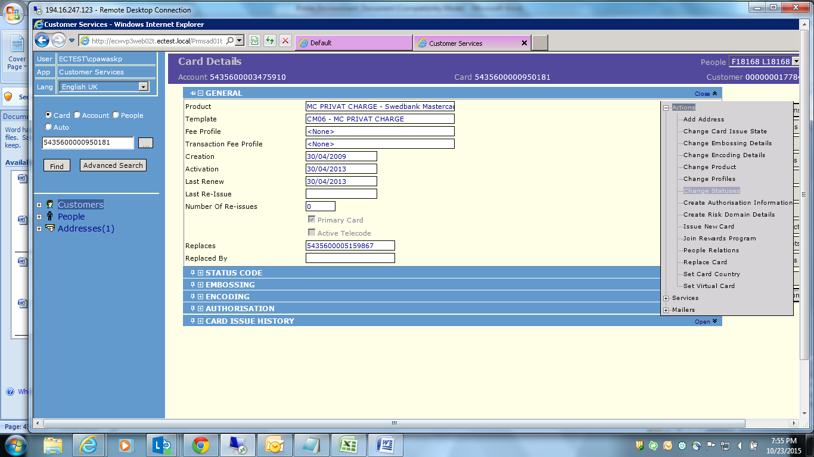

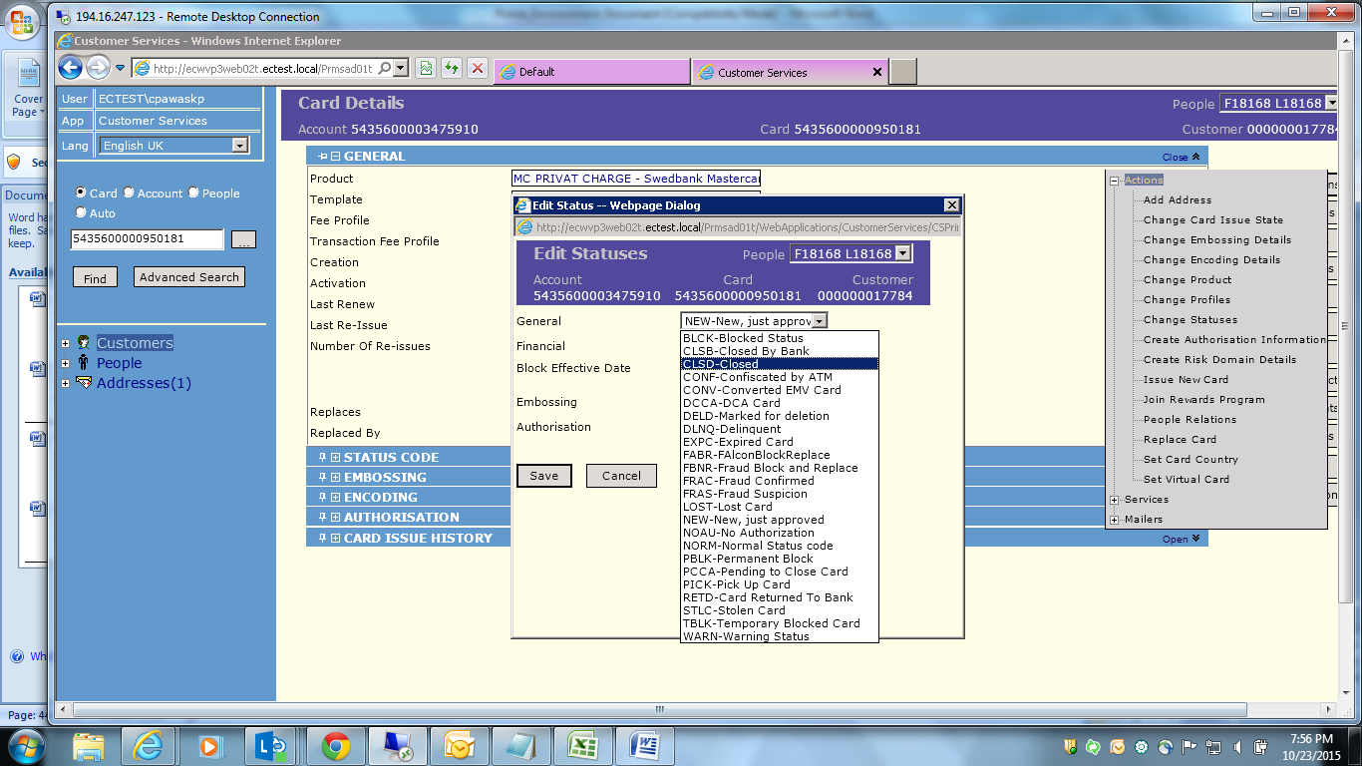

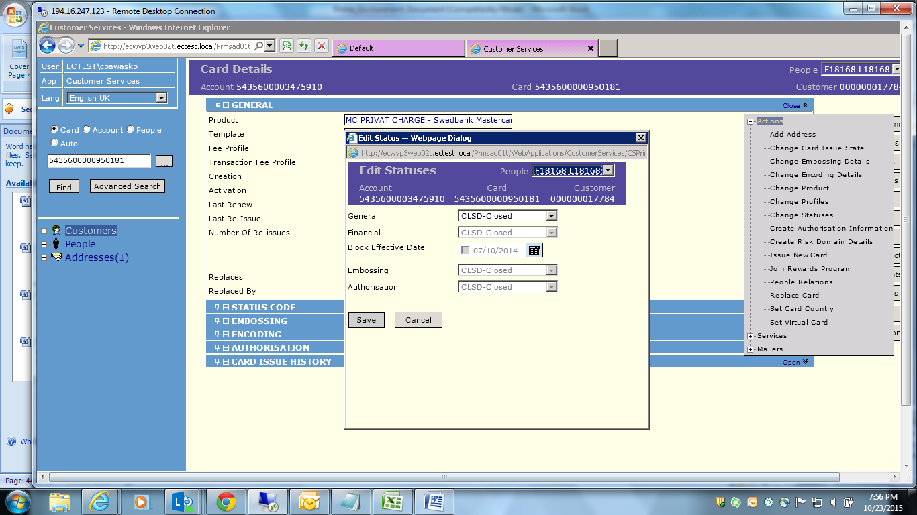

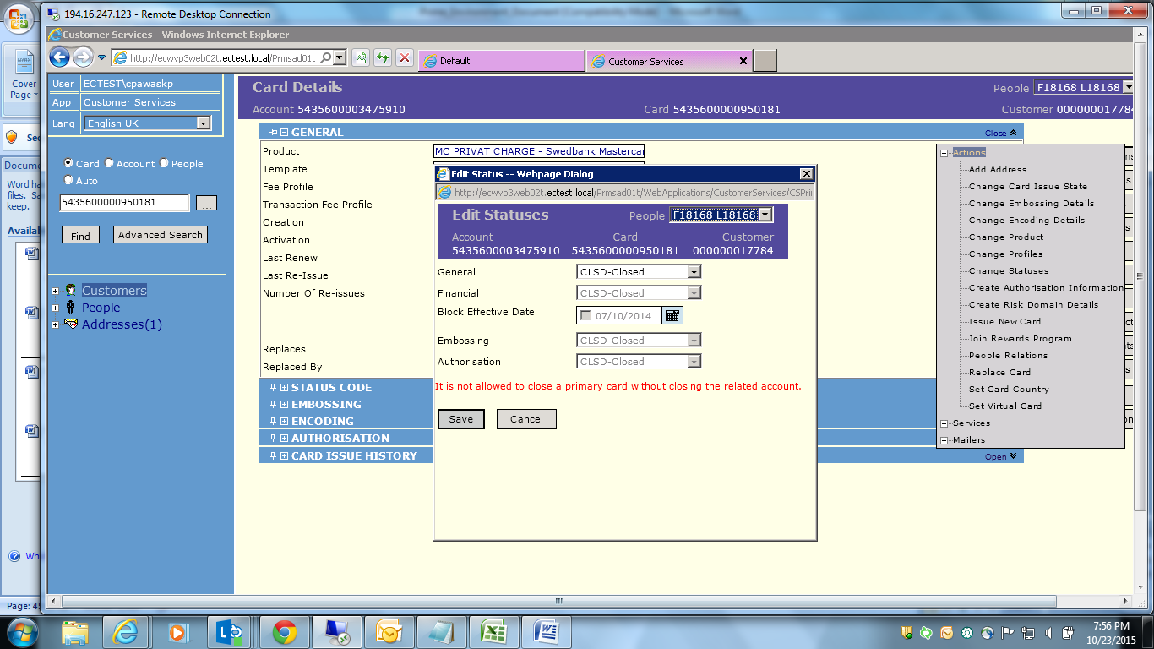

Secondary card:

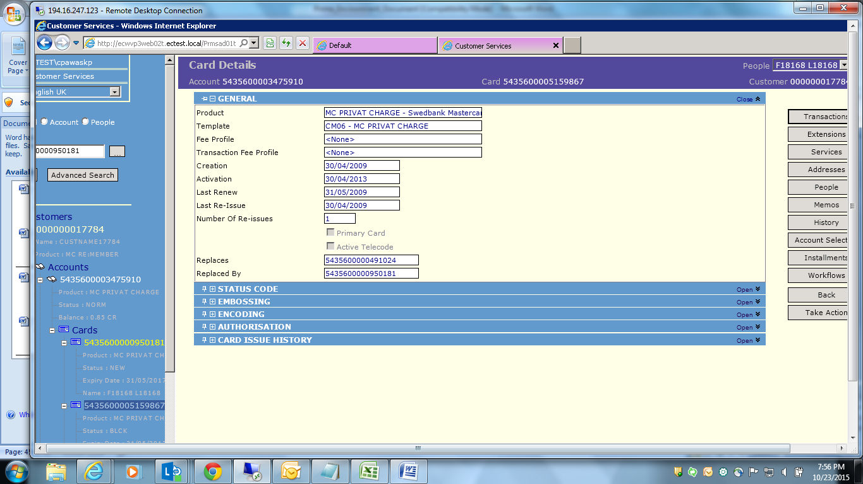

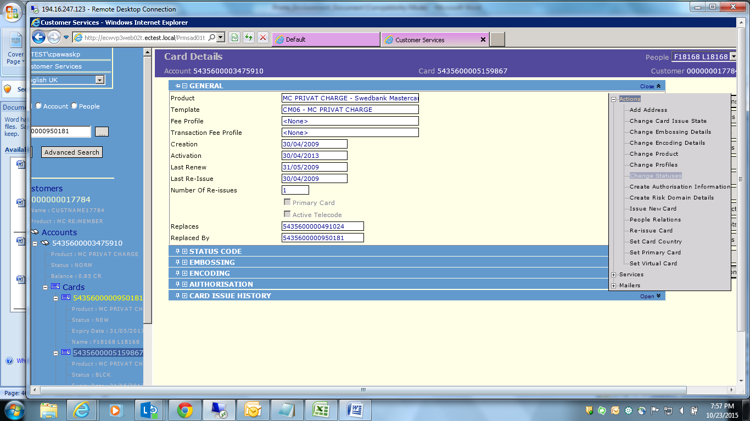

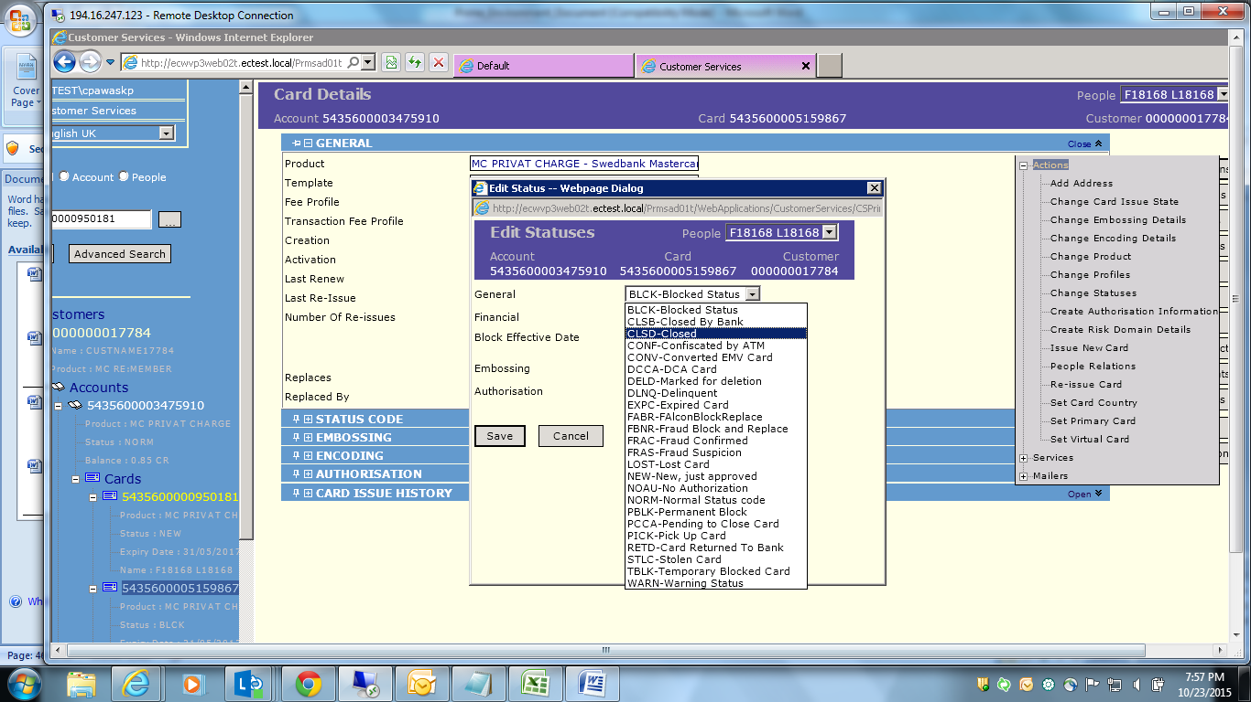

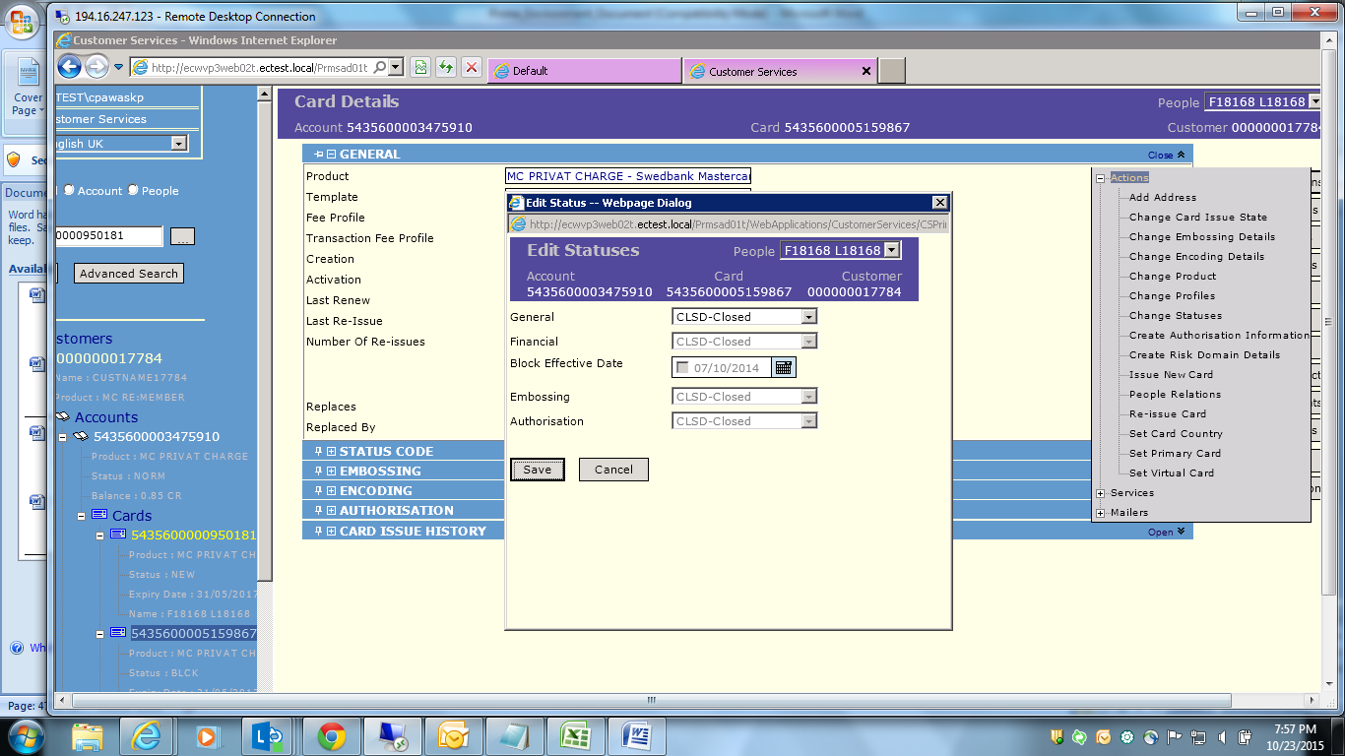

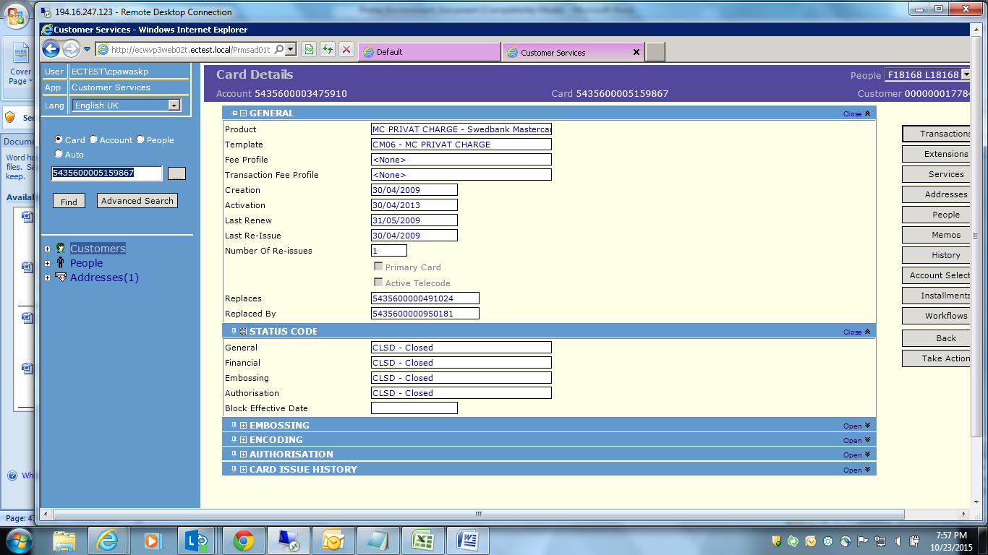

1. Change value for an Extension filed? And verify tables?

In cards : following logic exist :  
Opening Balance + Debit – Credit = Closing Balance

MTP =X% of Opening balance = value (if minimum amount=150 and Value<150) then MTP=150.

Loans Logic as follows:

* For Loan two accounts are created 1] financial account 2] Installment account (account no is same  
  -Credit Limit is on the basis of the Product and is displayed in Financial account.
* if 50000, is outstanding balance , and 5000 payment received , then after EOD the Outstanding balance reflected on installment account would be = 45000)

Is the above Logic what required to be applied for Loans. Are we missing some fields please clarify.

Database:

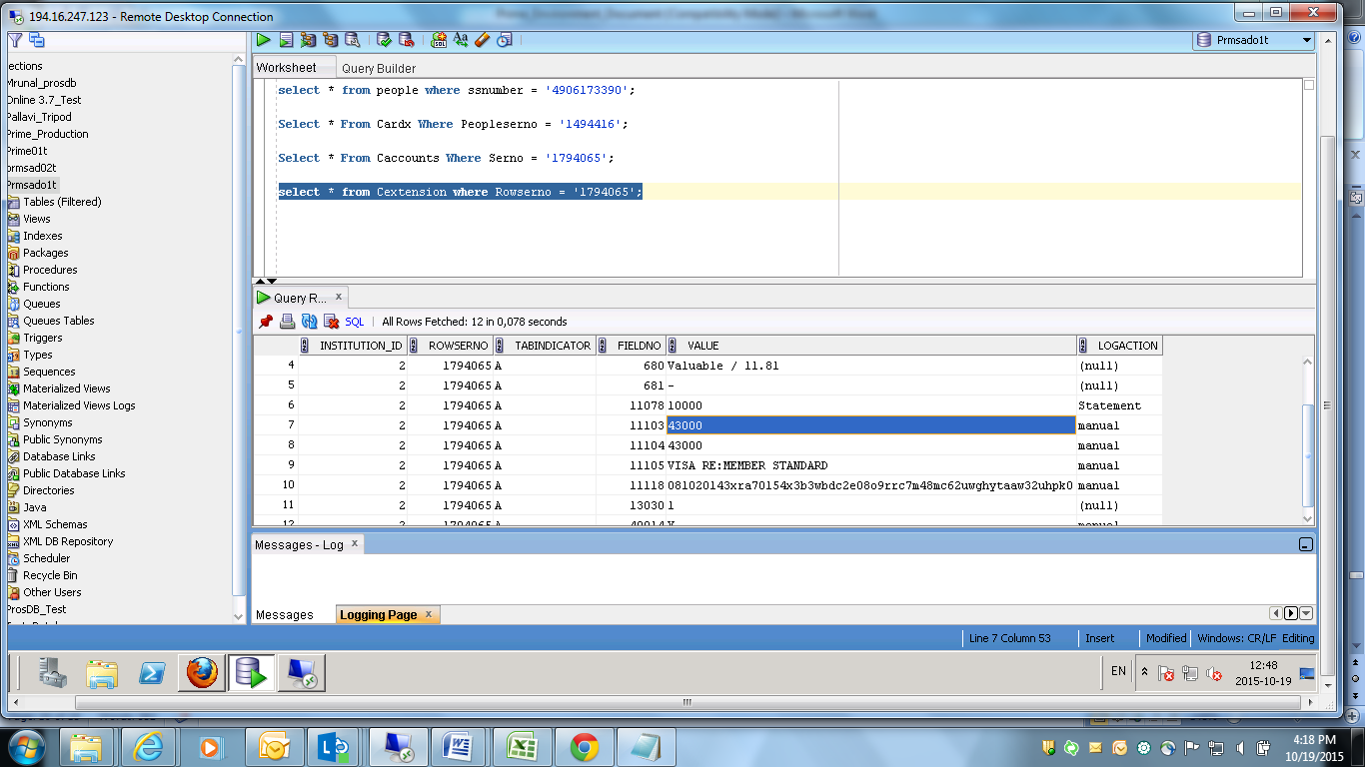

Frontend:

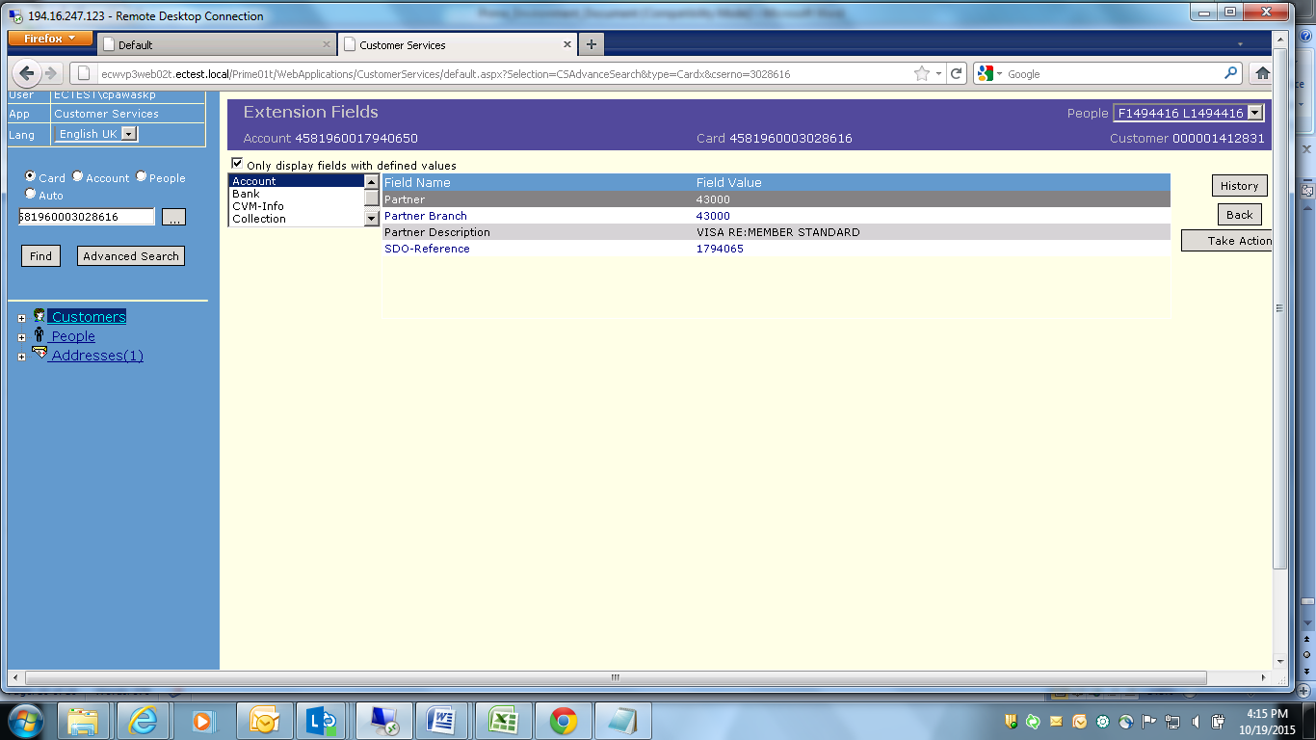

Click on Take Action:

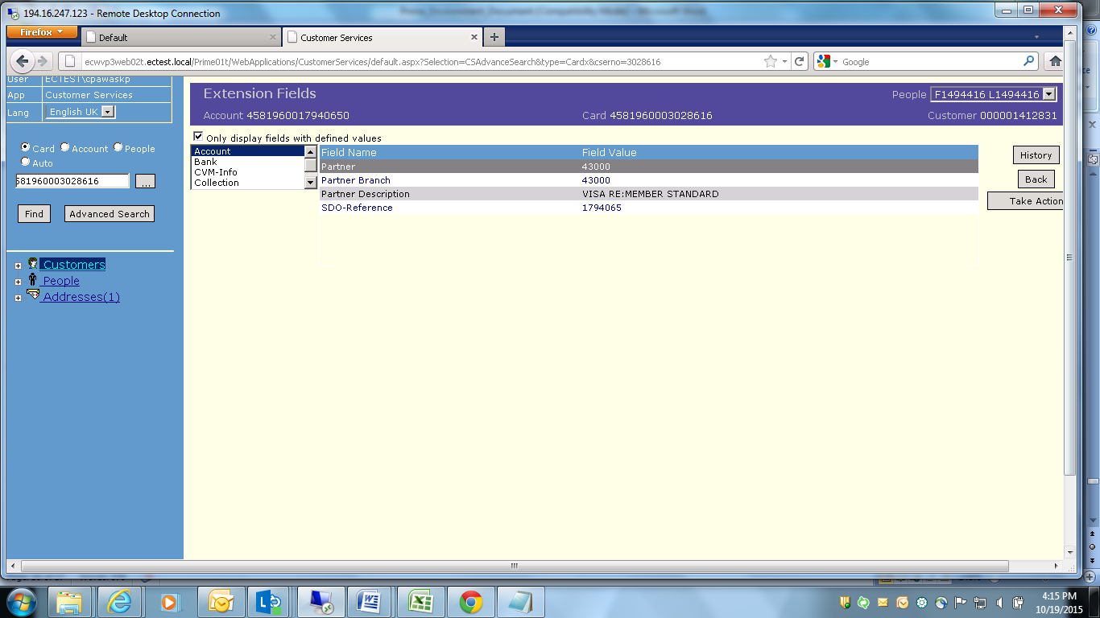

Click on Change Extension:

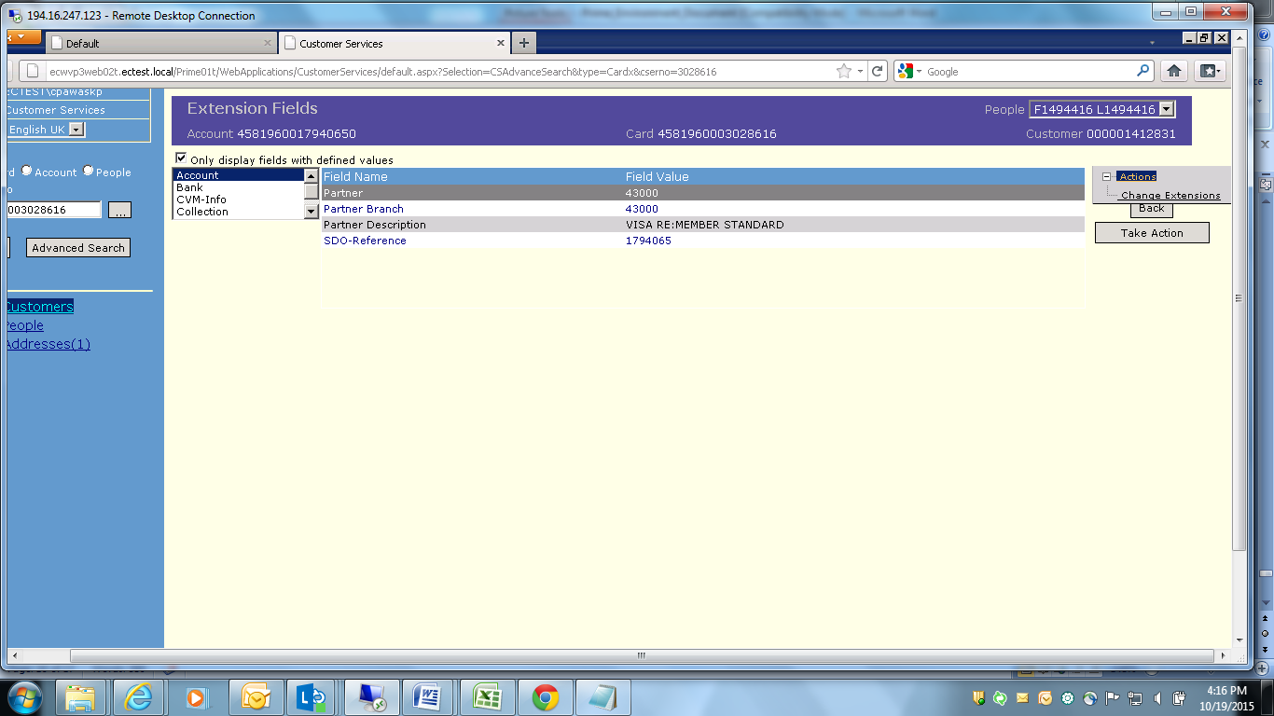

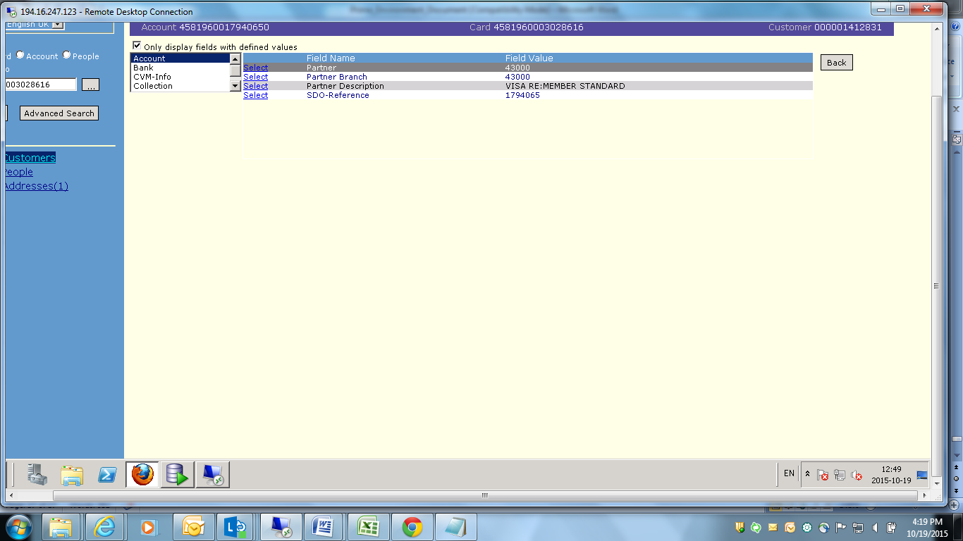

Click on Select link

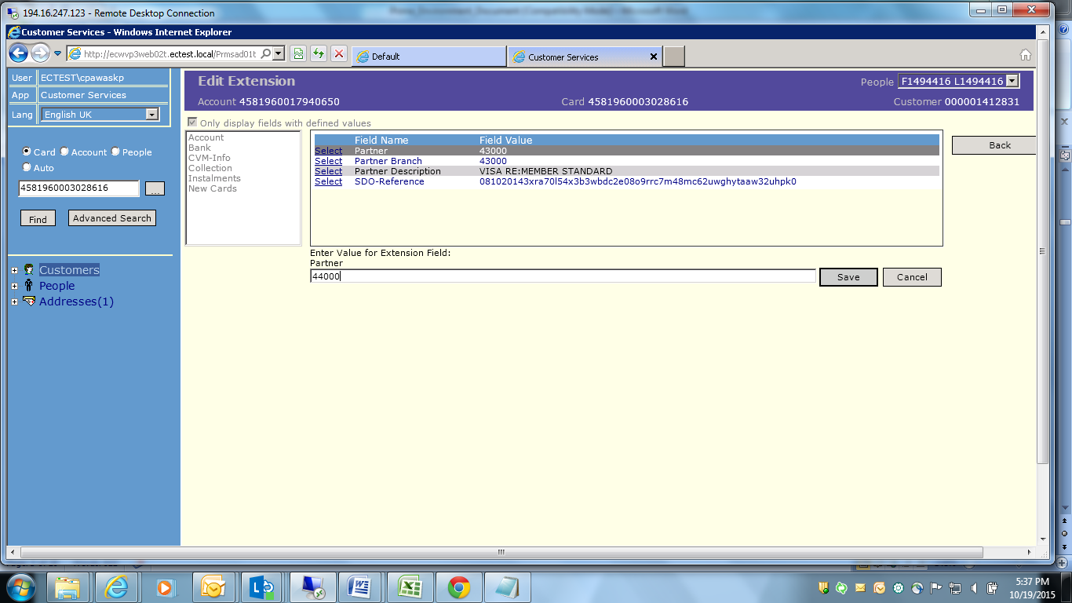

Change Number to “44000” and click on save

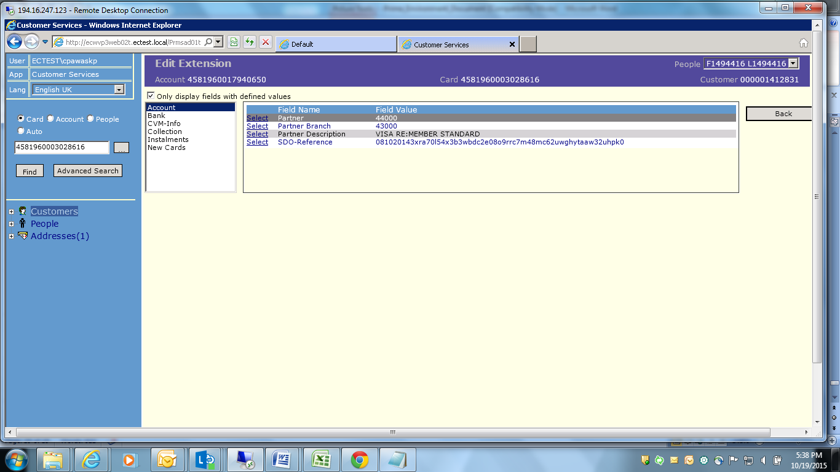

Field Value is changed to 44000 from 43000

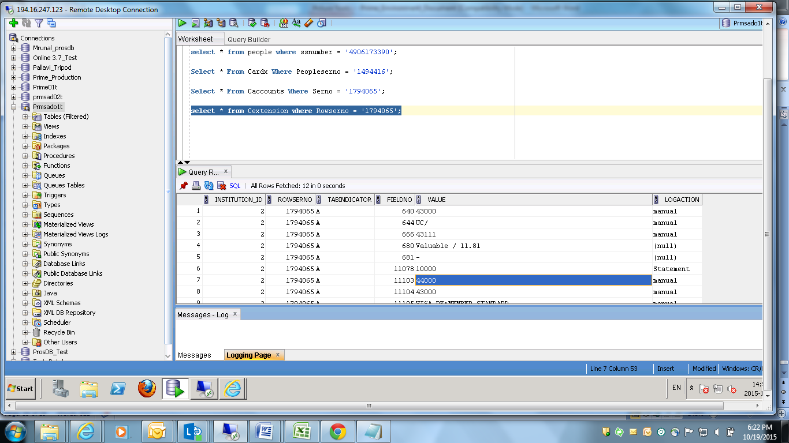

How EOD are executed? Give sequential steps? Don’t execute EOD

Under EC login > Enter mstsc > ecwvp3ts02t.ectest.local

Username: Ectest\cpawaskp

Password: ******

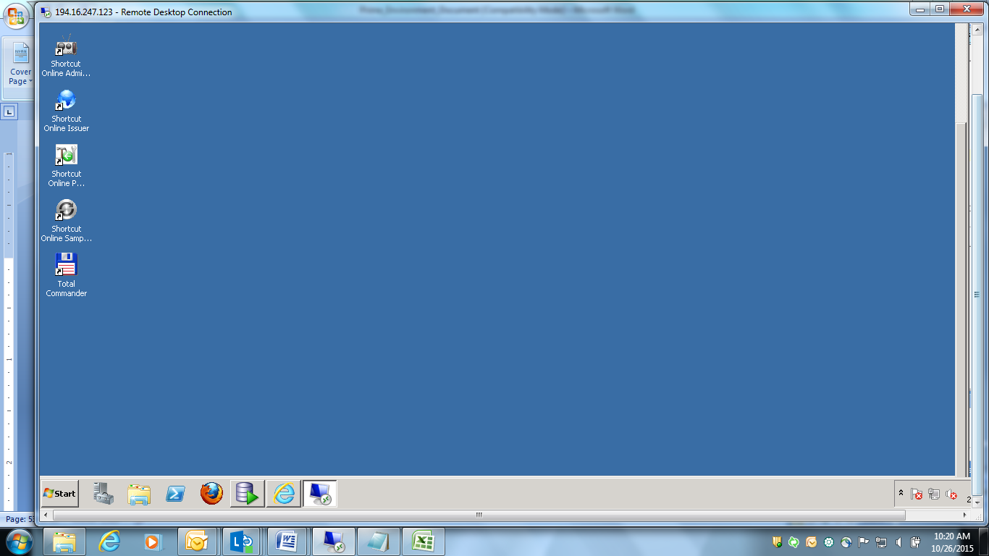

Start -> TSYS Card Tech -> Prime 3.0 -> Prime Job Administrator

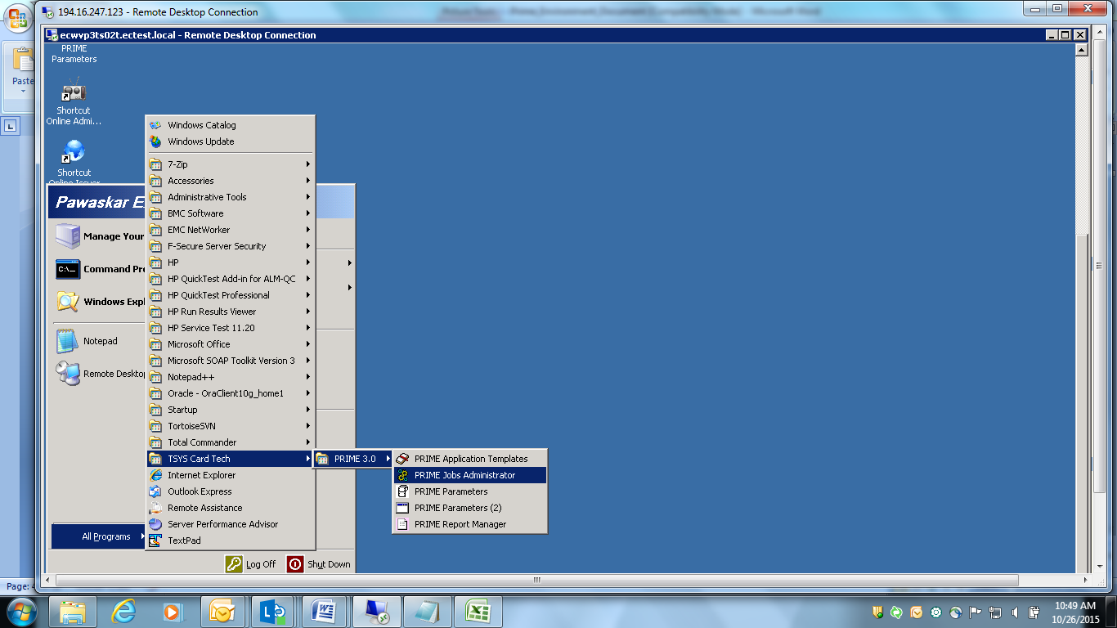

Enter Username: ec_swed

Password: *****

Service Name:

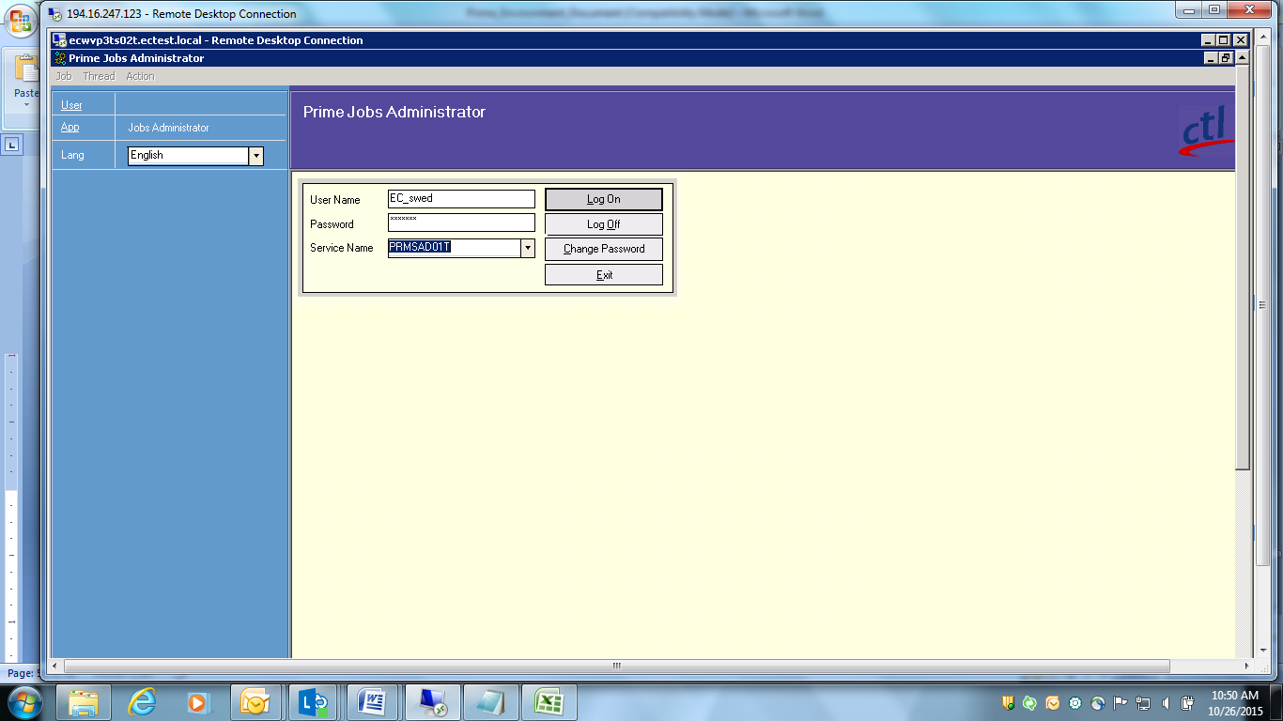

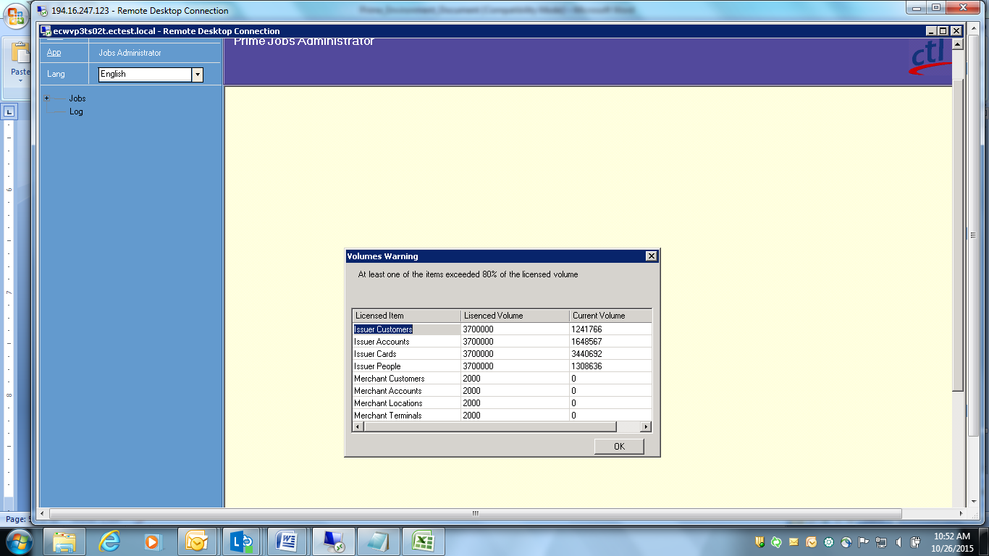

PRIME maintains a business date. If your business date does not match your system

Date, your system will display error message as shown below. Click **OK** to continue.

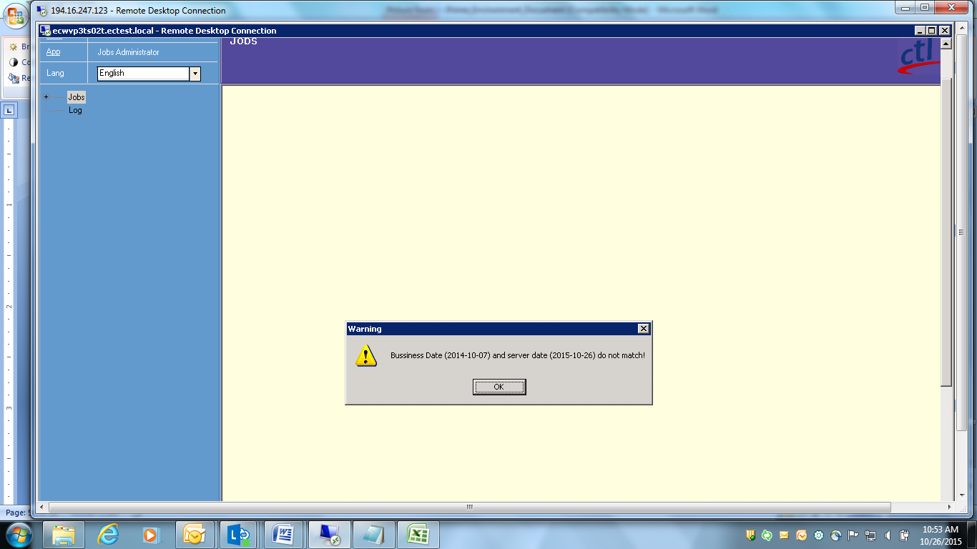

There are 4 types of Jobs as shown below:

* **Scheduled Jobs:** The jobs run regularly at a defined period are known as scheduled. scheduled jobs run automatically at predefined periods
* **Ad Hoc Jobs:** The jobs can be run when required.
* **Running:** The jobs are running currently
* **Disabled Jobs:** These are the jobs you do not want to run

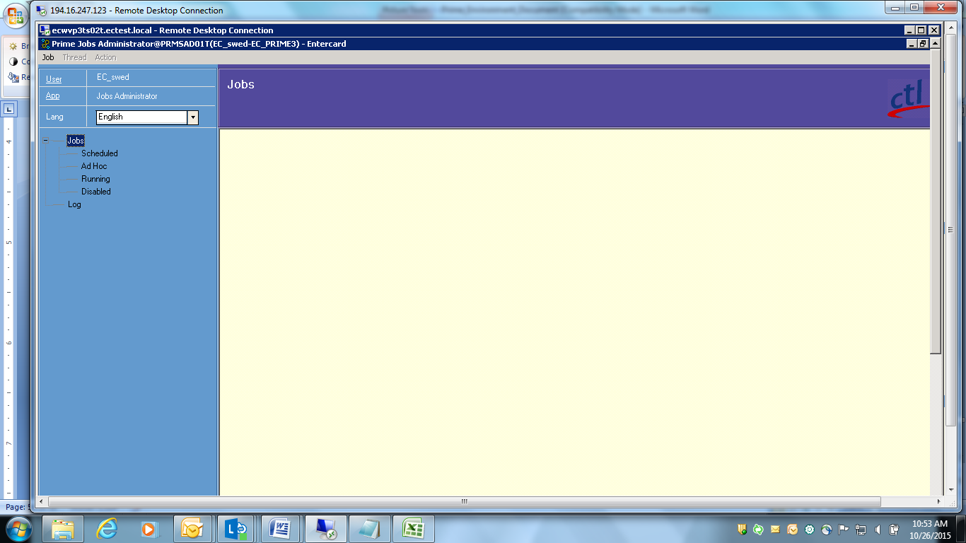

Double click on any type; u will see threads belonging to that type.

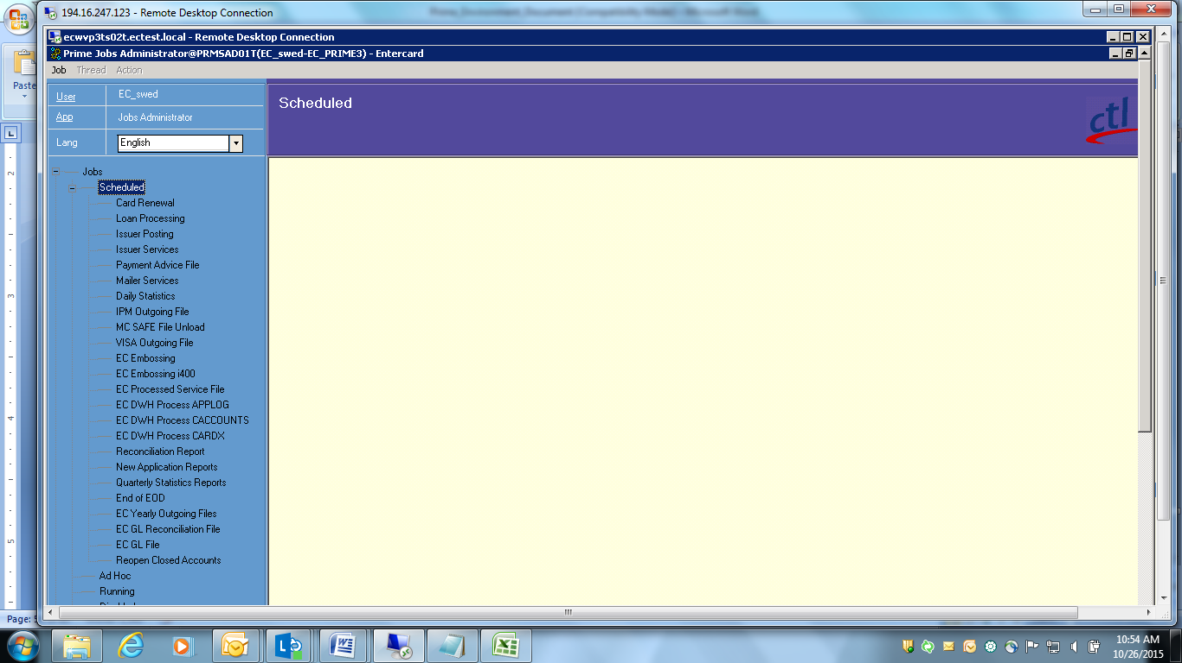

Example: Clicked on Card Renewal and u will see following details.

Card Renewal is a batch processing item which is called as thread. Each thread consists of one or more actions. Here Ad-hoc Renewal, Renew Cards, EC auto card replace are the actions. One action belongs to only one thread.

**Thread detail contains:**

Name, category, status, scheduling, options and when previous run was happened.

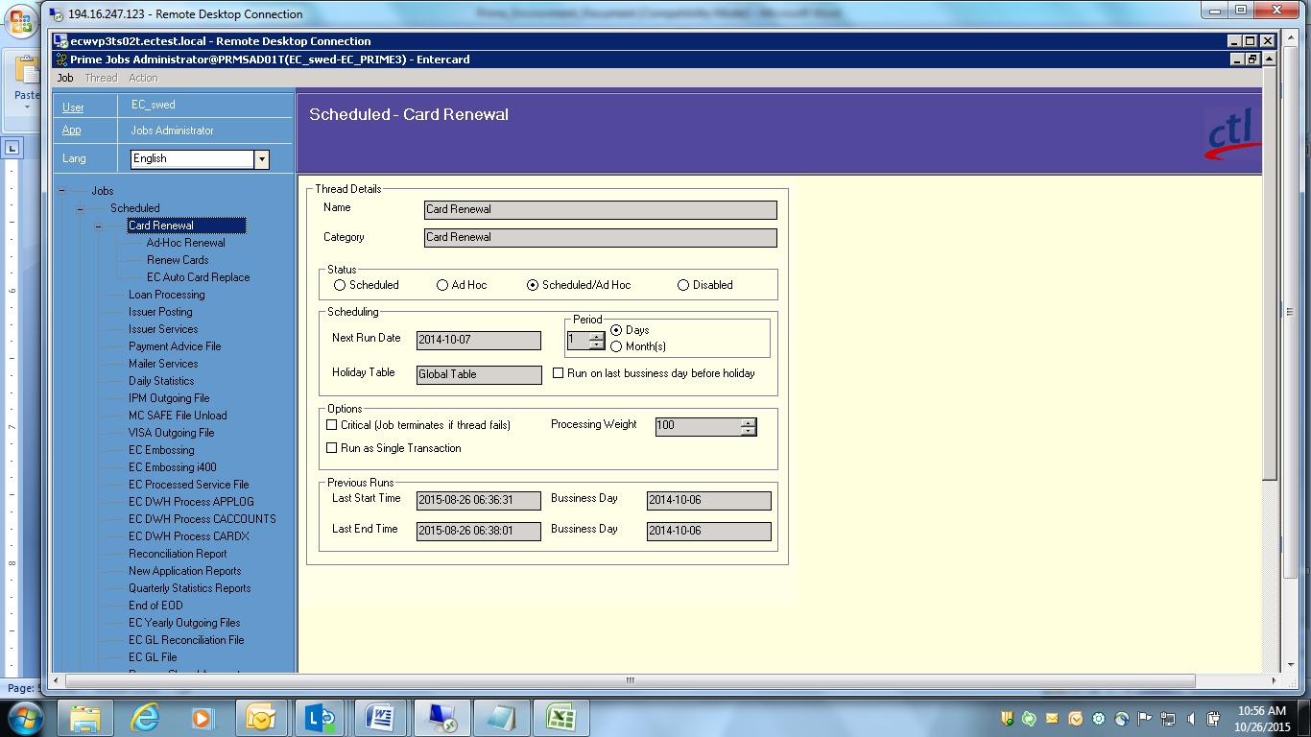

**Action detail contains:**

Name, Type, options, argument, argument details

Each action is controlled by one or more parameters called arguments. Arguments are one kind of details where we can make out which procedure or database etc was affected.

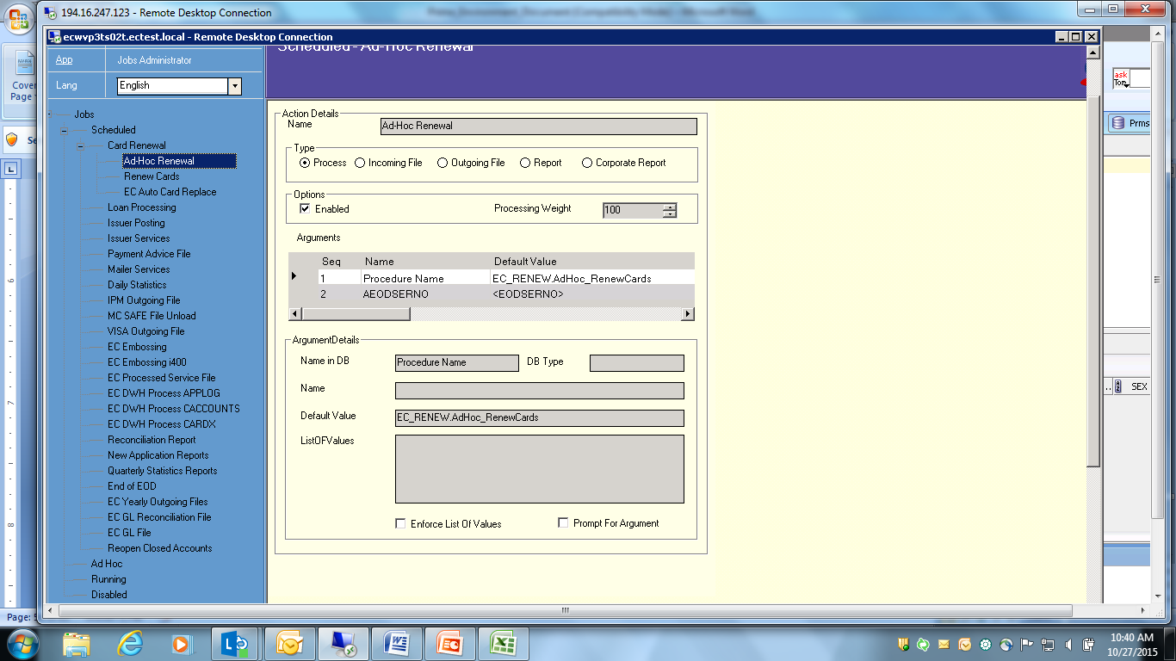

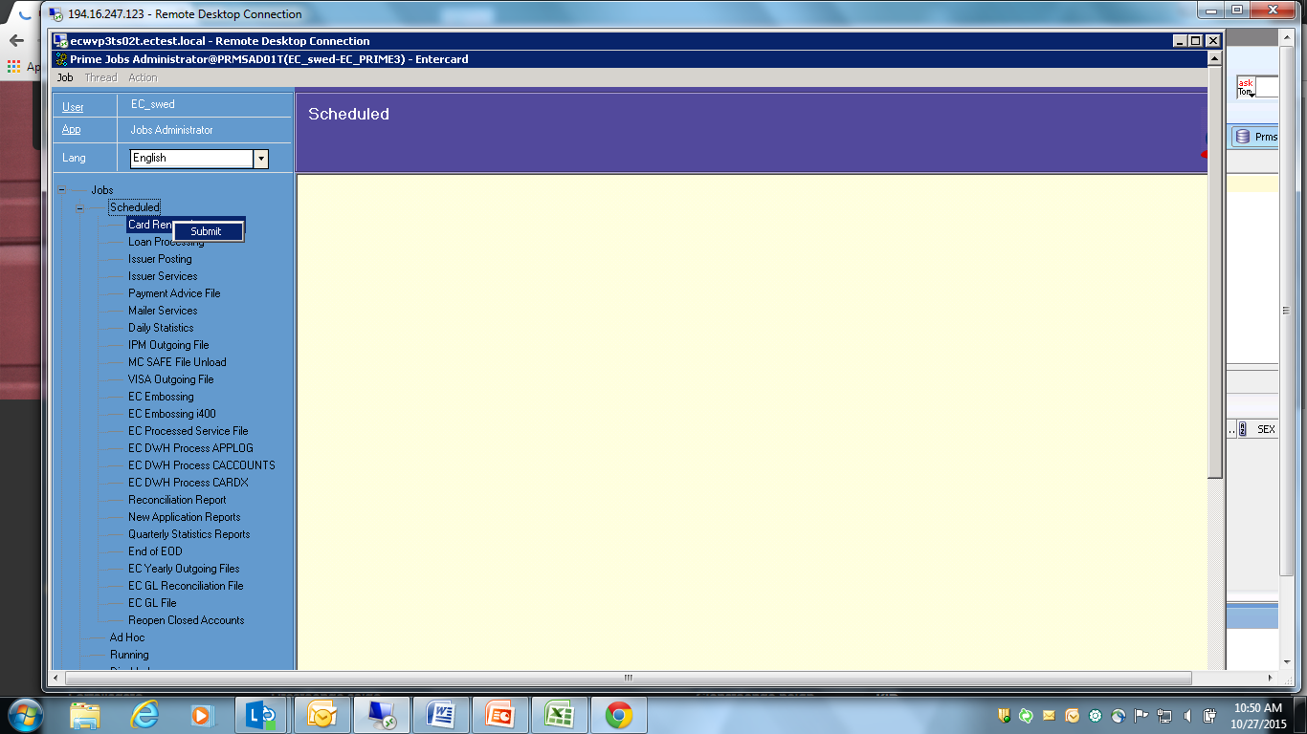

Eods details are stored in EODS table.

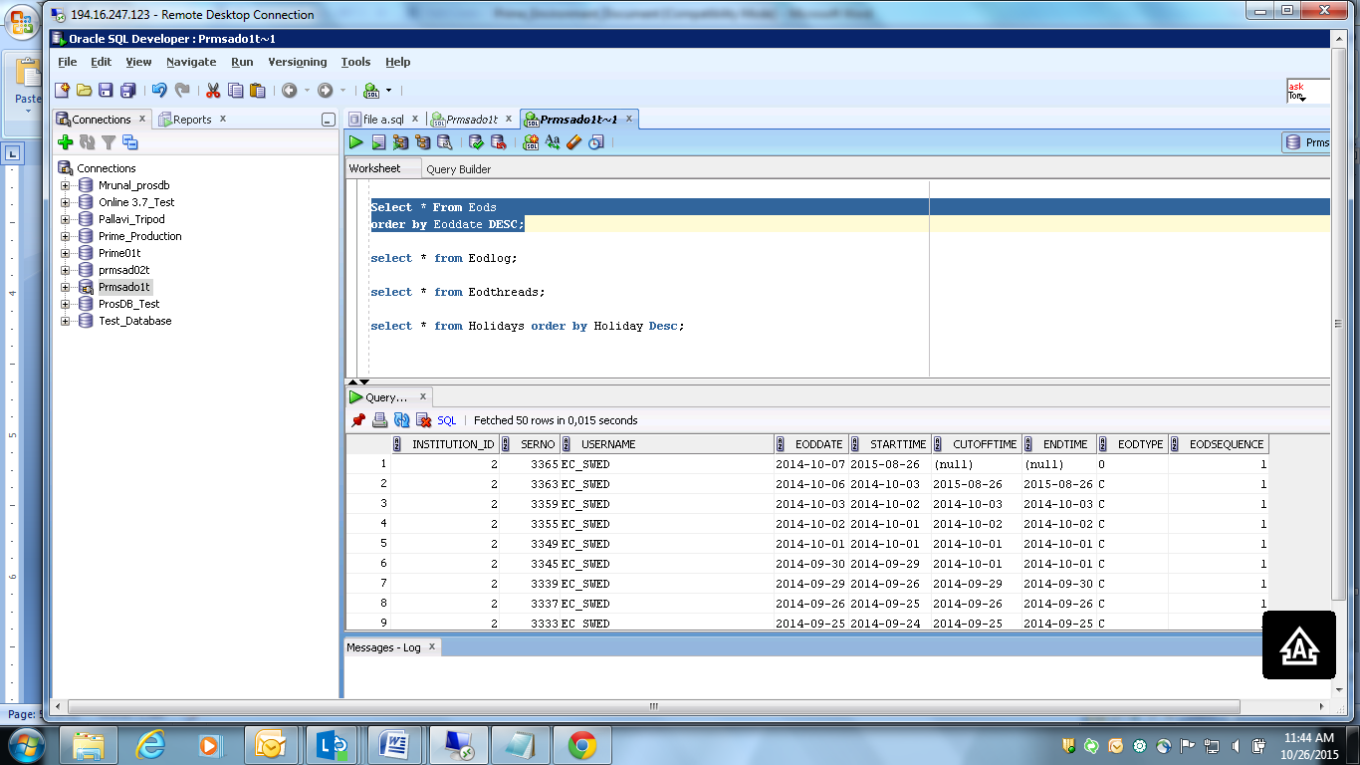

**Note: EODs are not present on Saturday, Sunday & Bank Holidays**

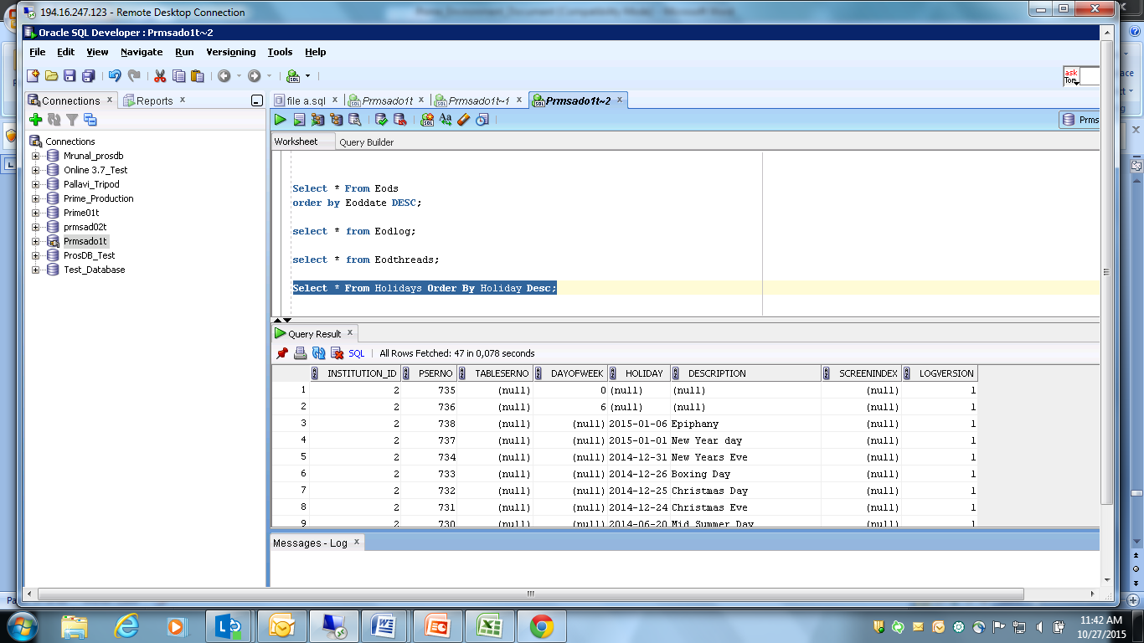14. From which module does u apply rights to a user for a screen? Explain with an example?

We can set access according to our requirement from security Screen.

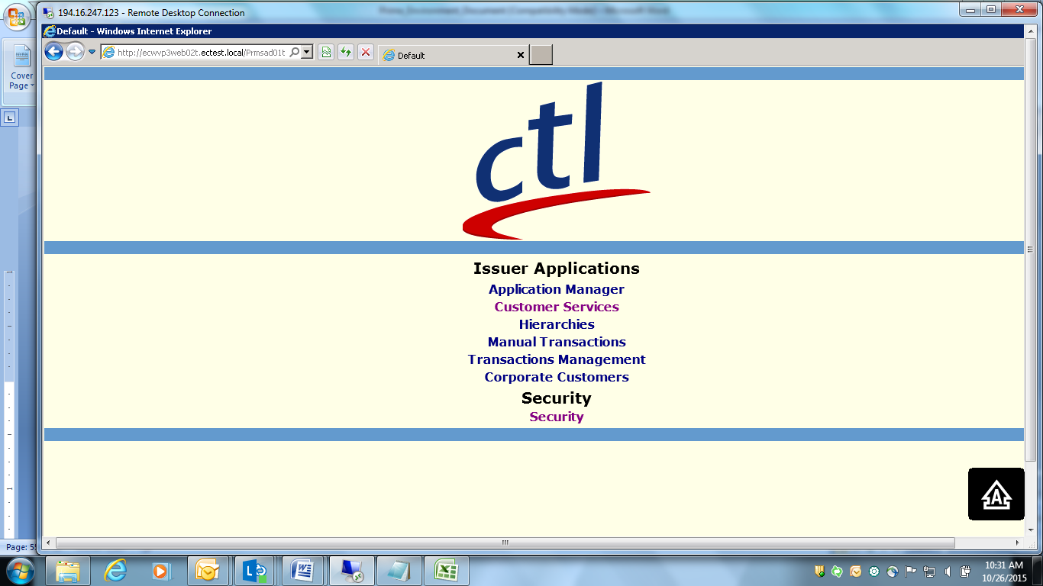

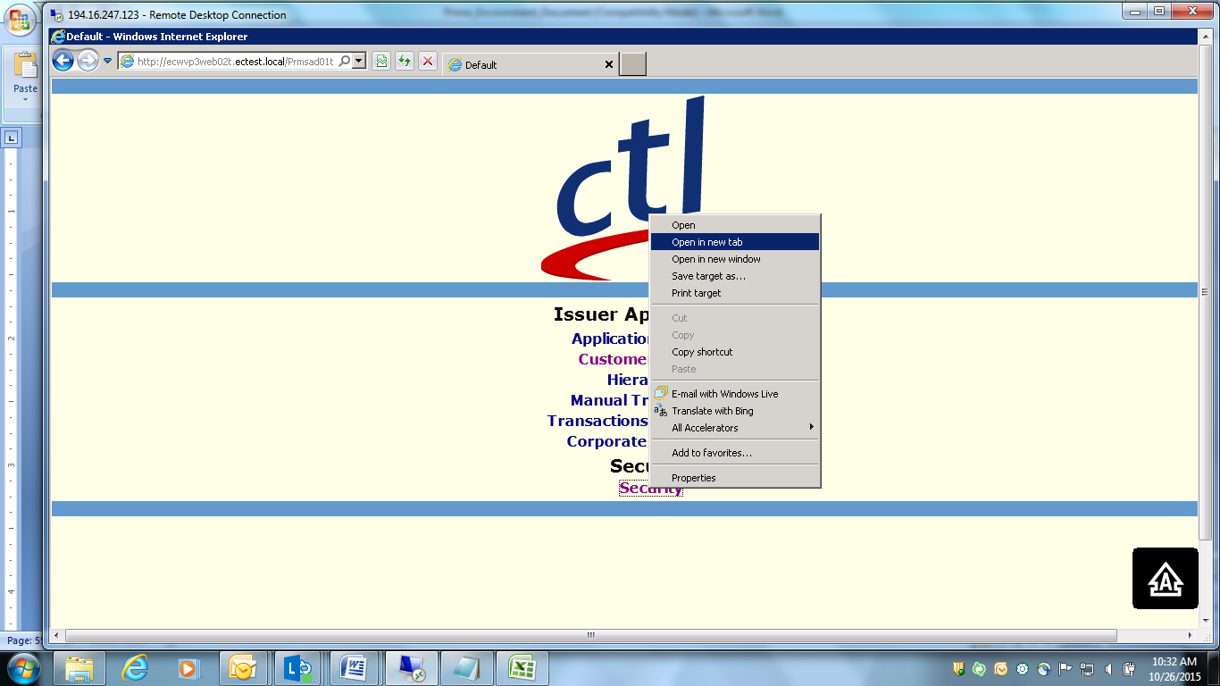

Instead of ECTest write cpawaskp (username)

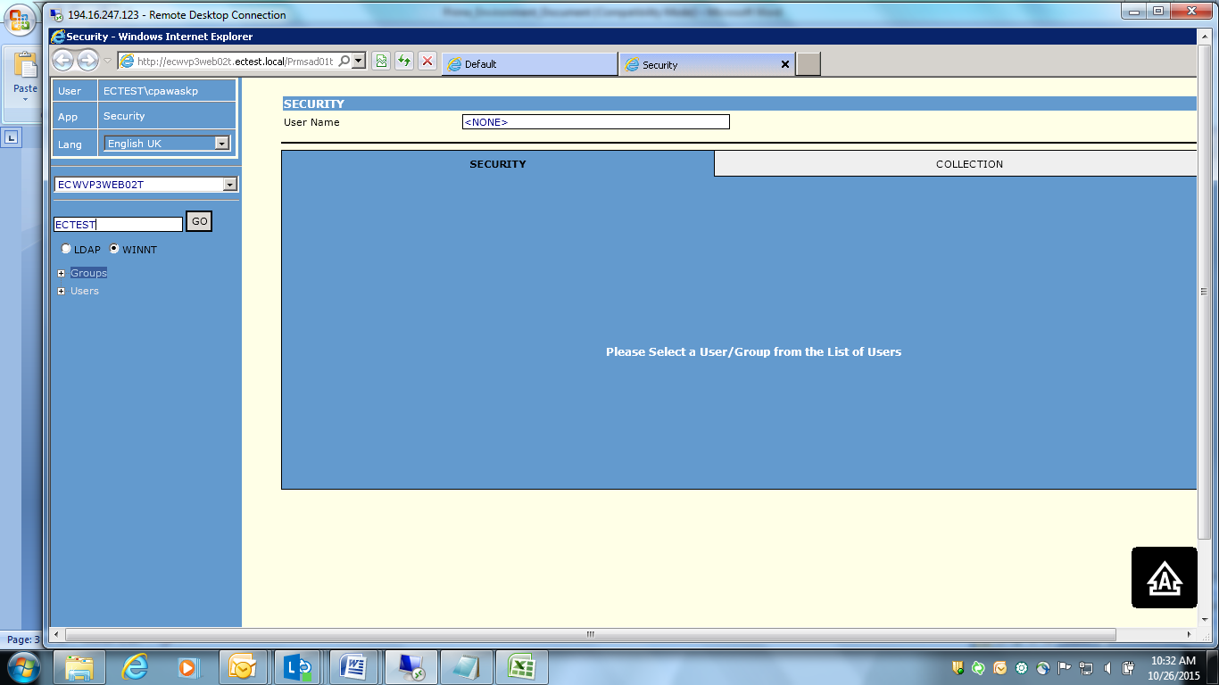

Enter username and password

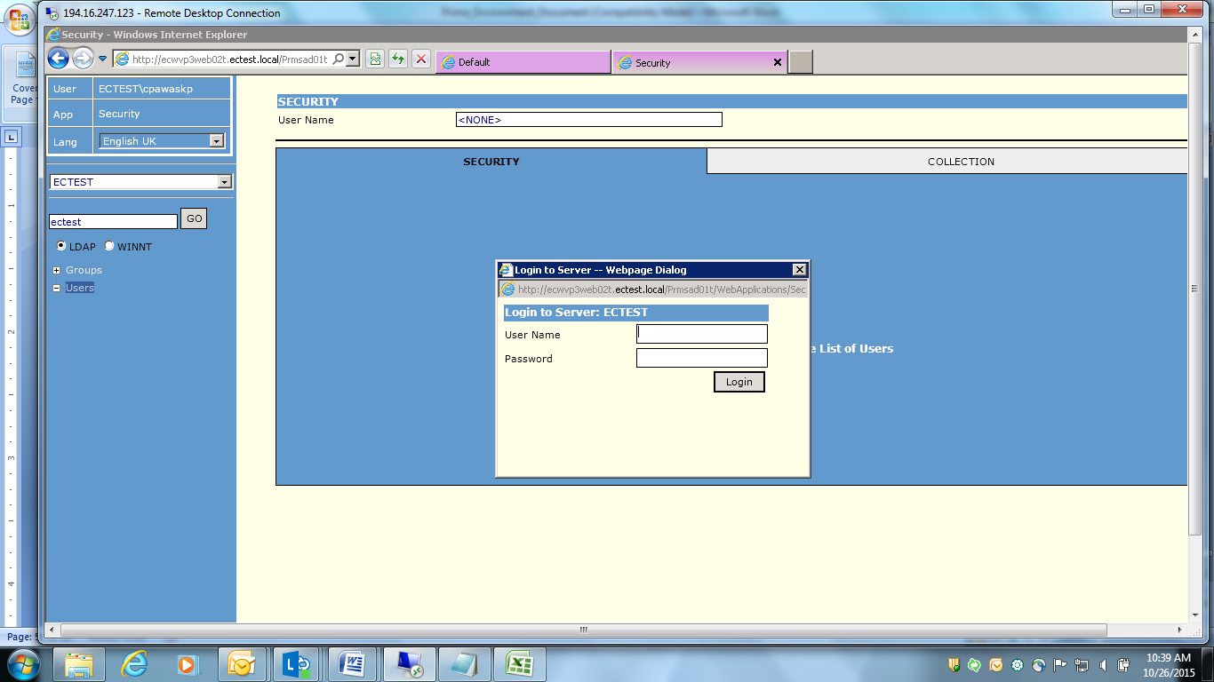

Click on Username listed “cpawaskp”

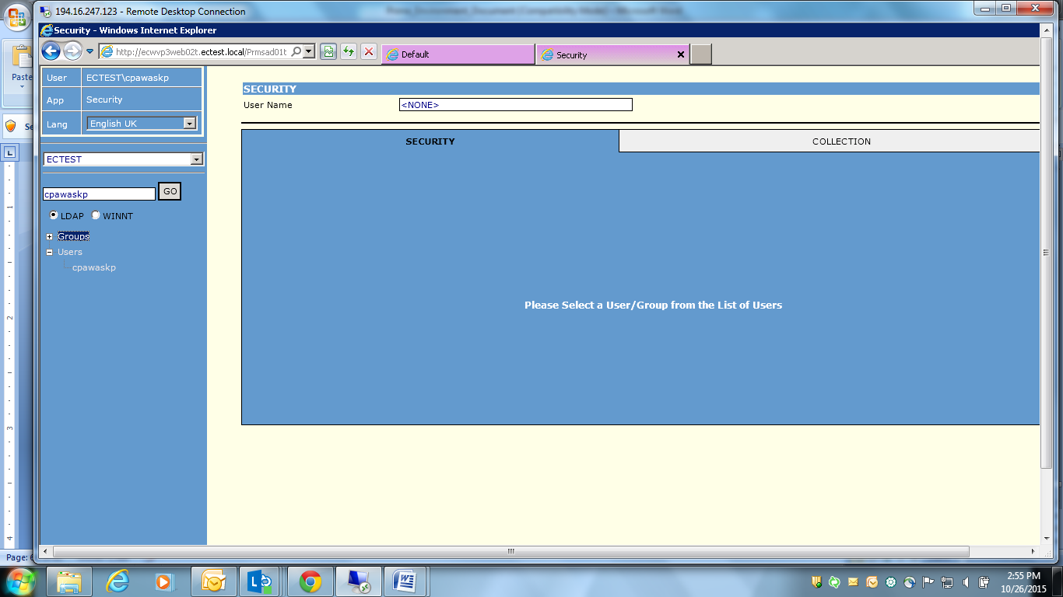

Tick required checkboxes and click on “Allow all Actions”. Access can be given to all forms available in application.

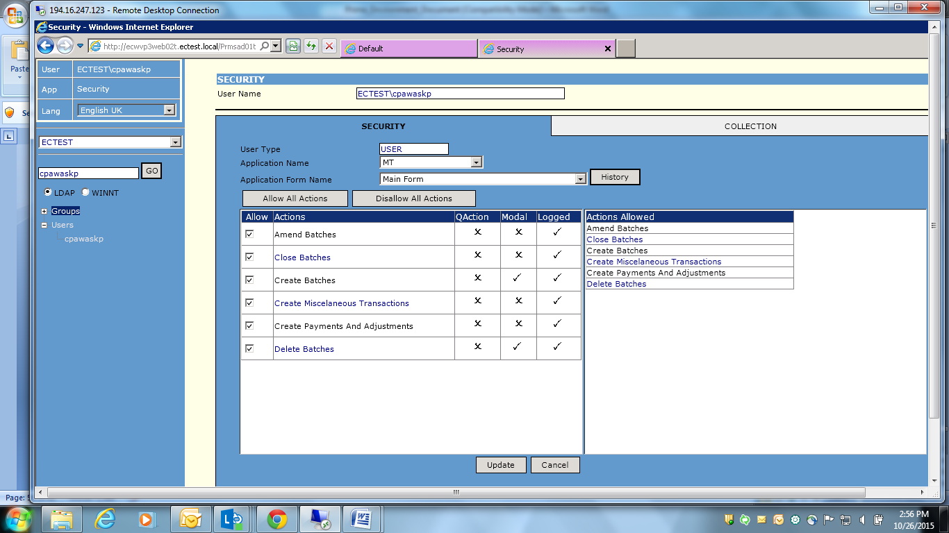

1. Give an example of manual transactions? With screenshot?

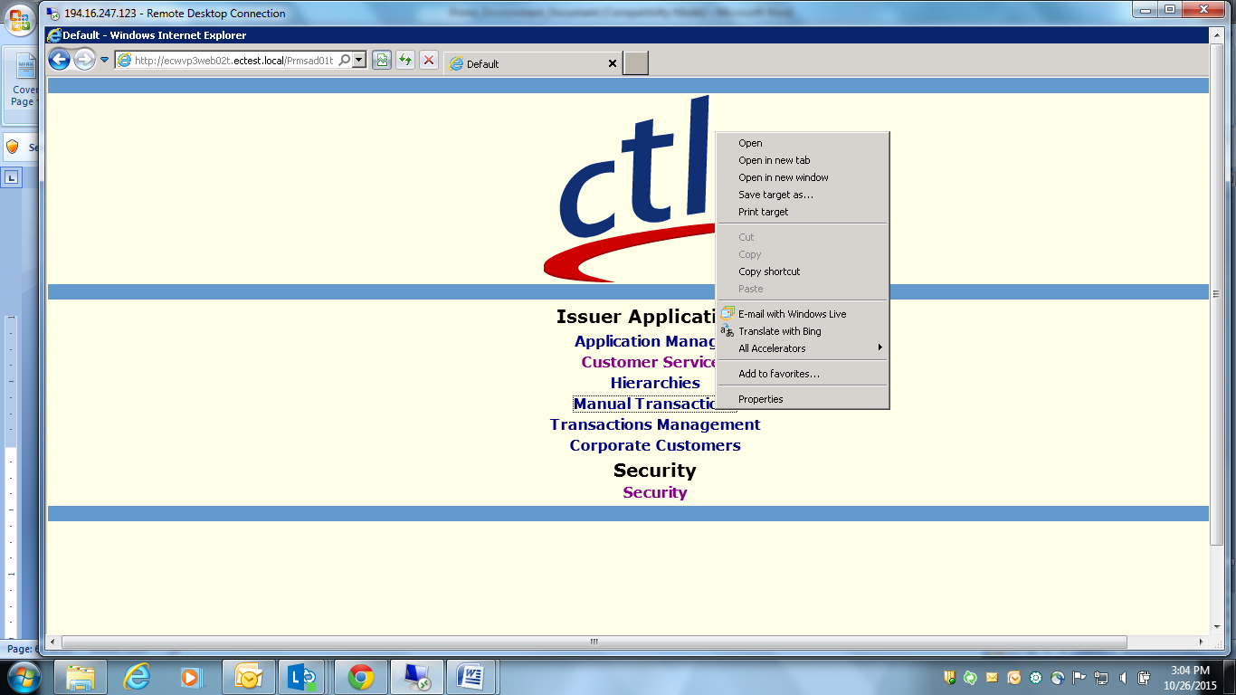

Click on “New Batch”

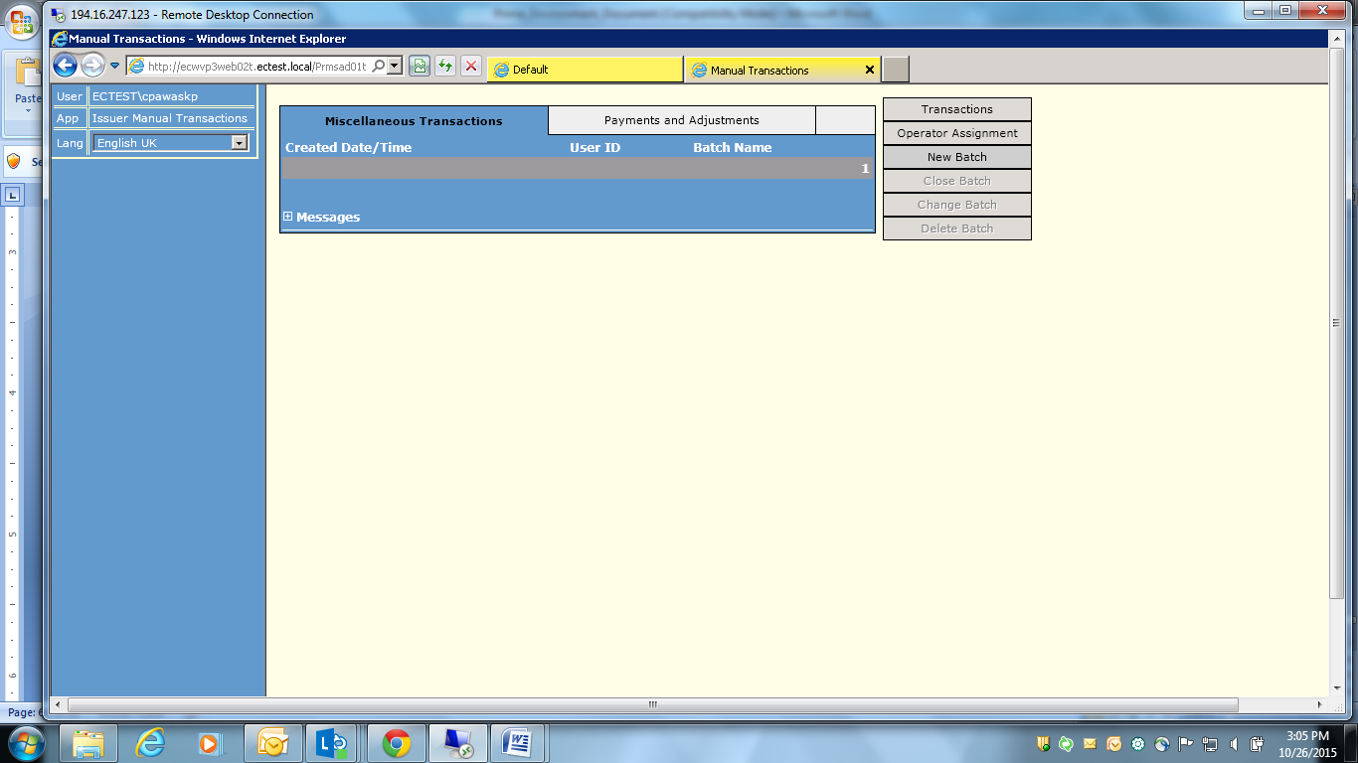

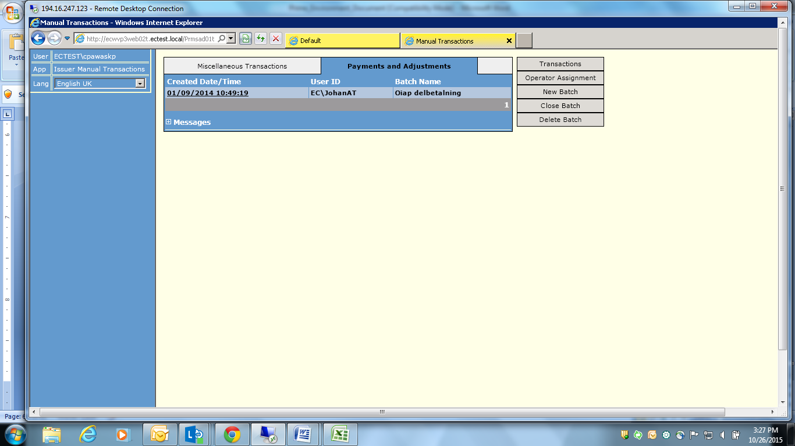

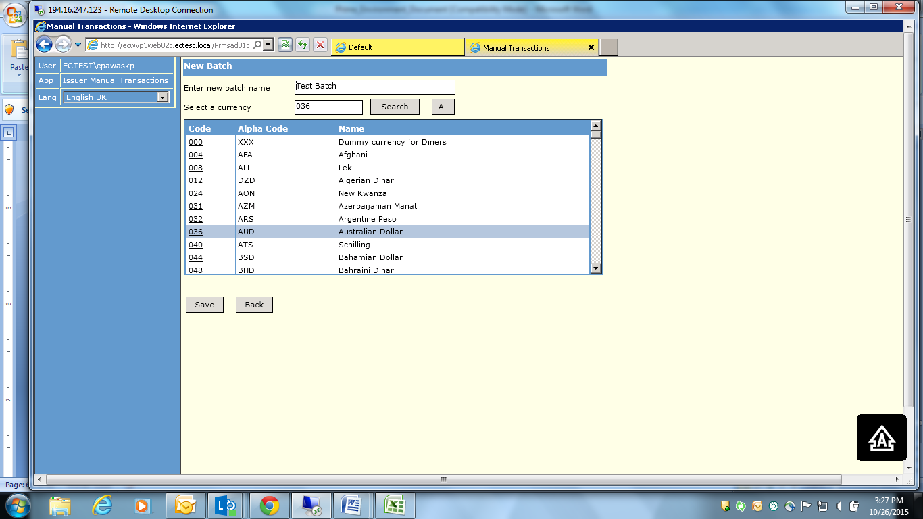

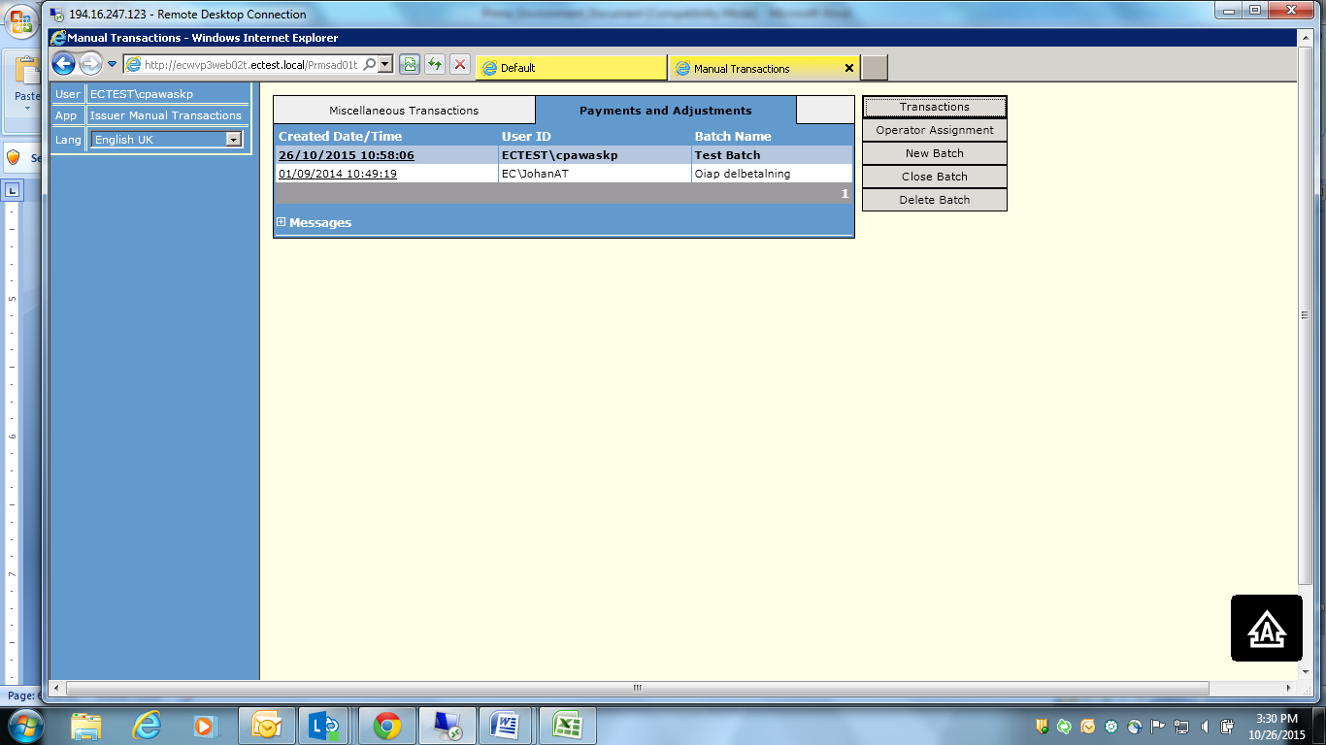

Select new added batch and click on Transactions

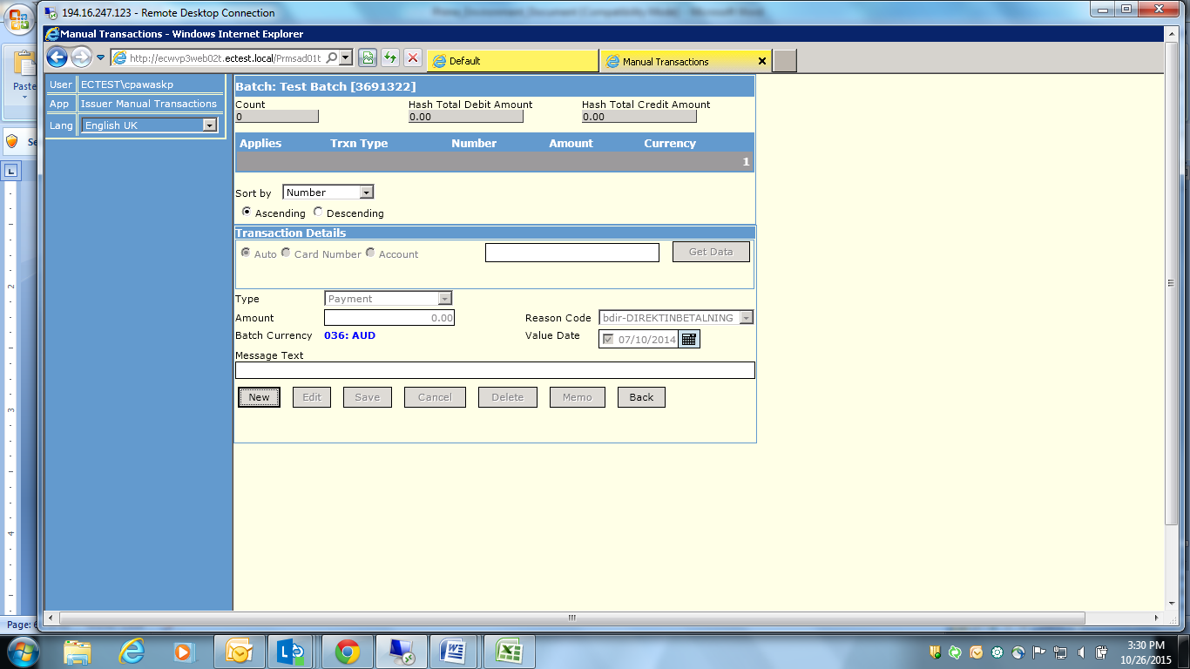

Add New:

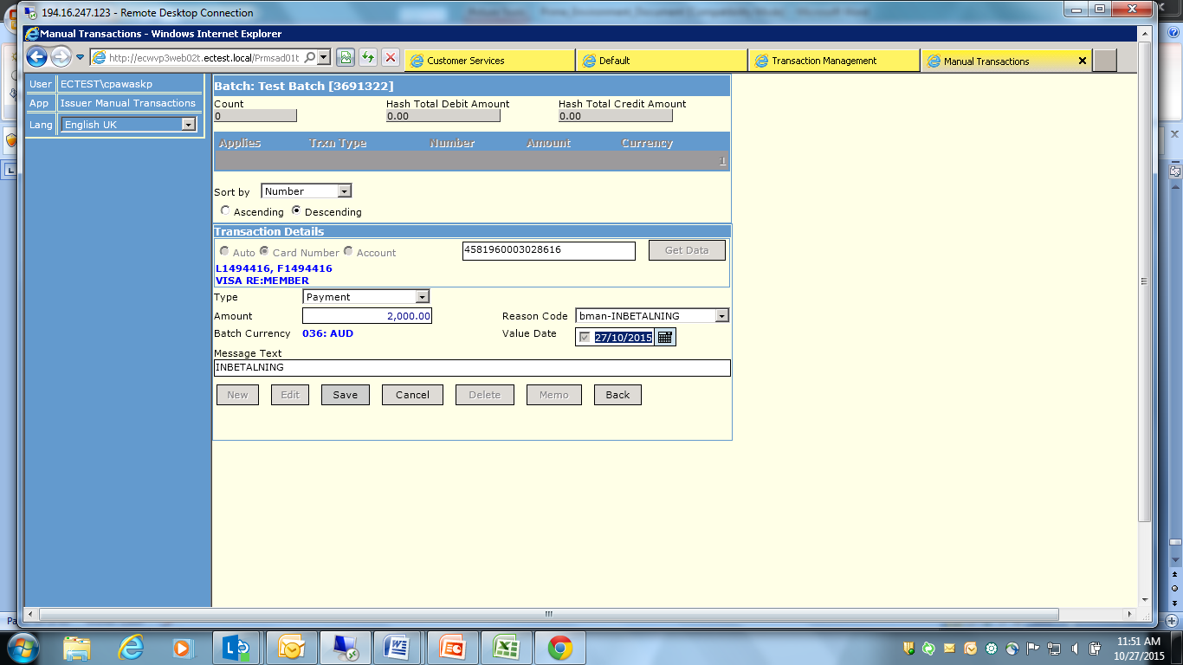

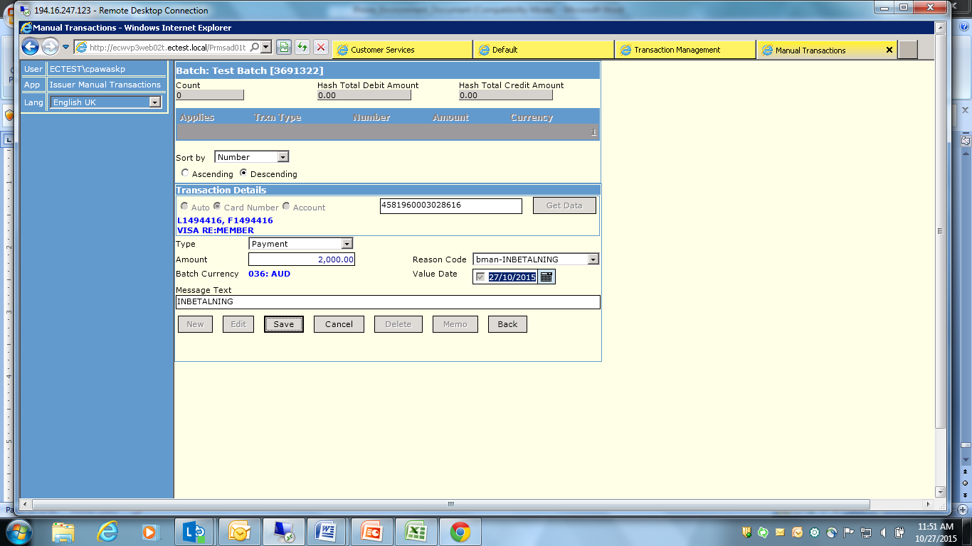

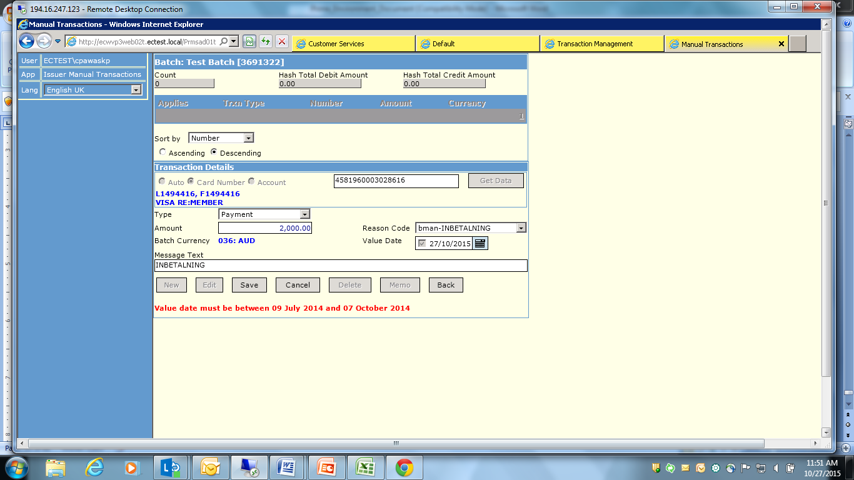

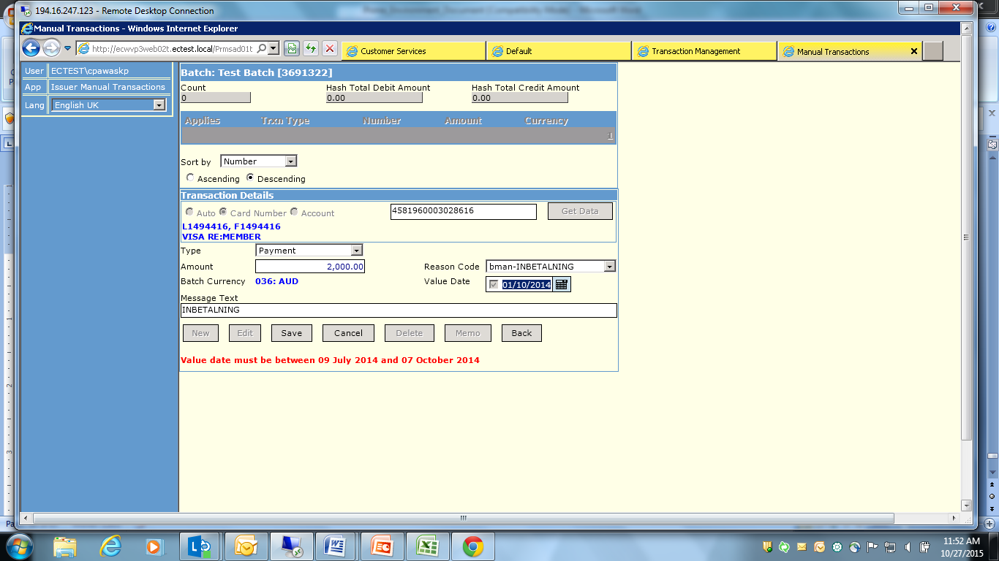

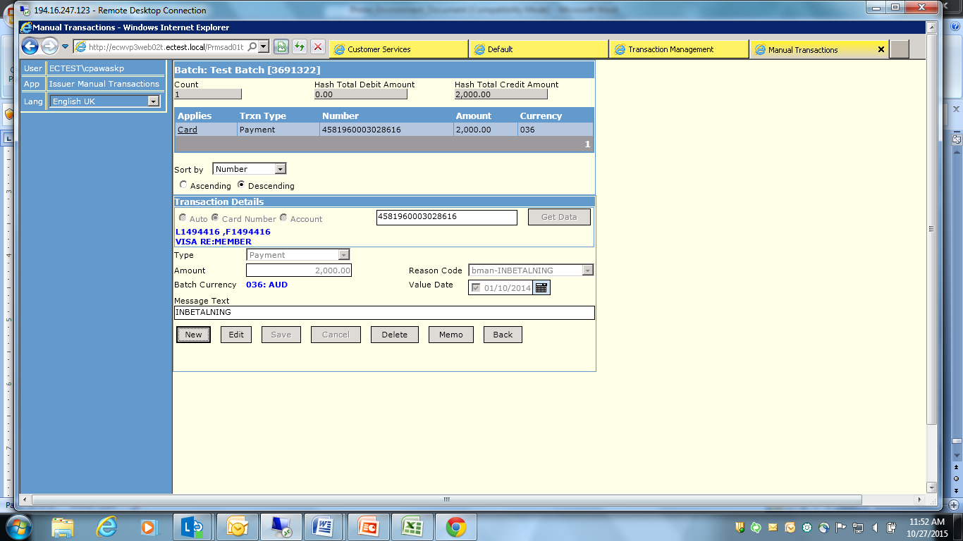

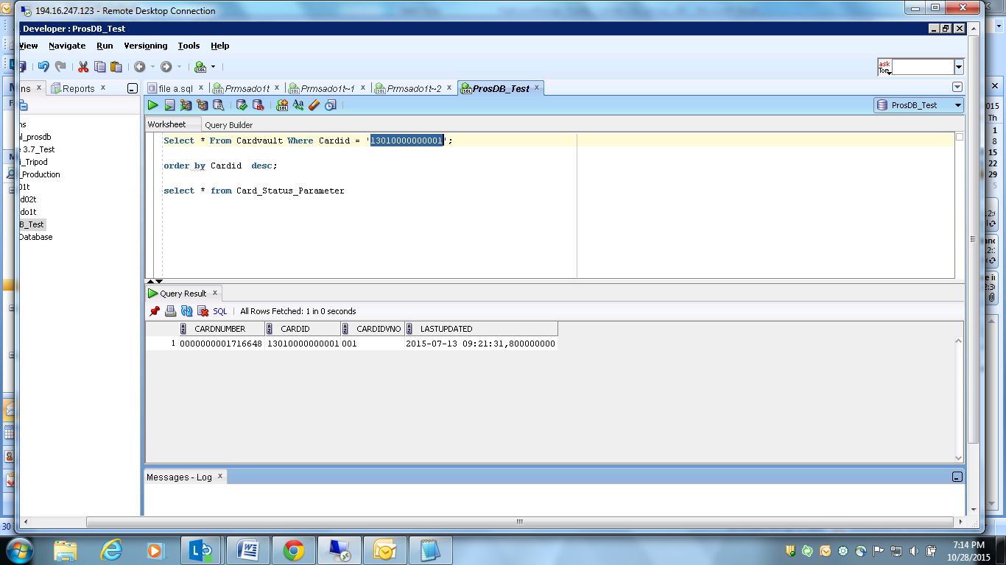

Login to “ecwsasbatch01t.ectest.local”

USERNAME: ECTEST\LOCAL\SAS_KONS-CAP-MB

Password: Entercard17

SAS Data Integration Studio 4.3

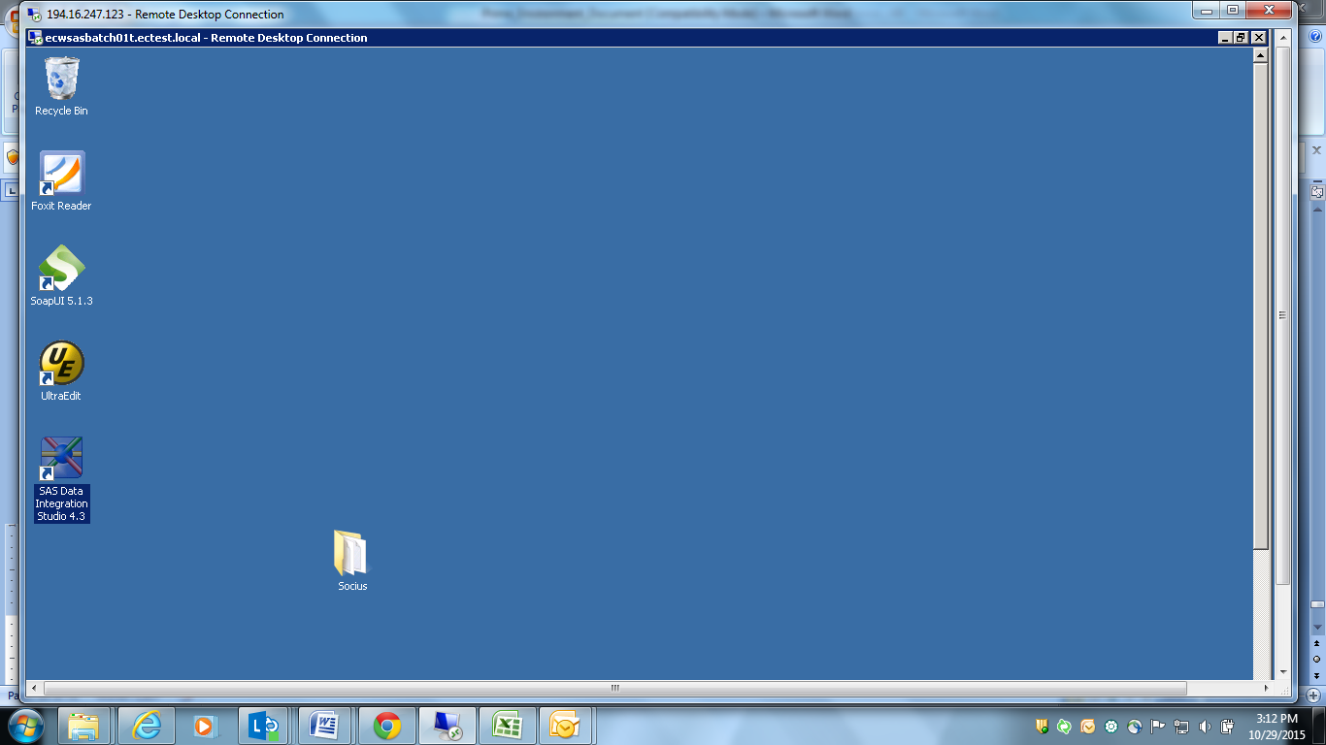

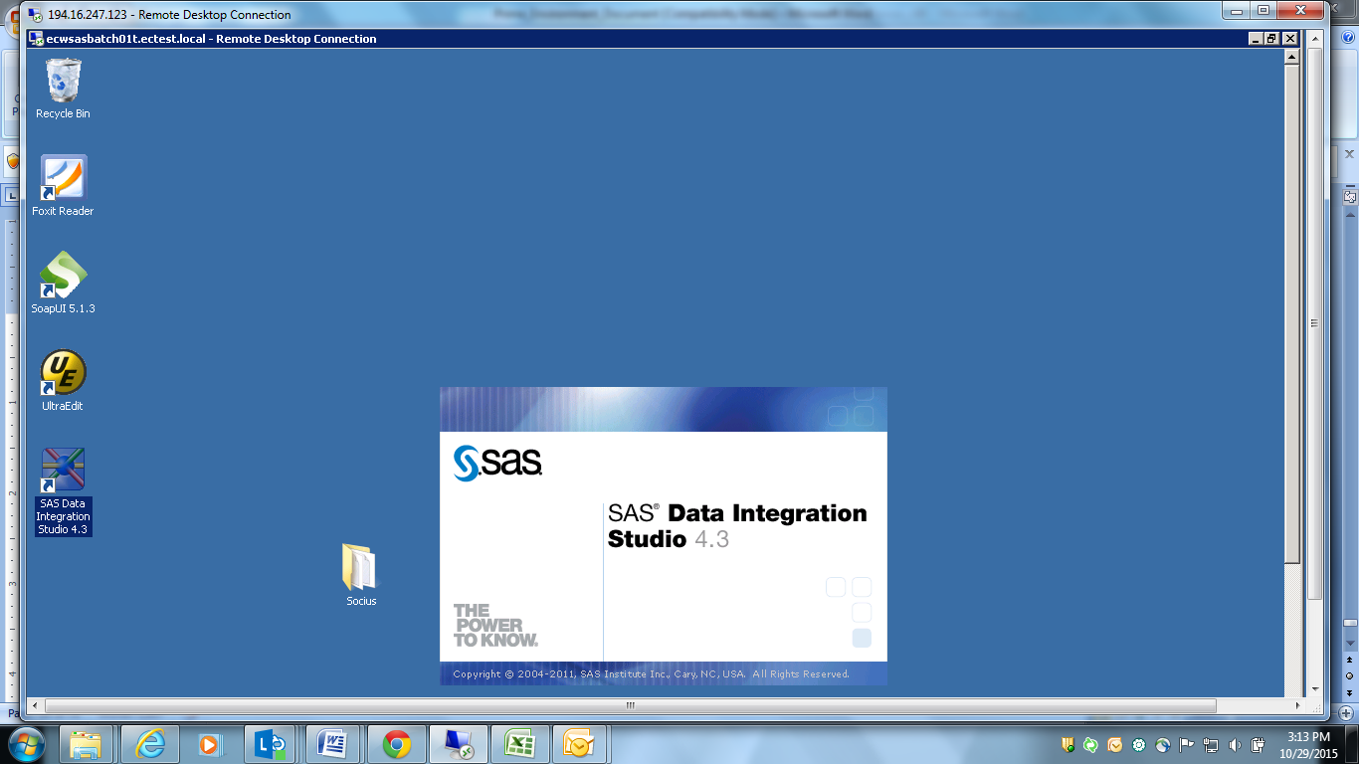

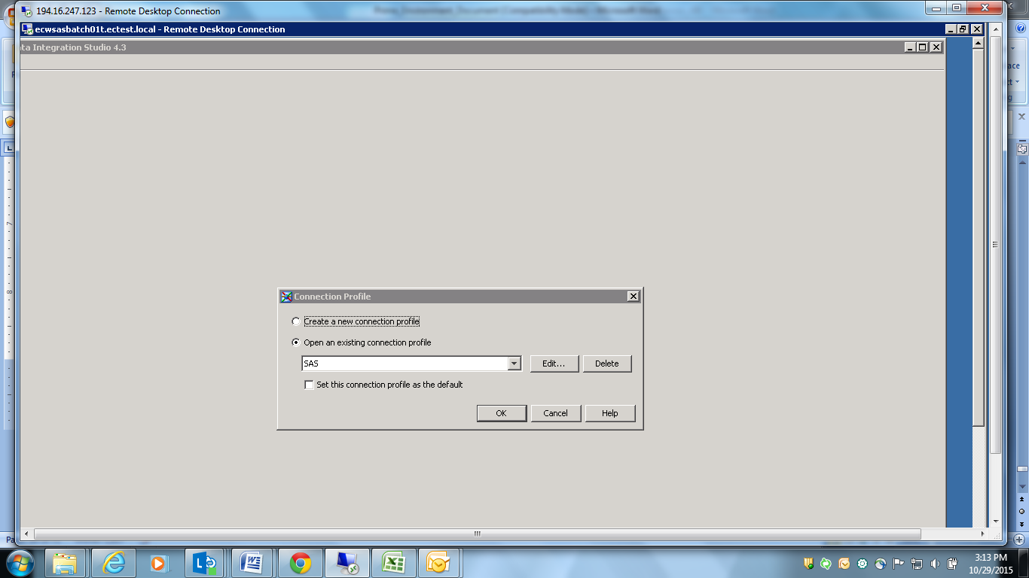

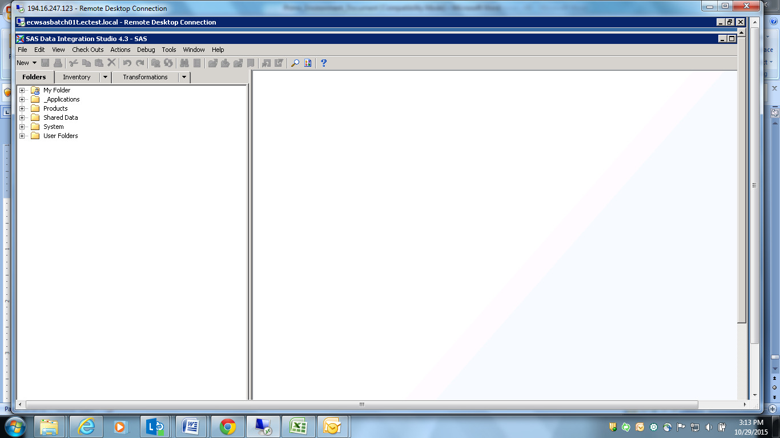

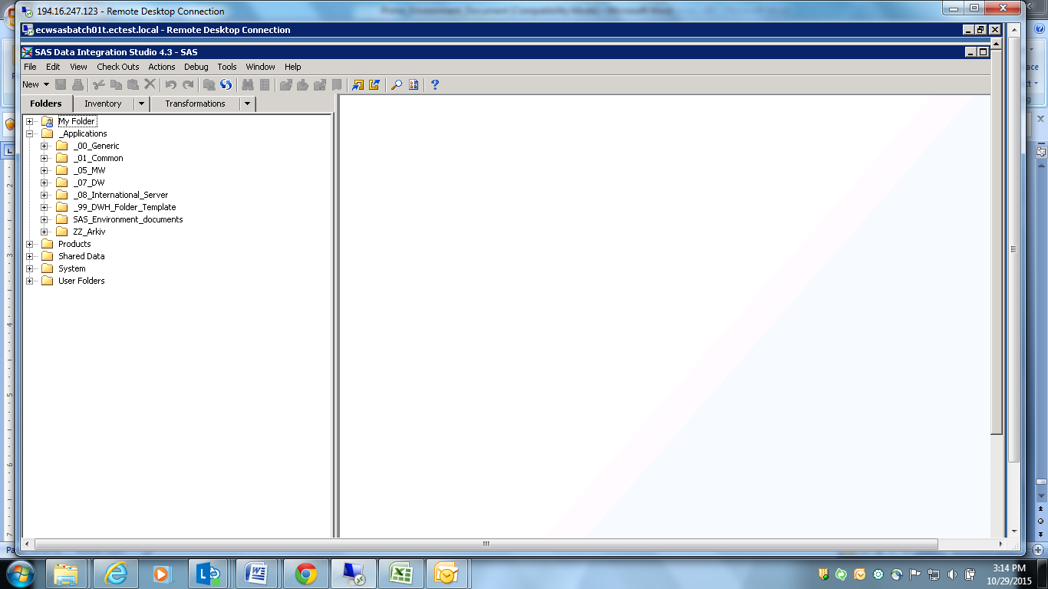

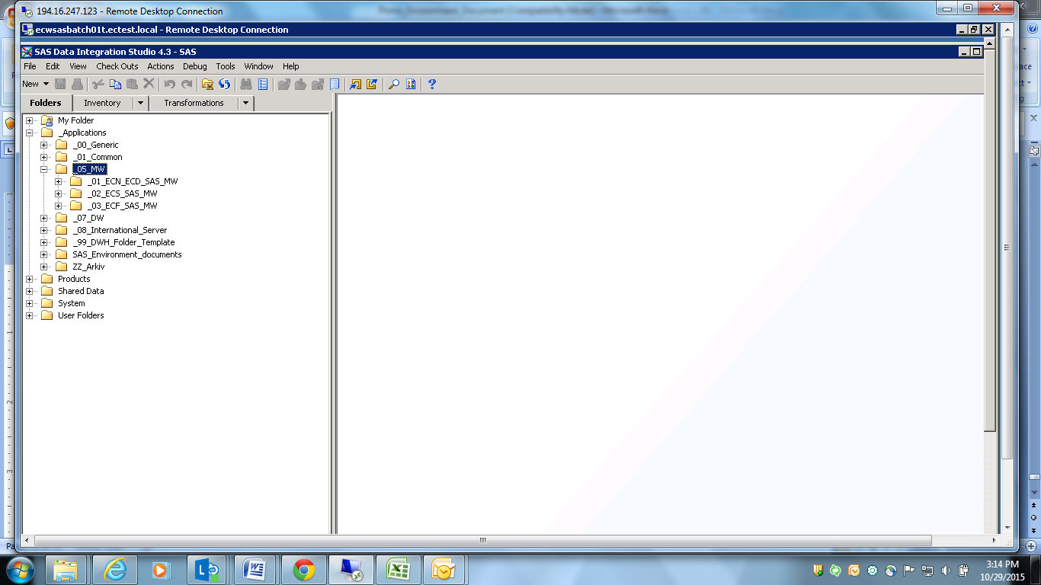

_01_ECN_ECD_SAS_MW belongs to Norway region

_02_ECS_SAS_MW belongs to Sweden region

_03_ECF_SAS_MW belongs to Finland region

Open Norway details.

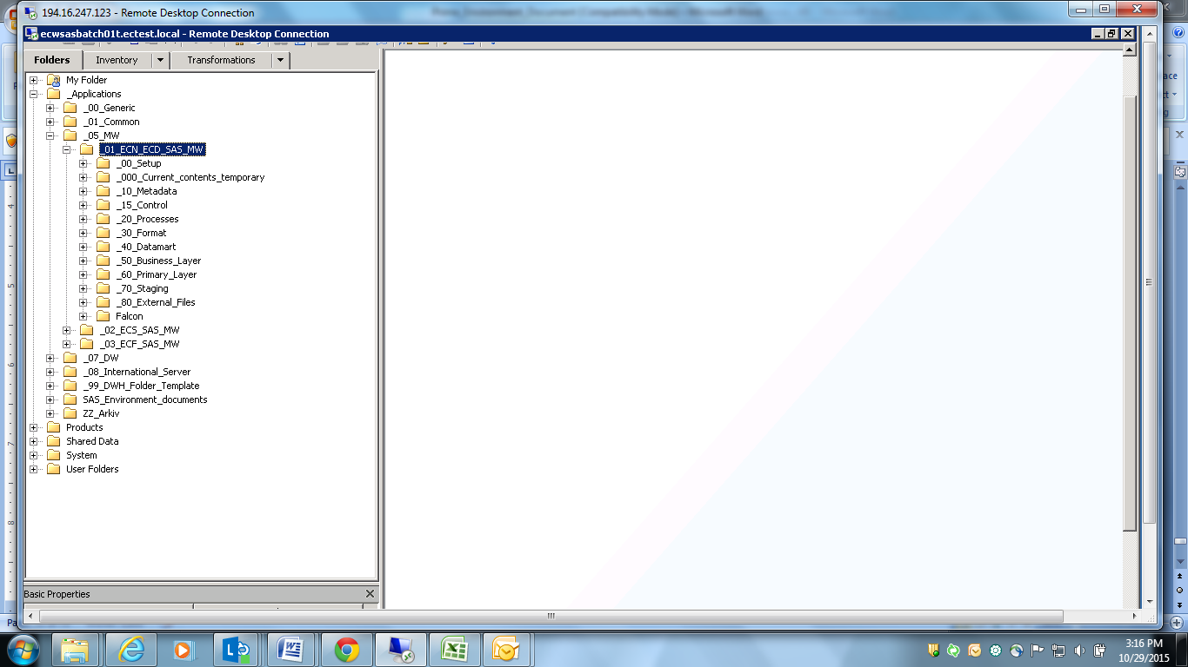

Click on 20_processes,

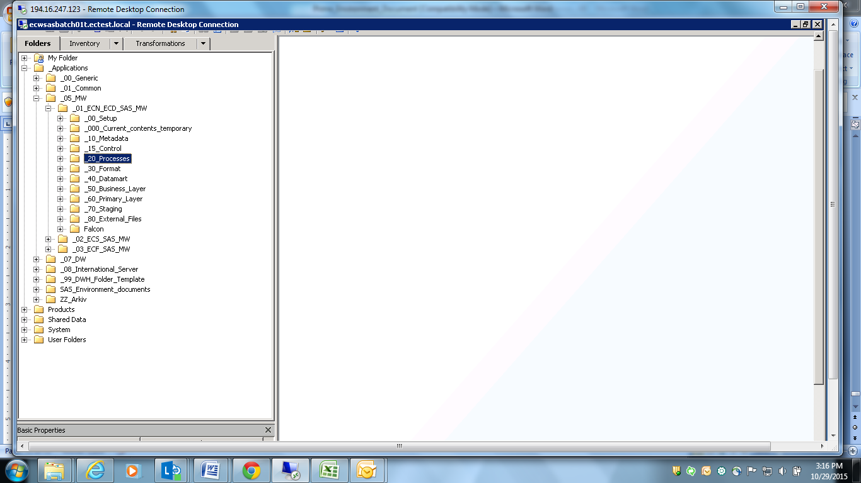

(All Projects will be displayed)

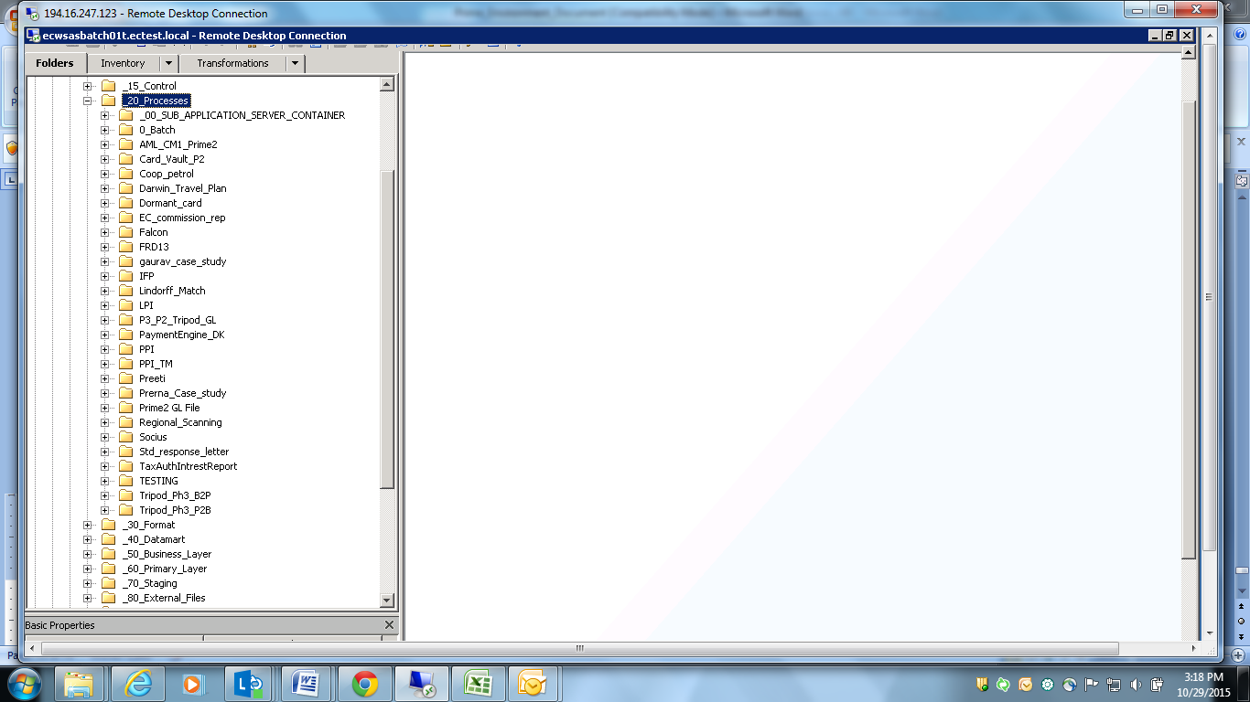

Select Socius

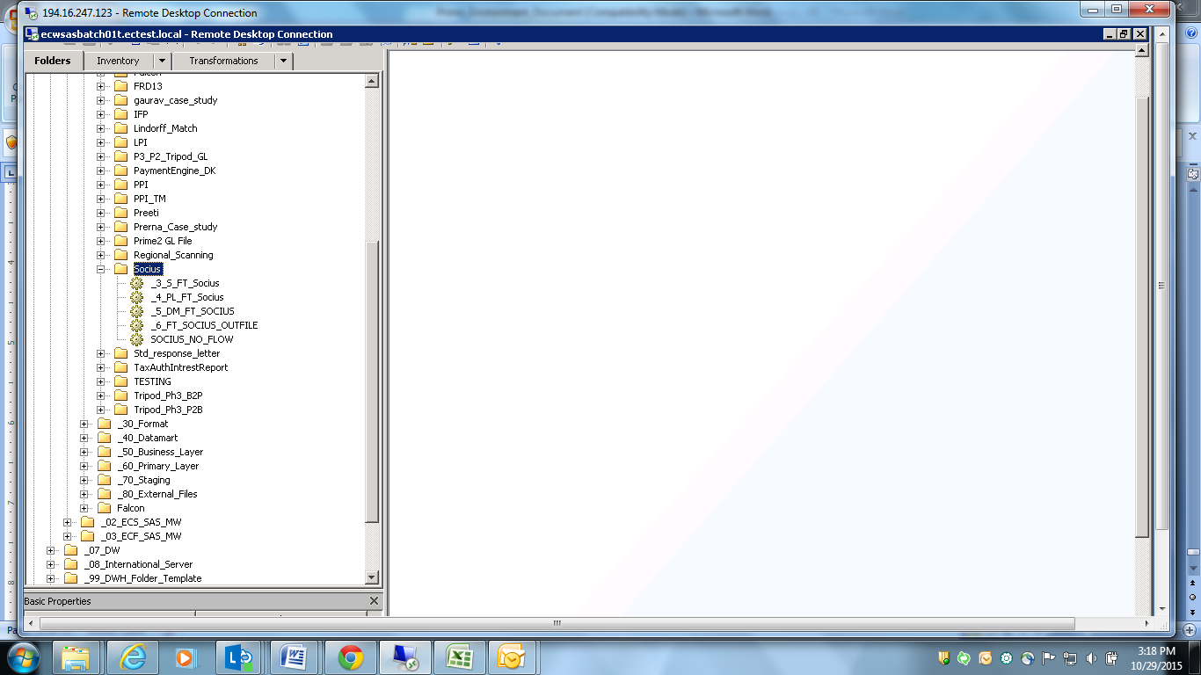

Click on SOCIUS_NO_FLOW

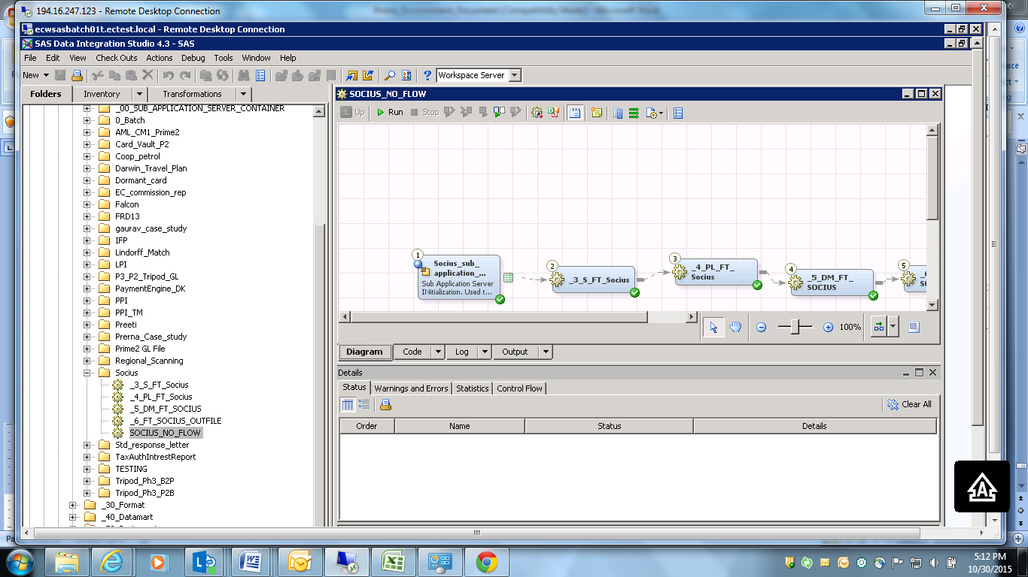

Click on Bottom, “NOMW_SASAPP” to check server so that we change as per our required server

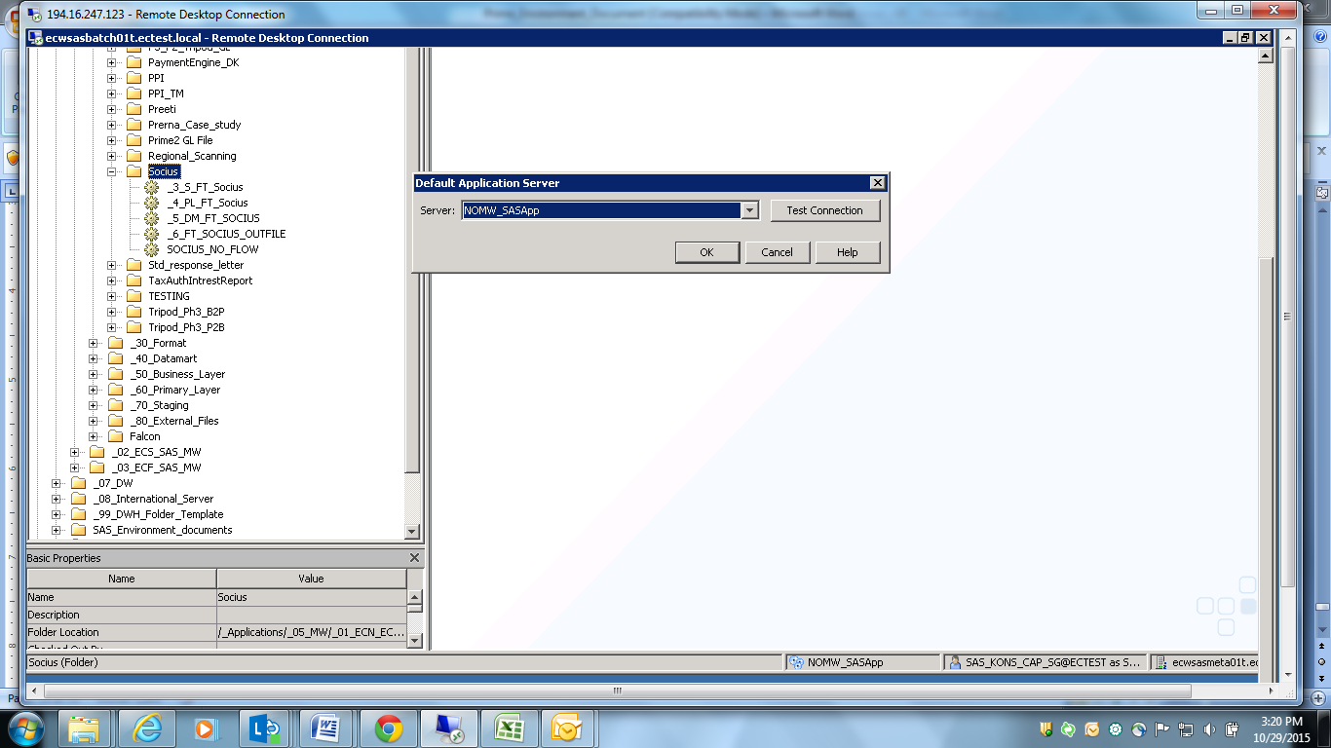

Click on “Run” Button

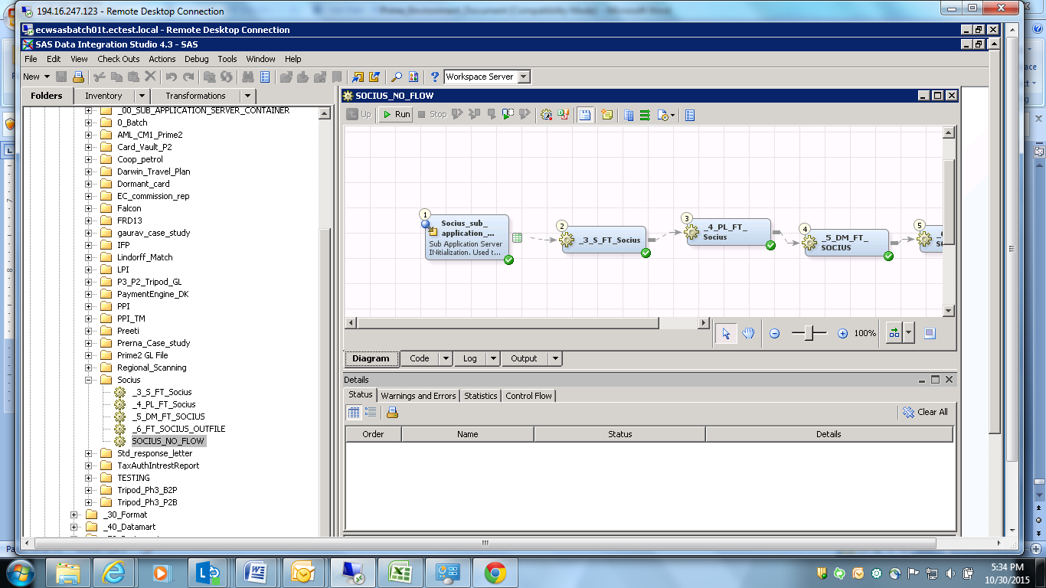

Error Occurred as Incoming File has not placed on the path “F:\SASENVIRONMENT\AD\TEST_MW_ECN_ECD\Programs\Batch\Socius\Files”

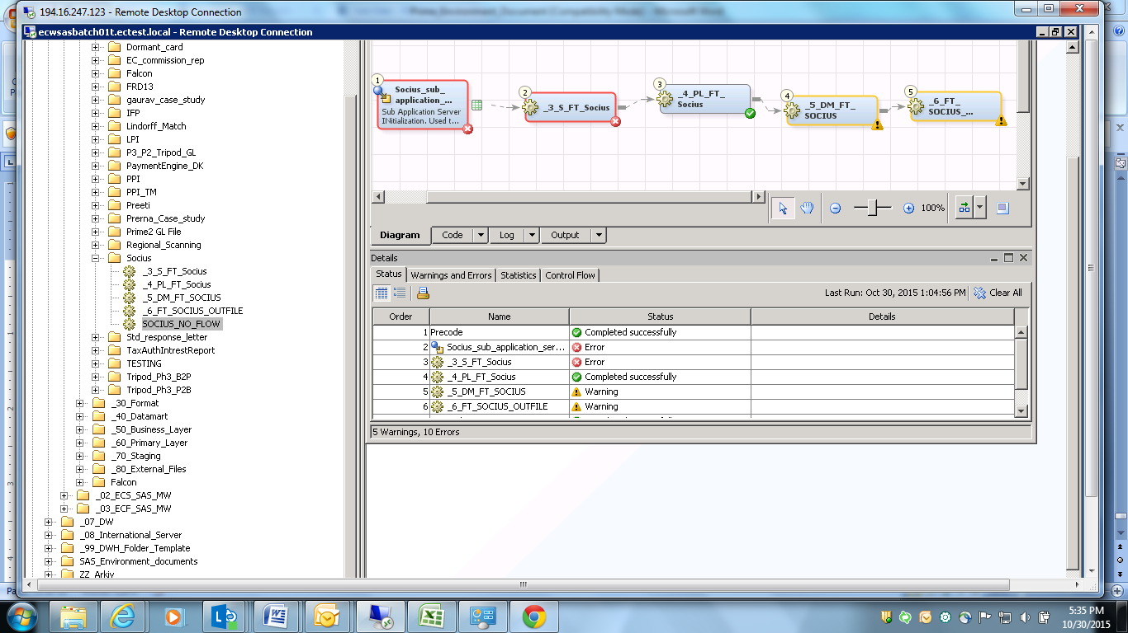

Place Incoming File under path “F:\SASENVIRONMENT\AD\TEST_MW_ECN_ECD\Programs\Batch\Socius\Files “

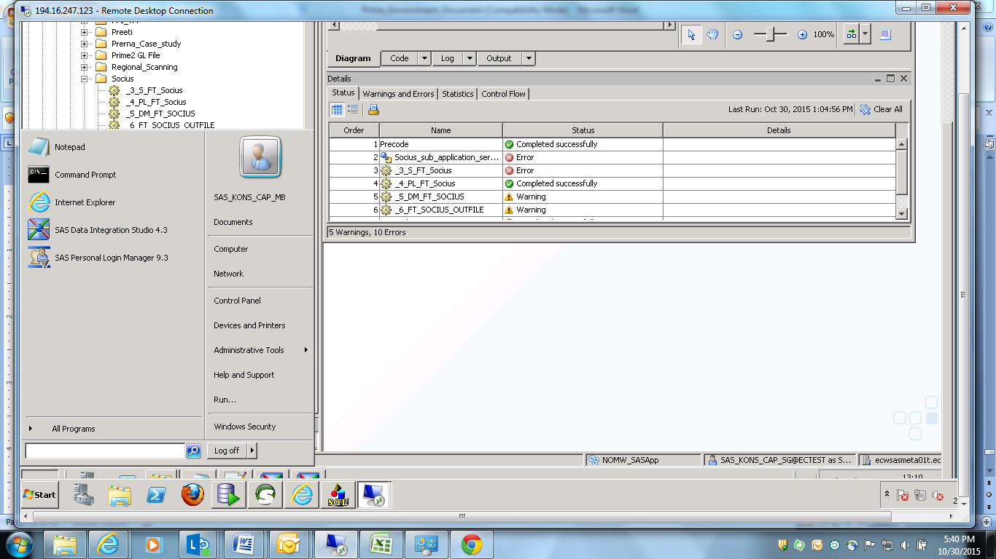

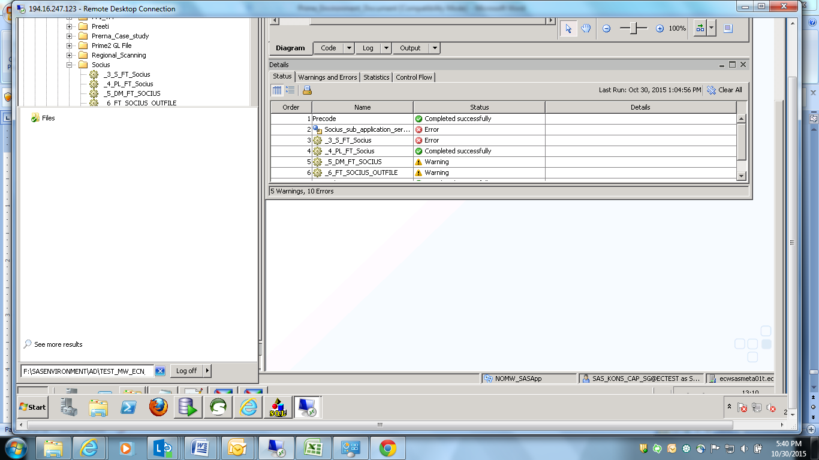

Incoming File will be provided as below:

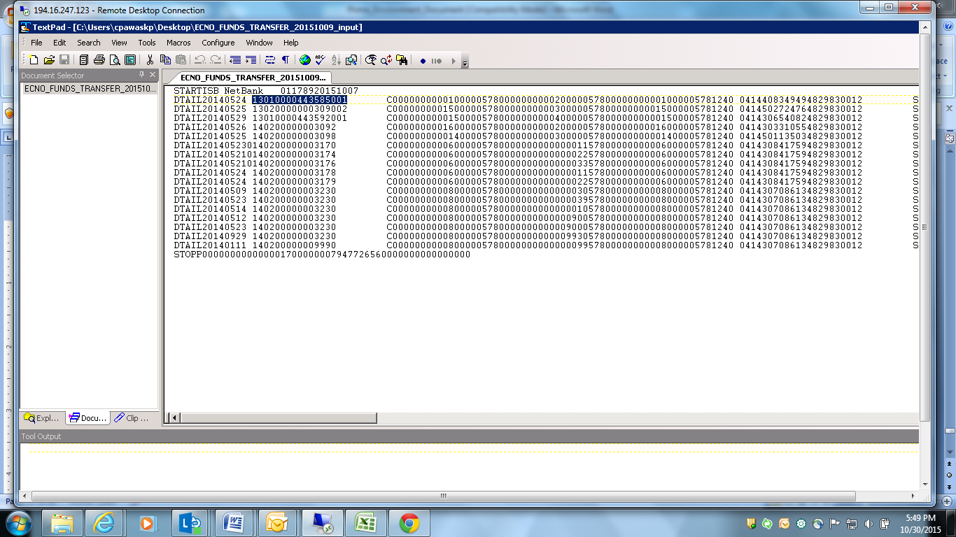

Now in existing File, we need to replace card ID, Card Version, if required Creation Date and Transaction Date. This depends on scenario.

Input file can be created referring soa card vault table for CardID and card version

**Note: card vault data and Prime data should be in Sync.**

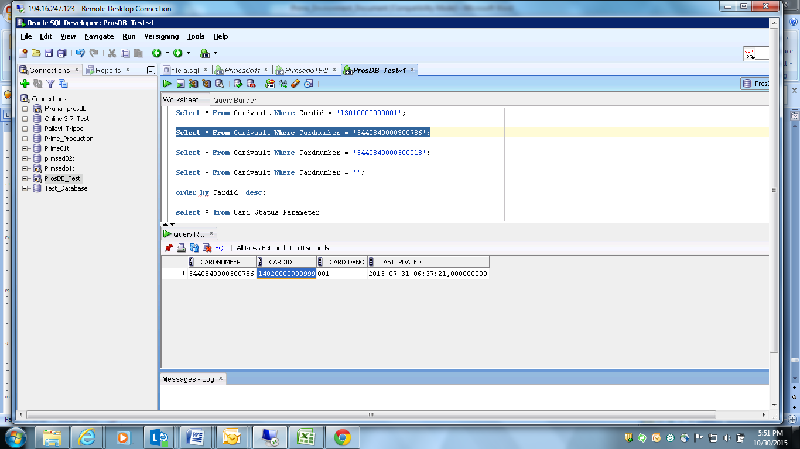

Here in updated incoming file, replace card ID, Card Version, created Date and Transaction date is replaced.

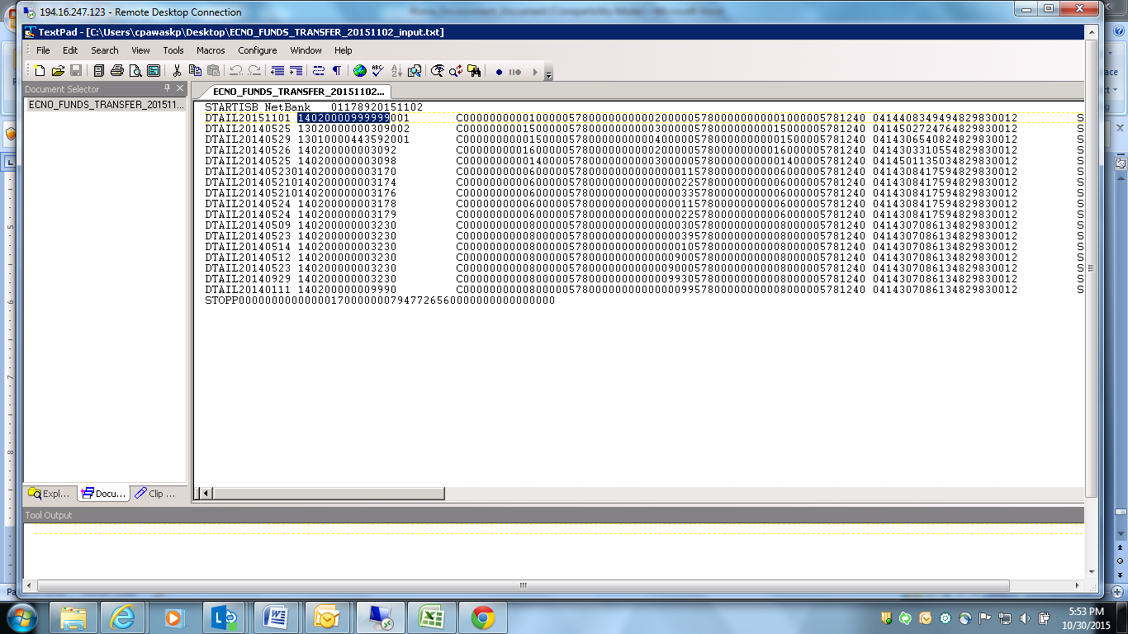

Copy Transaction file and paste it under path “F:\SASENVIRONMENT\AD\TEST_MW_ECN_ECD\Programs\Batch\Socius\Files “ as show below

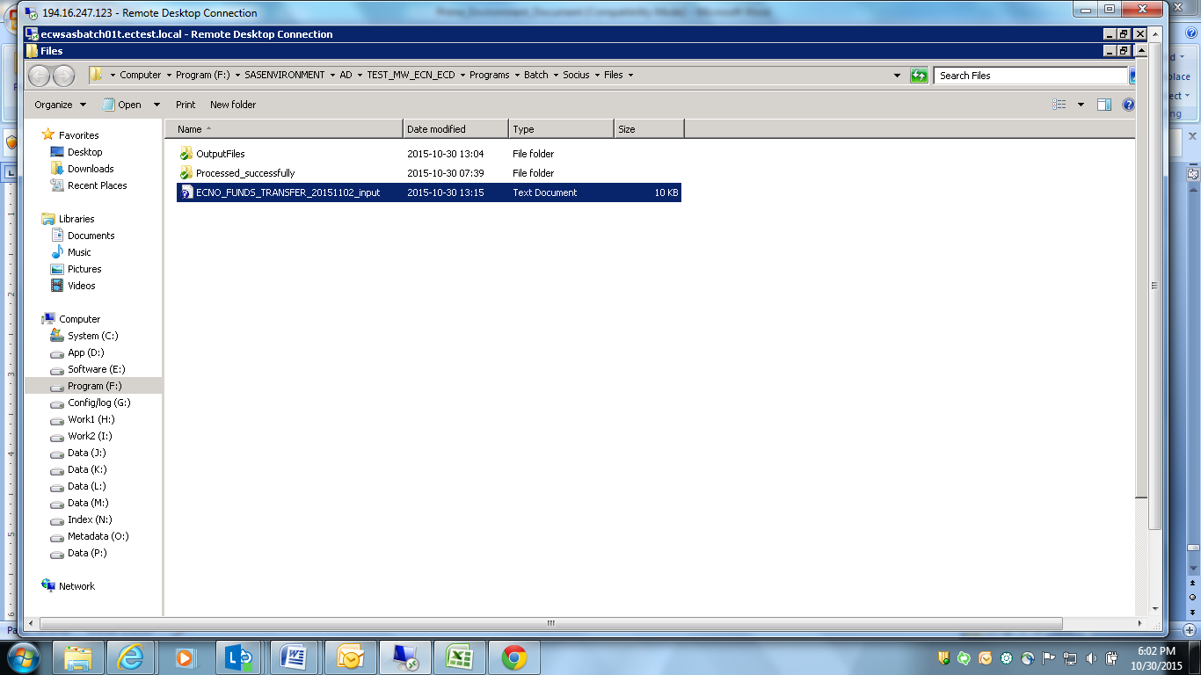

Open SOCIUS_NO_FLOW

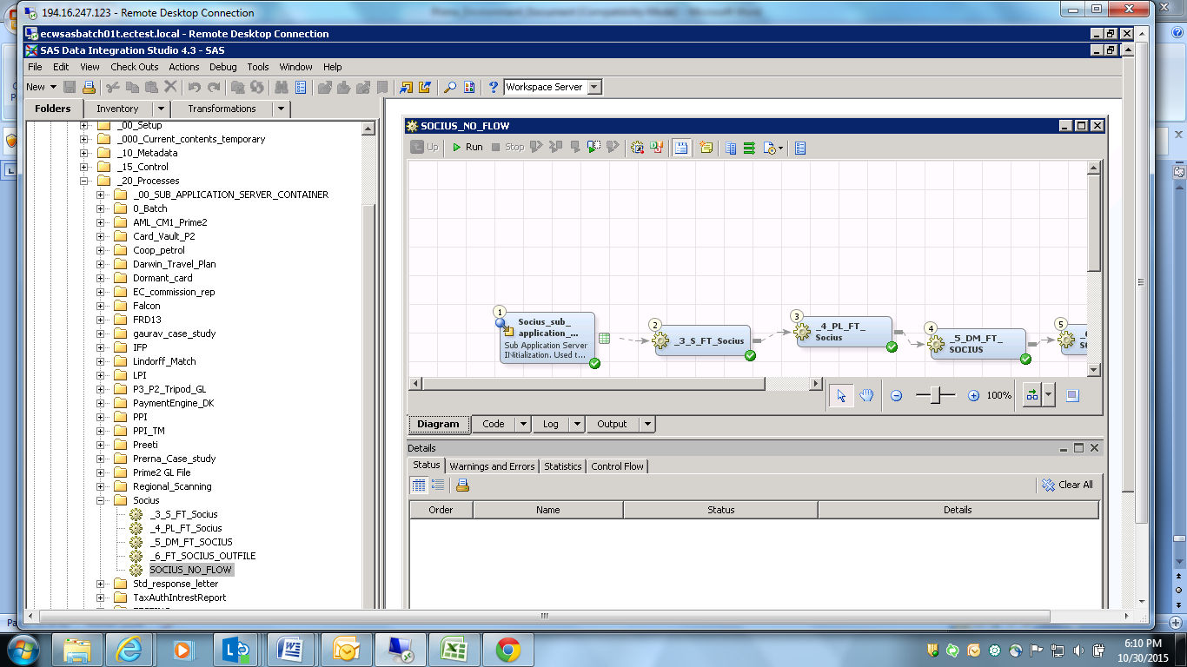

Click on Run

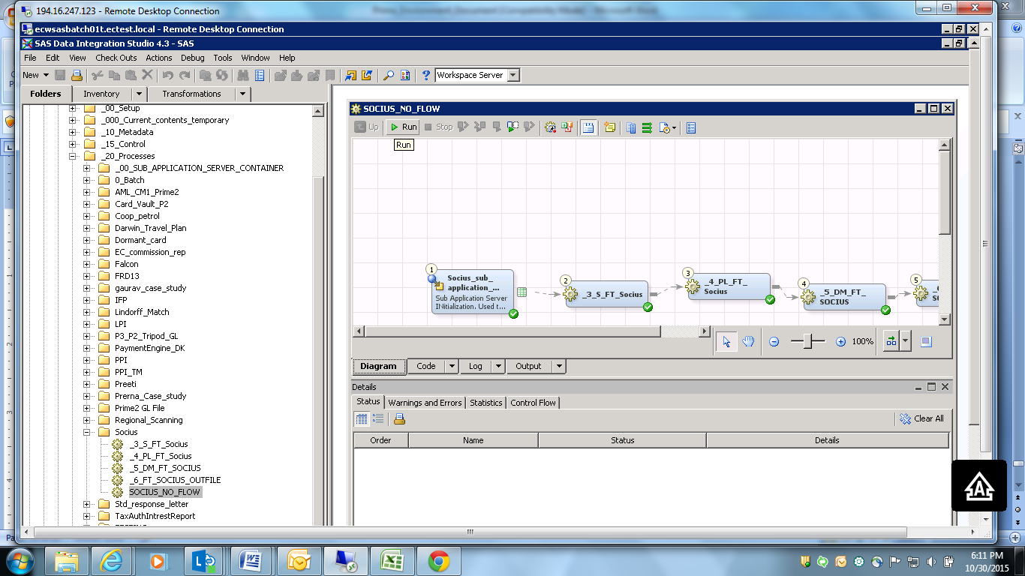

It will get process as shown:

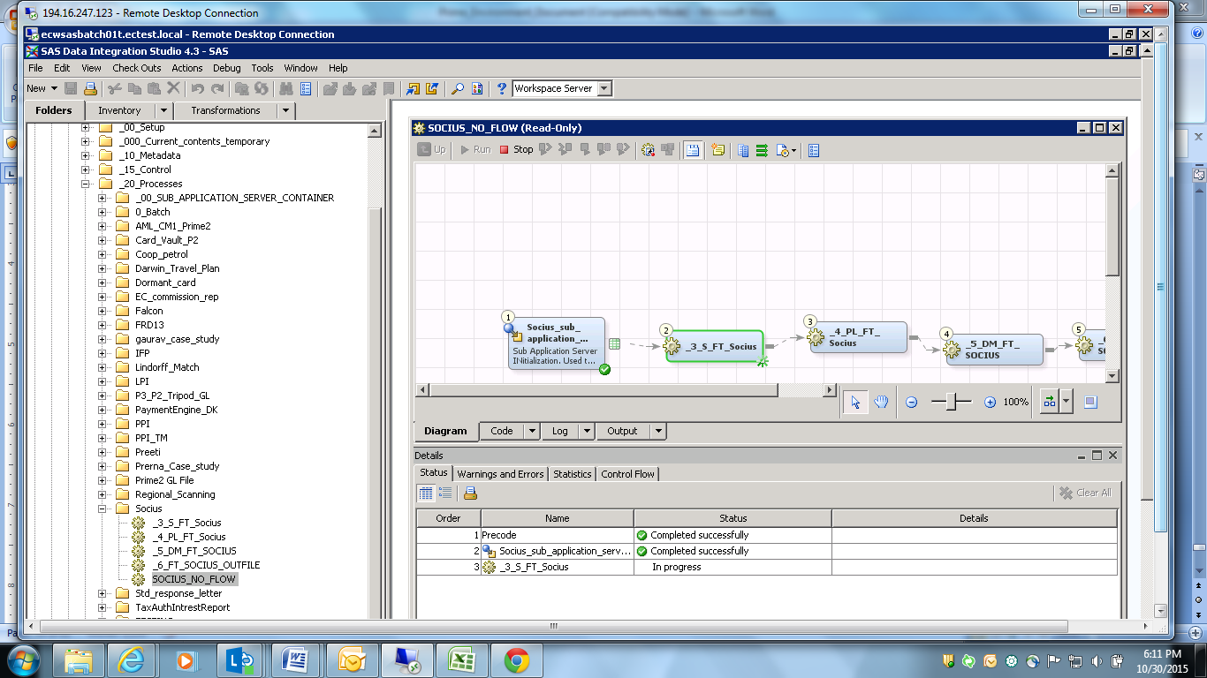

Once everything is processed, it will show status “Completed Successfully”

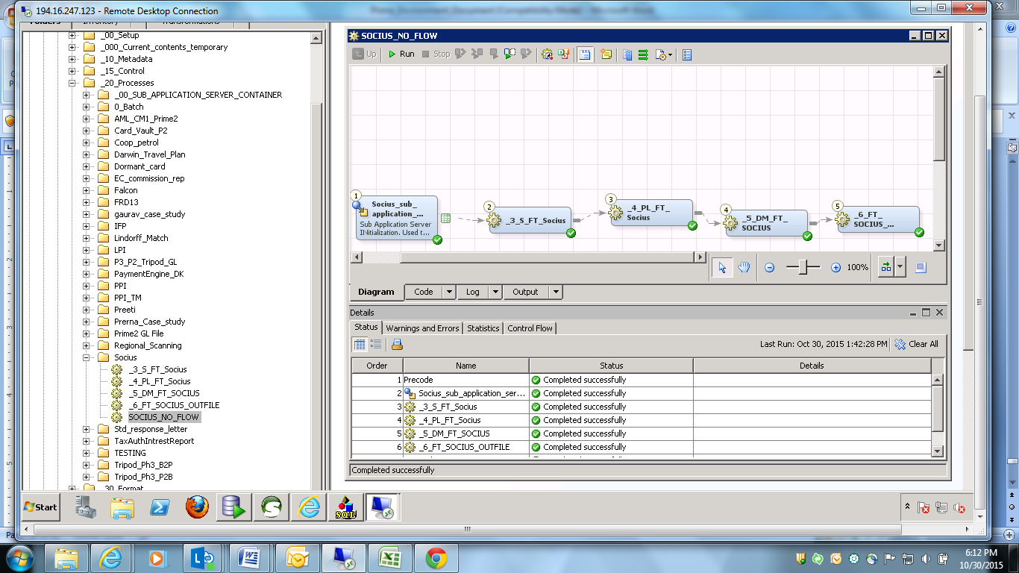

Now, check incoming file under same Incoming Path where we had paste. U will see file is not available as shown below

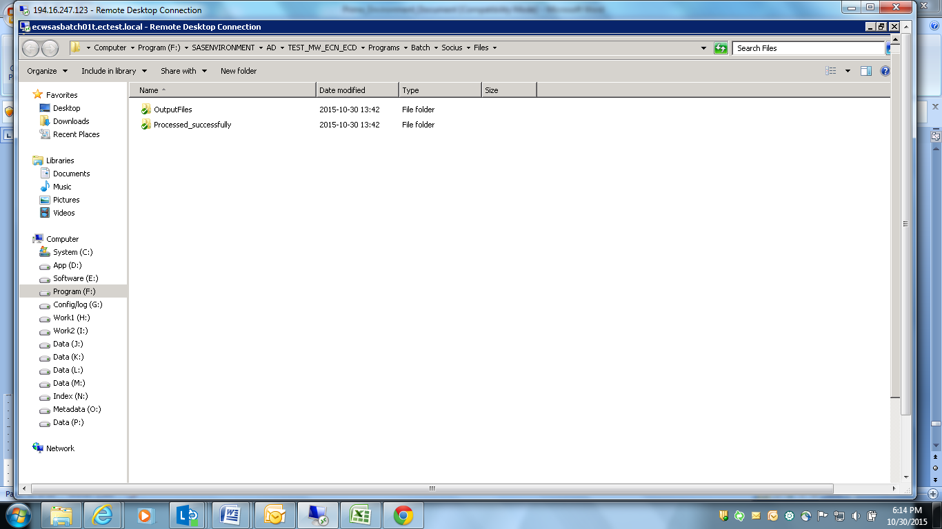

Now open processed successfully folder, u will see file has moved in this folder as it is processed successfully as shown below:

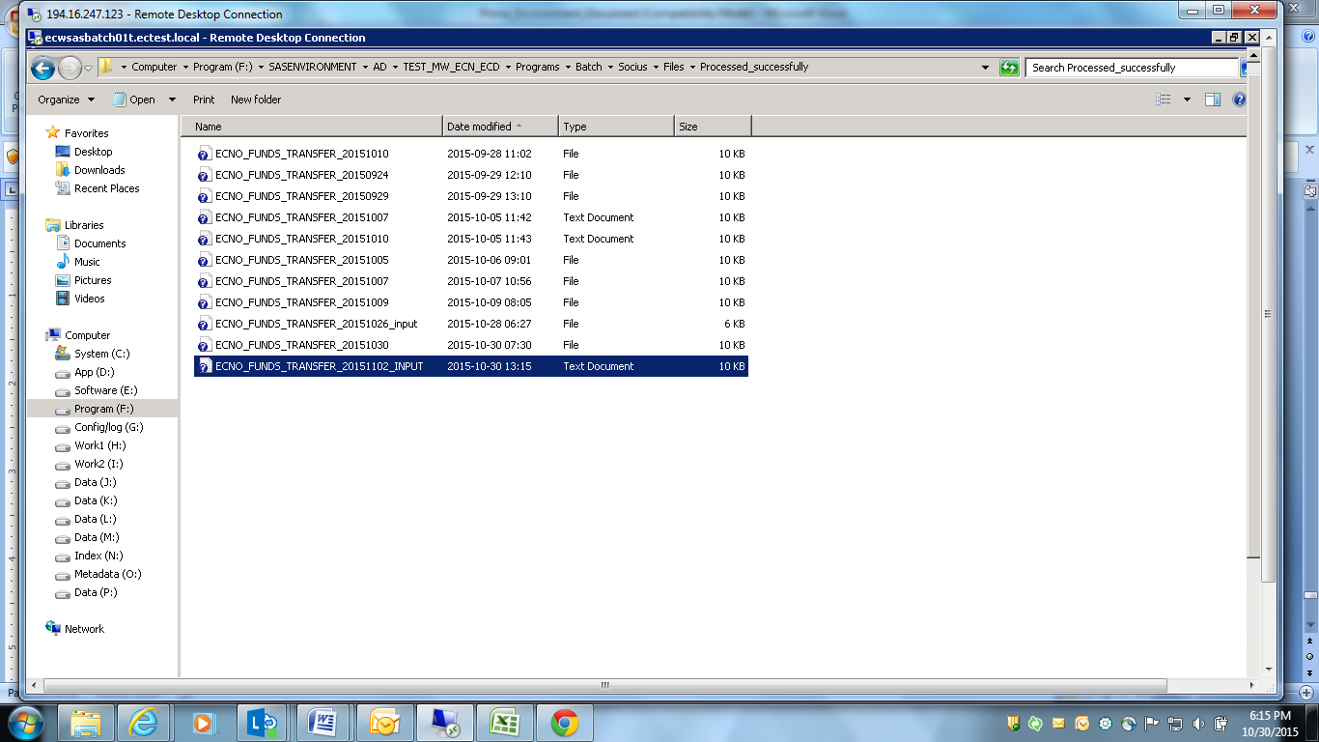

Now, check output files:

**FOR SAS Testing:**

Once code is deployed: **(Required below details to testers)**

Can u please confirm if the code is deployed for Socius, also please provide the sample file.

Could you please provide us the below details:

1. SAS Environment details
2. SAS MW DI job name
3. Incoming file folder
4. Outgoing file folder
5. Dwh processing is required.

Reply from developers will be as below:

I have deployed the code for Socius in SIT environment. Attached is the UTC document for your reference.

Below are further details:

1. SAS Environment details - ecwsasbatch01t.ectest.local
2. SAS MW DI job name – SOCIUS_NO_FLOW
3. Incoming file folder - F:\SASENVIRONMENT\AD\TEST_MW_ECN_ECD\Programs\Batch\Socius\Files
4. Outgoing file folder - F:\SASENVIRONMENT\AD\TEST_MW_ECN_ECD\Programs\Batch\Socius\Files\OutputFiles
5. Dwh processing is required. – No. Socius only access SOA Database to access Card vault details.

The sample test file from EVRY team is expected by tomorrow i.e. Sep 30, 2015. I will provide you the same once received.

|  |  |
| --- | --- |
| SR No | Questions |
| 1 | Explain Hierarchy of Prime  ? Give table names and how they are linked to each other ? |
| 2 | find accounts where balances are greater than 0? |
| 3 | What is a debit transaction , explain wit han example and how it effects account balances ? |
| 4 | Where would u be able to see transactions  between two statements dates ?Provide Screenshots? |
| 5 | Explain Closing balance calculation? Provide screen shot and explain ? |
| 6 | Explain the min amount calculation on a account? Provide screen shot and explain ? |
| 7 | Activate a service on an account? |
| 8 | Explain on what date Eod should be executed for  statement generation ? |
| 9 | How do renew , reissue  a card ? Provide screen shot ? |
| 10 | How can a card be closed  ? |
| 11 | change value for  an  Extension filed ? And verify tables ? |
| 12 | How EOD are executed ? Give sequential steps ? Don’t execute EOD |
| 14 | From which module do u  apply rights to a user for a screen ? explains with an example ? |
| 13 | Give an example of manual transactions ? With screenshot? |

**Testcases Scenarios:**

|  |  |
| --- | --- |
| **Test Name** | **Test (Scenario)** |
| TC_funds_Transfer Socius_001 | Verify the incoming file layout from Evry for Norway institution. |
| TC_Funds_transfer Socius_002 | Verify that user is able to generate the Incoming Transaction file by processing the" Socius_NO SAS" MW Job |
| TC_Funds_transfer Socius_003 | Verify two trigger file are generated in SAS in the outgoing file folder post sas job execution. |
| TC_Funds_transfer Socius_004 | Verify the content of the output file" ECNO_Funds_transfer_yyyymmdd" generated for Prime2. |
| TC_Funds_transfer Socius_005 | Verify an email is sent and a XLSX file is generated for CardID present in the input sample file of Evry and which does not exist In card vault |
| TC_Funds_transfer Socius_006 | Verify the subject and content of the email |
| TC_Funds_transfer Socius_007 | Verify an email is sent and a file is generated where blank AcquirerID is received in the incoming file from EVRY. |
| TC_Funds_transfer Socius_008 | Verify the subject and content of the email |
| TC_Funds_transfer Socius_009 | Verify that SAS MW populate card id instead of card number in the outgoing file where it does not find matching card number for the card id of the input sample file from Evry. |
| TC_Funds_transfer Socius_010 | Verify that SAS MW populate blank Aquiver Id in case where blank AcquirerID is received in the incoming file from EVRY. |
| TC_Funds_transfer Socius_011 | Verify the output file from SAS is loaded successfully in Prime2. |
| TC_Funds_transfer Socius_012 | Verify the Data is displayed in the Prime Front End as per the output file generated by SAS. |
| TC_Funds_transfer Socius_013 | Verify the name and layout of the reconciliation file generated by SAS Mw. |
| TC_Funds_transfer Socius_014 | Verify the content of the Reconciliation file |